INTRODUCTION TO PROJECT MANAGEMENT PRINCIPLES
FOR
NON-GOVERNMENTAL ORGANISATIONS
(ON DEMAND COURSE)
________________________________________________________________________________________________________

The Project Management Institute, Southern Caribbean Chapter (PMISCC) Volunteer Outreach Team is pleased to provide this basic Introductory Course on Project Management to the local NGO Community. This course is designed to offer a rudimentary understanding of project management principles. The content is derived from PMI's "A Guide to the Project Management Body of Knowledge" (PMBOK), Seventh Edition, a globally recognized standard in the field.
While the PMISCC Volunteer Outreach Team strives to provide accurate and up-to-date information, please note that this course is a general introduction to the principles of project management only, and does not qualify as a comprehensive or exhaustive source of information on Project Management. Project Management is a fully established profession, which requires significant technical education and relevant experience to qualify as a project management professional. However, the knowledge and practice of project management principles and tools could significantly assist persons across all industries to provide services more economically, efficiently and effectively.
We encourage you to explore the field of project management further by visiting our website at https://pmiscc.org/ to discover more about the discipline and accredited programs or organizations that provide formal project management certification. Please also note the following:
No Professional Certification: Completion of this course does not confer professional certification in project management.
Legal Advice: The information presented in this course should not be considered legal advice. Project management involves a multitude of legal, regulatory, and ethical considerations that can vary by jurisdiction. Seek appropriate legal and professional counsel when necessary.
Industry-Specific Practices: Project management practices and methodologies can vary significantly across industries. This course offers a general overview and does not cover industry-specific practices.
Dynamism of Project Management: The field of project management is dynamic, with new practices, tools, and techniques continuously emerging. Some course content may become outdated over time.
Liability: The PMISCC, as the creators of this course, shall not be held liable for any damages or losses resulting from the use of the information or materials provided. By enrolling in this course, you acknowledge and accept these disclaimers and limitations.

We encourage you to use the knowledge gained from this course in a responsible and informed manner.
Date: 1 January, 2024
TABLE OF CONTENTS
_______________________________________________________________________________________________________
MODULE 1: INTRODUCTION AND OVERVIEW 9
MODULE OBJECTIVES 9
MODULE STRUCTURE 9
INTRODUCTION 10
What makes a project a project? 11
How does this relate to NGOs? 12
LESSON 1 QUIZ (True or False) 14
Stages of a Project 15
What is project management? 16
LESSON 2 QUIZ (True or False) 17
MODULE 2: PROJECT SCOPE 19
MODULE OBJECTIVES 19
MODULE STRUCTURE 19
INTRODUCTION 20
LESSON 1 - SCOPE MANAGEMENT PLAN 21
LESSON 2 – REQUIREMENTS TRACEABILITY MATRIX 22
LESSON 2 QUIZ 24
LESSON 3 - PROJECT SCOPE STATEMENT 25
LESSON 3 QUIZ 26
LESSON 4 – CREATE A WORK BREAKDOWN STRUCTURE 27
LESSON 4 QUIZ 29
LESSON 5 - VALIDATE SCOPE 30
LESSON 5 QUIZ 31
LESSON 6 – CONTROL SCOPE 32
Figure 5 Control Scope: Process of Inputs, Tools and Techniques and Outputs 33
LESSON 6 QUIZ 34
MODULE 3: PROJECT SCHEDULE & TIME MANAGEMENT 36
MODULE OBJECTIVES 36
MODULE STRUCTURE 36
INTRODUCTION 36
LESSON 1: WHAT IS TIME MANAGEMENT? 37
LESSON 2: PROJECT SCHEDULE MANAGEMENT 38
LESSON EXERCISE 49
MODULE 4 - PROJECT RESOURCES 50
MODULE OBJECTIVES 50
MODULE STRUCTURE 51
INTRODUCTION 51
LESSON 1 - TYPES OF PROJECT RESOURCES 52
LESSON 2 – PROJECT RESOURCE MANAGEMENT 53
LESSON 3 – THE PROJECT RESOURCE MANAGEMENT PROCESS 55
LESSON EXERCISE 56
MODULE 5 – PROJECT COST MANAGEMENT 57
MODULE OBJECTIVES 57
MODULE STRUCTURE 57
INTRODUCTION 58
LESSON 1: PROJECT COST MANAGEMENT 59
LESSON QUIZ 66
MODULE 6 – PROJECT COMMUNICATION 68
MODULE OBJECTIVE 68
MODULE STRUCTURE 69
INTRODUCTION 69
LESSON 1 – PMBOK® GUIDE PROCESSES IN COMMUNICATION MANAGEMENT 71
LESSON 1 QUIZ 73
LESSON 2 - COMMUNICATIONS MANAGEMENT PLAN 74
LESSON 2 QUIZ 77
LESSON 3 – IMPORTANT CONCEPTS IN COMMUNICATIONS 78
LESSON 3 QUIZ 80
LESSON 4 - THE 5 CS OF WRITTEN COMMUNICATION 81
LESSON 4 QUIZ 82
LESSON 5 – COMMUNICATION METHODS 82
LESSON 5 QUIZ 83
LESSON 6 - COMMUNICATION MODEL 84
LESSON 6 QUIZ 86
LESSON 7 - COMMUNICATION CHANNELS 86
LESSON 7 QUIZ 87
LESSON 8 – MEETINGS & REPORTS 88
LESSON 8 QUIZ 90
LESSON 9 - COMMUNICATION BLOCKERS 91
LESSON 9 QUIZ 92
COMMUNICATION MANAGEMENT SUMMARY 93
MODULE 7 – PROJECT PROCUREMENT 95
MODULE OBJECTIVE 95
MODULE STRUCTURE 95
INTRODUCTION 96
LESSON 1: DIFFERENCE BETWEEN MOUs, MOAs AND SLAs 96
LESSON 1 QUIZ 97
LESSON 2 – CONTRACTS 98
LESSON 2 QUIZ 100
LESSON 3 – DATA GATHERING 100
LESSON 3 QUIZ 101
LESSON 4 – BID DOCUMENTS 102
LESSON 4 QUIZ 104
LESSON 5 – MANAGING PROCUREMENTS 104
LESSON 5 QUIZ 106
MODULE 8 – PROJECT RISK 107
MODULE OBJECTIVE 107
MODULE STRUCTURE 107
INTRODUCTION 108
LESSON 1 - What is Project Risk Management? 109
Definition of Risk: 109
LESSON 2 – Plan Risk Management and Identifying Risks 112
Risk Management Plan…What is it? 114
Identifying Risks 114
Risk Register 115
LESSON 3 – Perform Qualitative Risk Analysis 117
LESSON 4 - Perform Quantitative Risk Analysis 120
MODULE 9 – PROJECT QUALITY 124
MODULE OBJECTIVE 124
MODULE STRUCTURE 124
INTRODUCTION 125
LESSON 1 – WHAT IS QUALITY MANAGEMENT AND WHY IS IT IMPORTANT 128
LESSON 1 QUIZ 129
LESSON 2 – DEFINITIONS IN QUALITY MANAGEMENT YOU NEED TO UNDERSTAND 130
LESSON 2 QUIZ 132
LESSON 3 – WHAT IS ISO AND WHY IS IT IMPORTANT 134
LESSON 3 QUIZ 134
LESSON 4 – QUALITY MANAGEMENT PROCESS (PMI) 135
LESSON 4 QUIZ 143
LESSON 5 – TOOLS & TECHNIQUES FOR YOUR QUALITY MANAGEMENT PROCESS 145
LESSON 5 QUIZ (Multiple Choice, Matching & True or False) 162
MODULE 10 – PROJECT INTEGRATION 165
MODULE OBJECTIVES 165
MODULE STRUCTURE 165
INTRODUCTION 166
LESSON 1 - PROJECT INTEGRATION MANAGEMENT 166
LESSON 2 - PROJECT INTEGRATION MANAGEMENT STEPS 167
LESSON 3 - IMPORTANCE OF INTEGRATION MANAGEMENT 177
LESSON 4 - HOW TO SUCCEED AT PROJECT INTEGRATION MANAGEMENT 178
LESSON QUIZ 178
MODULE 11 – PROJECT CLOSURE 181
MODULE OBJECTIVES 181
MODULE STRUCTURE 181
INTRODUCTION 182
LESSON 1 - ACTIVITIES INVOLVED IN THE PROJECT CLOSURE PHASE 182
LESSON 2 - REASONS FOR PROJECT CLOSURE 183
LESSON 3 - PROJECT CLOSURE SCENARIOS 184
LESSON 4 - STAKEHOLDERS INVOLVED IN THE PROJECT CLOSURE PHASE 184
LESSON 5 - INPUTS OF THE PROJECT CLOSURE PHASE 185
LESSON 6 - OUTPUTS OF THE PROJECT CLOSURE PHASE 185
LESSON QUIZ 186

MODULE 1: INTRODUCTION AND OVERVIEW
________________________________________________________________________________________________________

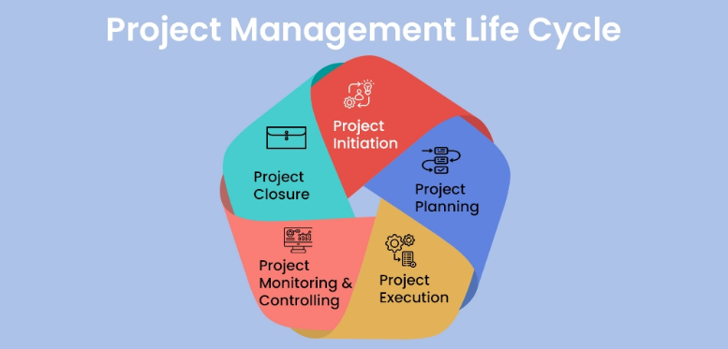

MODULE OBJECTIVES

At the end of this module, participants will be able to:
- Understand what makes a project.
- List the components of a project.
- Understand the difference between project lifecycle and the project management process.
- Understand what project management is.
- Describe the phases of the project life cycle.

MODULE STRUCTURE

This module will comprise of two lessons to be completed over the course of 4 hours.
- Lesson 1 – Project Management Concepts
- Lesson 2 – The Project Life cycle
At the end of each lesson, a short true or false quiz will be administered to concretize key learning points.

INTRODUCTION

The term "Non-Government Organization" (abbreviated as "NGO") refers to a group of people who come together to form an organization that is completely independent of government control and performs a range of services and humanitarian tasks. It is a non-profit organization that, depending on its reach and connectivity, operates on a regional, national, or international scale. It may be organized as a trust, a society, or a business. These organizations receive funding from various sources, including government, foundations, corporations, and individual donors.
In contrast, a Non-Profit Organization, also known as a NPO, is a group of people who came together legally to advance social, professional, religious, or cultural goals. The NPO's trustees or members raise the initial capital. The organization, which is a non-profit, uses its excess funds to further its goals rather than distributing them to its members because it is a non-profit entity.
To summarise, an NGO is a group of people who work together to advance cooperative or humanitarian goals rather than profit-oriented ones. The NPO, on the other hand, is an organization founded to advance art, science, education, or any other social or cultural goal. It intends to use its profits to advance its objectives rather than distributing them among the members.
Regardless as to whether you are part of an NGO or NPO, the Project Management principles, practices, toolkit of templates and other aids provided in this On Demand Course will assist in performance enhancement.
The application of Project Management methodologies within NGO’s and NPO’s is a feature that serves to augment the professionalism of the organisation while expanding services without increasing resources. With the underlying project management principles of effective and efficient resource use, organisational projects designed to serve a social cause that are carried out either internally or externally can be achieved.
Every team and organisation need to understand how to plan, manage, and execute work economically, efficiently, and effectively, within acceptable risks. Project management methodologies enable teams to define problems, conceptualise solutions, assess risks and costs, achieve objectives and complete projects more quickly and successfully.
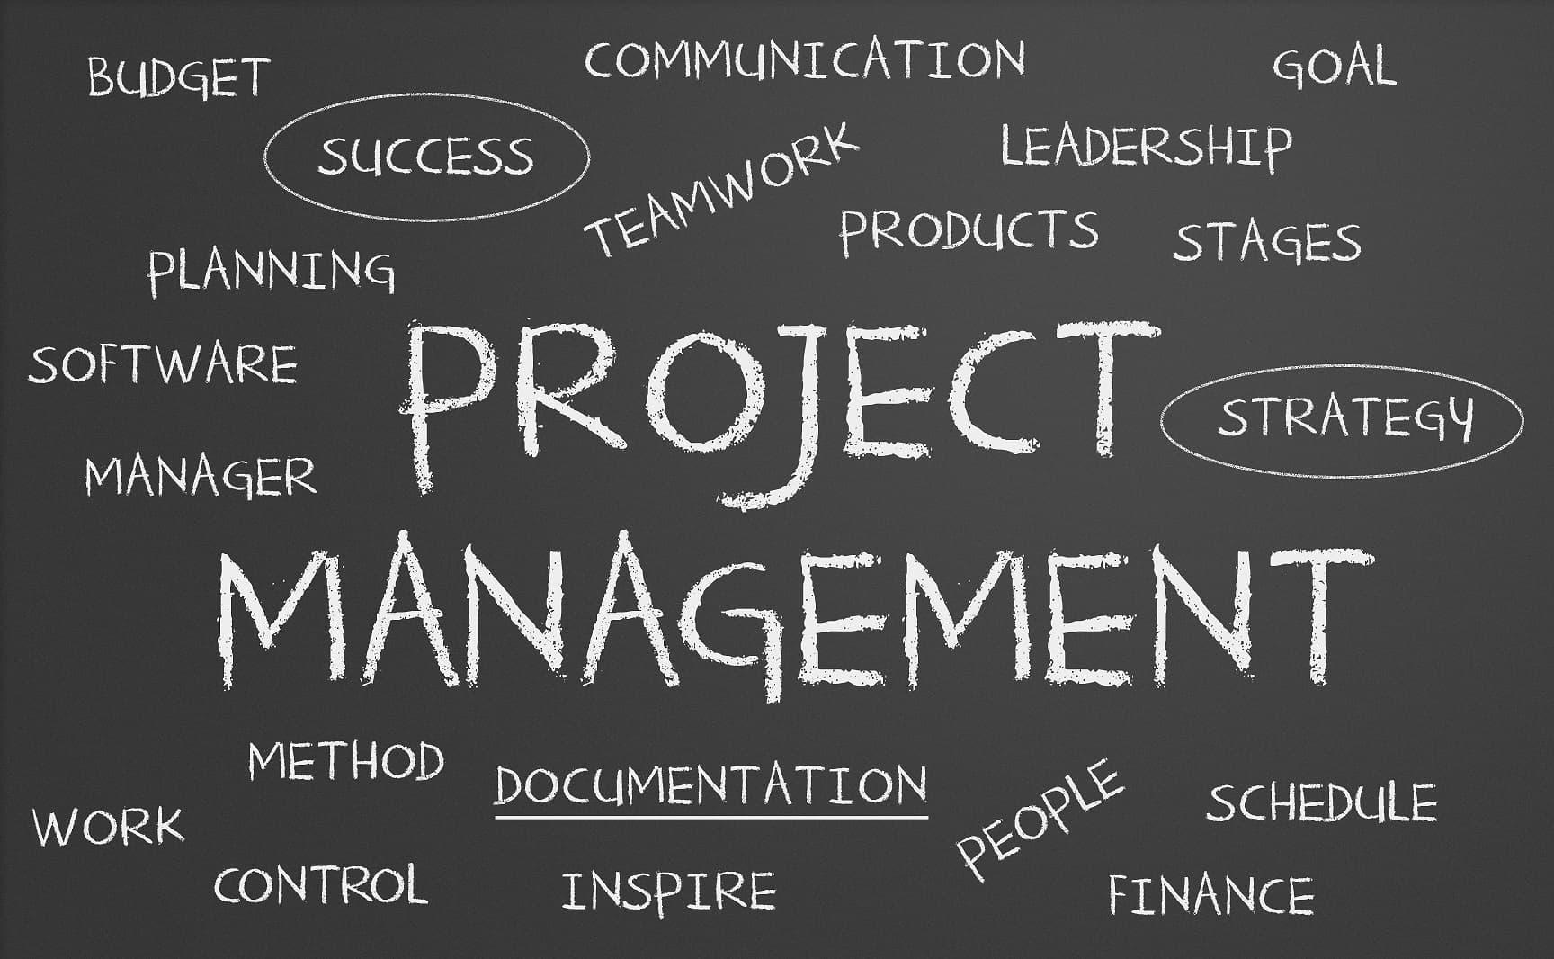
As an NGO/NPO, not all components of a traditional project management system may not be required, but your team will benefit from some of the fundamental components.
________________________________________________________

Lesson 1 - Project Management Concepts

What makes a project a project?

Let’s begin by defining a project. The Project Management Institute (PMI) defines a project as “a temporary endeavour undertaken to create a unique product or service”.
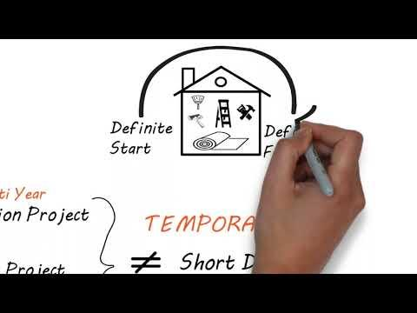

How does this relate to NGOs?
It is important for NGOs to ensure the project undertaken is specific, has a beginning and an end and produces an observable and measurable result, output, outcome or deliverable that is clearly defined and articulated. This result should be properly aligned to the needs of the NGO/NPO. The desired results of the project are pre-defined with specific conditions outlined. These conditions are a sequence of tasks that must be completed to attain the project outcome.
There are three main components of a project.
- Specific scope – the work performed to deliver a product, service or result with the specified features and functions. Alternatively stated, the desired result of the project
- Schedule – an output of a work plan that presents linked activities with planned dates, durations, milestones, and resources. The schedule establishes the dates when the project begins and ends, as well as dates by when key activities must be completed if the overall project end date is to be achieved.
- Required resources – a resource is a team member, or any physical item needed to complete the activity (i.e. funds, equipment, people, raw materials, facilities)

Product

Schedule

Resources

While there are many factors, both internal and external, that impact the performance of a project, the only reason a project exists is to produce the results specified in the scope. The project's end date is an important factor in defining successful performance, and the nature of the resources provided shapes the nature of the product that will be produced.
What does a project look like?
Projects come in all shapes and sizes.
- They can be large or small –
  - Providing sanitary napkins and healthcare packages to three million girls in Africa
  - Preparing an ad hoc report of monthly global humanitarian aid which may take a day to complete.
- They may involve many people or just one individual –
  - Training 1000 staff to utilize software designed to oversee disaster response after natural disasters.
  - Rearranging furniture and equipment.
- They may be defined by a legal contract or informal agreement –
  - A signed agreement with a customer to provide drug support services to the previously incarcerated.
  - An informal promise to design a website for an NGO.
- They may be business related or personal –
  - conducting an annual charity fun run.
  - Having a fundraiser dinner party for 20 people.
Regardless of the individual characteristics of the project, all projects are defined by applying the three components – results (scope), schedule and resources. The information required to manage a project is the same, although size and complexity will impact the qualifications and experience level of the project team and time needed to achieve the desired output or outcome. The more thoroughly a project is planned and managed, the more likely it is to succeed.

LESSON 1 QUIZ (True or False)
- A project is an endeavour undertaken to create a unique product or service.
False - a project is a temporary endeavour undertaken to create a unique product or service.
- The desired results of a project are never pre-defined.
False - the desired results of a project should be pre-defined as much as possible.
- The three main components of a project are scope, schedule, resources.
True.
- Preparing a weekly report is a project.
False – a project a temporary endeavor undertaken to create a unique product or service. A weekly report is not a temporary endeavor.
- The three components of a project cannot be applied to large long-term projects.
False - Regardless of the individual characteristics of the project, all projects are defined by applying the three components – results (scope), schedule and resources.

Lesson 2 – The Project Life Cycle

It is important to make a distinction between the project life cycle and the project management process. The project lifecycle refers to a series of stages in the development of a project. The project lifecycle is the organisation’s methodology for managing a project. Project lifecycles can be either plan driven or change driven. In contrast, the project management process refers to what is required to be done to manage the work throughout the project lifecycle. More simply, the project lifecycle is what is needed to do the work and the project management process is what is needed to manage the work. Both are required for a successful project.
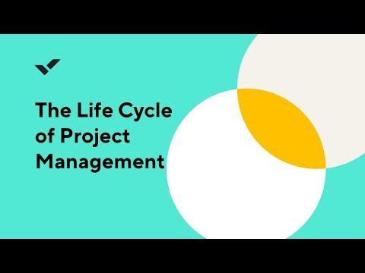

Stages of a Project

Start

Organise/Prepare

Work performance

Close

Every project, no matter how large, small or complex, goes through the four stages listed below.
- Stage 1 Project start – During this stage the business need for the project, the approach to performing the project, in addition to a detailed project plan, are prepared.
- Stage 2 Organisation and preparation – The work to be done, time, cost, resources required and plan for how to address risks are developed, discussed, and documented in a project plan or project schedule.
- Stage 3 – Work performance – the project team is established, and they perform the planned worked. The project team lead monitors and controls performance to ensure adherence to the plan.
- Stage 4 – Close – The results of the project are assessed; a post project evaluation is conducted and lessons learned documented in a final report.
The project stages are linear and usually occur in succession, however the success of a project depends upon adopting a flexible approach and responding to real life situations which may require working on two stages at the same time to meet deadlines.

What is project management?
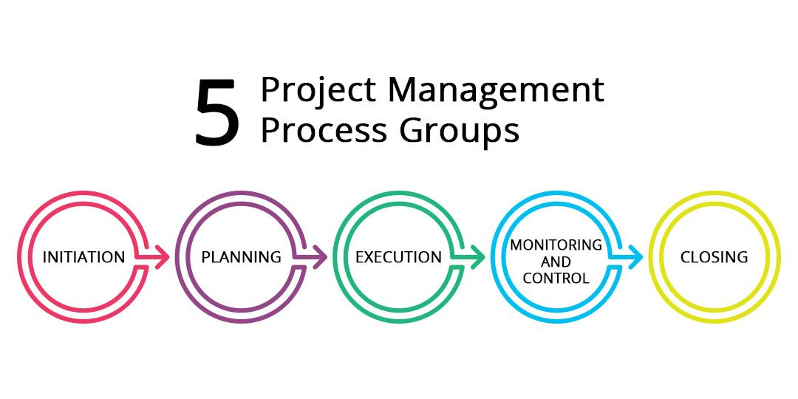
The Project Management Institute (PMI) defines project management as “the use of specific knowledge, skills, tools and techniques to deliver something of value to people”. Project management helps teams organize, track, and complete work within a project. Project management also assists teams in planning, managing, and executing work so that project deadlines can be met.
Every project will be slightly different depending on its nature, the individual role you play on the team, and how the team members collaborate. However, despite these variations there are five major project phases that occur during the project management process:
- Initiating Process – formally starts a new project. Identifies and analyzes stakeholders in order to align their expectations about the project. This process also provides a guiding vision for the project in terms of strategic objectives and project benefits. The project team is assembled, and the scope of the project is defined. Depending upon the complexity and scale of the project a roadmap is also created during this phase.
- Planning Process – the project requirements are outlined and a definition of what "project success" entails. This project phase is essential for successful project management and meeting project objectives. A project plan, identification of key milestones, and consensus on project costs and timelines are established.
- Executing Process - the executing phase makes up the majority of the project. The goal is to complete project deliverables within the project's budget and timeline while delivering the agreed-upon benefits. The practical applications of workload management, risk management, time management, and task management are employed to keep the team on track and working in an integrated manner.
- Monitoring and Control - Examining what is going on with the project and comparing actual and projected performance to what was planned. Reporting occurs both during and after the execution phase. Reporting will help the project remain on course, promote collaboration, and increase cross-functional visibility throughout the project.
- Closing Process – finalizing all activities to formally close out the project. This includes confirming that all work was completed in alignment with the requirements, the solicitation of stakeholder feedback, production of a final report and documenting lessons learned.

LESSON 2 QUIZ (True or False)
- Project lifecycle is what is needed to manage the work and the project management process is what is needed to do the work.
False - project lifecycle is what is needed to do the work and the project management process is what is needed to manage the work.
- The stages that every project goes through are project start, work performance and close.
False – project start, organisation and preparation, work performance, close.
- Project management is the use of specific knowledge, skills, tools and techniques to deliver something of value to people.
True.
- During the initiating process, identification of key milestones and consensus on project costs and timelines are established.
False – during the initiating process, strategic objectives and project benefits are identified. The project team is assembled, and the scope of the project is defined.
- The order in which the project management phases occur is initiating, planning, monitoring and control, executing, closing.
False – the project management phases are initiating, planning, executing, monitoring and evaluation, closing.
- The monitoring and controlling process will take up the majority of the project.
False - the executing phase will take up the majority of the project.
- Confirming that all work was completed in alignment with the requirements occurs during the closing process.
True.
- The project team is assembled, and the scope of the project is defined during the planning process.
False – assembling the project team and defining the scope that occurs during the initiating process.
- Depending upon the complexity and scale of the project, a roadmap is also created during the planning process.
False – a roadmap is created during the initiating process.
- A project plan, identification of key milestones, and consensus on project costs and timelines are established during the planning process.
True.

MODULE 2: PROJECT SCOPE
________________________________________________________________________________________________________

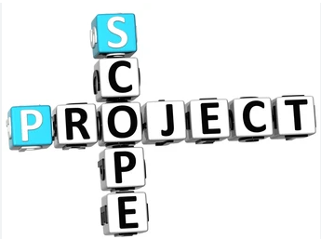

MODULE OBJECTIVES

At the end of this module, participants will be able to understand:
- The process of creating a scope management plan that documents how the project and product scope will be defined, validated, and controlled.
- The process of determining, documenting, and managing stakeholder needs and requirements to meet project objectives.
- The process of developing a detailed description of the project and product.
- The process of subdividing project deliverables and project work into smaller, more manageable components.
- The process of formalizing acceptance of the completed project deliverables.
- The process of monitoring the status of the project and product scope and managing changes to the scope baseline.

MODULE STRUCTURE

This module will be delivered in six lessons to be completed over the course of 12 hours.
Lesson 1 - Scope Management Plan
Lesson 2 – Requirements Traceability Matrix
Lesson 3 – Project Scope Statement
Lesson 4 - Create Work Breakdown Structure
Lesson 5 - Validate Scope
Lesson 6 - Control Scope

INTRODUCTION

Project Scope Management is the knowledge area in which we describe specifically the requirements of the project by stating what work will be in scope and what work will be out of scope. Project requirements are elicited from all stakeholders. Requirements must be evaluated against the business case, ranked, and prioritized to determine what is in and out of scope. Scope must be clearly defined and formally approved before work starts.
Any changes to scope must be evaluated for its effect on time, cost, risk, quality, resources and customer satisfaction. The project scope is also aligned to project deliverables. The project manager is responsible for getting acceptance of deliverables throughout the project.
Four (4) of the scope processes are done during the planning stages of the project, the Validate and Control scope are performed during the monitoring and controlling stage.
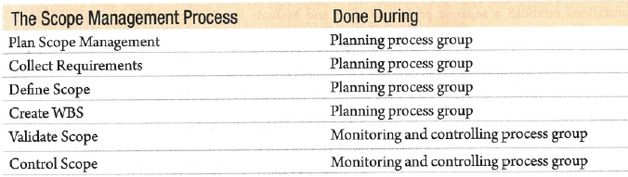
Figure 1 – Scope Management Process

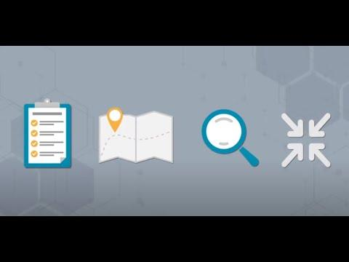

LESSON 1 - SCOPE MANAGEMENT PLAN

This plan is a component of the project or program management plan that describes how the scope will be defined, developed, monitored, controlled, and validated.
Creating a Scope Management Plan is an essential step in any project, and it helps to ensure that the project remains within its constraints and that any changes to the scope are managed effectively. The Scope Management Plan outlines how the project scope will be defined, validated, controlled, and communicated.
Here are some easy steps to create a Scope Management Plan in a non-complex way:
- Define the scope: Define what will be covered within the project, including the project objectives, deliverables, and boundaries. Identify the stakeholders and their expectations, and check what can reasonably be accomplished within the project.
- Define the scope management approach: Define how the project scope will be managed, including how changes will be handled, how the scope will be validated, and how communication will be managed.
- Define the change control process: Define how changes to the project scope will be requested, evaluated, approved, and communicated. Identify who has the authority to approve changes.
- Define the scope validation process: Define how the project scope will be validated to ensure that all deliverables have been completed and that the project objectives have been met.
- Define the scope control process: Define how the project scope will be monitored and controlled to ensure that any changes to the scope are managed effectively, and that the project remains within its constraints.
- Define the communication plan: Define how project scope will be communicated to stakeholders, including how progress reports will be provided and to whom, how changes to the scope will be communicated, and how any issues related to the project scope will be managed.
- Define the roles and responsibilities: Define the roles and responsibilities of the project team members and stakeholders related to scope management.
By following these steps, the relevant member of the organisation can create a Scope Management Plan that outlines how the project scope will be managed throughout the project. It helps to ensure that the project remains within its constraints and that any changes to the scope are managed effectively. The plan serves as a roadmap for managing the project scope and helps to ensure that the project meets its objectives.

LESSON 2 – REQUIREMENTS TRACEABILITY MATRIX

Creating a Requirements Traceability Matrix (RTM) is a process that helps to ensure that all requirements are documented, tracked, and met throughout the project. The purpose of the RTM is to create a link between the project requirements and the project deliverables to ensure that all requirements are fulfilled.
Some common categories used when collecting requirements are:
- Business requirements: Why was the project undertaken? For example, we need a new computerised system to enter NGOs contact information.
- Stakeholder requirements: What do stakeholders want to gain from the project? For example, a stakeholder would like to get a report showing all the NGOs in Trinidad and their contact information e.g., Phone numbers, email addresses.
- Quality requirements: What constitutes a successfully completed deliverable? For example, the report generated must have reliable and accurate information about the NGOs.
To create an RTM in an excel spreadsheet is quite simple, and there is no need for any fancy project management software, Follow these steps below:
- Identify the project requirements: Gather all the requirements for the project from the project stakeholders, including the customer and end-users.
- Create a spreadsheet: Create a spreadsheet that will serve as the RTM. You can use a tool like Microsoft Excel or Google Sheets.
- Define the columns: Create the necessary columns in the spreadsheet. You will need columns for the requirement ID, requirement description, source of the requirement, and the status of the requirement.
- Map the requirements: For each requirement, enter the ID, description, and source of the requirement in the corresponding columns of the spreadsheet.
- Add the status: Use the status column to track the status of each requirement throughout the project. You can use labels such as "Not Started," "In Progress," or "Completed."
- Link to deliverables: Create columns in the spreadsheet to link each requirement to the project deliverables. You can use the columns to specify which deliverables meet each requirement.
- Update the matrix: As the project progresses, update the RTM to ensure that all requirements are met. Add new requirements, update the status of existing requirements, and link them to the appropriate deliverables.

By following these steps, anyone can create an RTM that helps to ensure that all project requirements are met. The matrix serves as a tool to track progress and ensure that the project meets its objectives.
The video below shows how to use Microsoft Excel with some tips and tricks for easy use in creating a Requirements Traceability Matrix:
https://www.youtube.com/watch?v=b3qPWGwfCwE

LESSON 2 QUIZ

- We often talk with stakeholders one on one to help collect requirements. What is this called?
A. prototypes
B. facilitated workshops
C. questionnaires
D. interviews

Answer D: Interviews involve talking to stakeholders one on one

- Another name for job shadowing when collecting requirements is?
A. focus groups
B. observations
C. prototypes
D. questionnaires

Answer B: observations is the method of watching someone as they perform their job (job shadowing) so as to collect requirements.

- Carl Johnson is presently separating the Mangrove Project into distinct subcomponents by research, requirements gathering, design etc. He can divide the project into subcomponents based on all the below choices, except?
- Characteristics of the organisation
- Project business case
- Nature of the project
- Funding

Answer B: project business case sets out why you should start the project, the benefits and costs of the project.

LESSON 3 - PROJECT SCOPE STATEMENT

A project scope statement is a document that outlines the goals, deliverables, boundaries, and constraints of a project. It defines the parameters of the project and sets the expectations for what will be delivered at the end of the project.
To explain the project scope statement, you can use the analogy of planning a road trip. Imagine you are planning a trip across the country, and you want to create a scope statement to define the parameters of the trip. The scope statement would include the following information:
- The goals of the trip: You may want to see famous landmarks, visit friends or family, or attend a specific event.
- The deliverables: The deliverables of the trip may include visiting specific destinations, taking photos, and having fun experiences.
- The boundaries: The boundaries of the trip may include the timeframe of the trip, the budget, and the mode of transportation.
- The constraints: The constraints of the trip may include factors such as weather, road closures, and availability of accommodations.
- The assumptions: Published opening and closing times for visits to landmarks remain in force, and there are no unscheduled interruptions.
In this way, a project scope statement is like a roadmap for a project. It defines the objectives, the deliverables, the acceptance criteria, the assumptions, and the constraints of the project, and it helps to ensure that everyone involved in the project has a clear understanding of what is expected. By using this analogy, you can understand that a project scope statement is a critical document in project management that sets the direction and boundaries of the project.

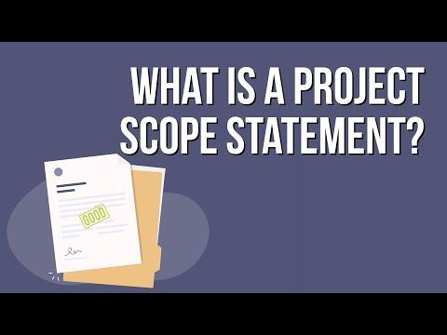

LESSON 3 QUIZ

- The client has given you a project to build a day care for him. You have met with all stakeholders, noted their requirements, and you are now deciding which requirements should be included in the project and which should not. What process is this?
- Identify stakeholders
- Collect requirements
- Define scope
- Define requirements
Answer C: Define Scope.
- You are busy with an important milestone and after that you have to deliver a deliverable to the client. Since the client is known for his difficult behaviour, you are worried whether the client will accept the deliverable. You check the product acceptance criteria again before calling the client. What document will you look at to get this information?
- WBS
- WBS Dictionary
- Project scope statement
- RACI Matrix
Answer C: Project scope statement.
- During which part of the project management process is the project scope statement created?
- Initiating
- Planning
- Executing
- Monitoring and Controlling
Answer B: The project scope statement is an output of the define scope process, which occurs in project planning.

LESSON 4 – CREATE A WORK BREAKDOWN STRUCTURE

A work breakdown structure (WBS) is a hierarchical representation of a project's tasks, activities, and deliverables. It breaks down the project into smaller, more manageable components, allowing project managers to better plan, execute, and control the work required to complete the project.
Creating a Work Breakdown Structure (WBS) before the project starts helps to identify dependencies between tasks, clarify project scope, and ensure all necessary tasks are accounted for and completed within the given timeframe.
To explain this concept, we can use the analogy of building a house. The video below provides an example.
https://www.youtube.com/watch?v=BVcd9uy9kuQ

A code of accounts is a hierarchical structure used to categorize and organize project costs and resources in project management. The code of accounts provides a standard way of identifying and tracking project expenses, which is essential for budgeting, forecasting, and reporting purposes.
Each account code is typically made up of a unique combination of numbers and letters, which corresponds to a specific category of expenses or resources. For example:
- Labour costs might be categorized using account codes that start with the number "1,"
- Equipment costs might be categorized using account codes that start with the number "2."
By using a code of accounts, project managers can easily monitor project expenses and resource utilization, compare actual costs to budgeted costs, and identify any areas where costs are exceeding expectations. This information can then be used to adjust the project plan, allocate resources more effectively, and make better-informed decisions.

A control account is a management control point within a project that represents a significant part of the total budget. It is a summary of the costs and schedule performance for a group of related work packages or activities within a project.
Control accounts are used to track and monitor the performance of a project by comparing actual progress and costs against the planned performance. They are often used to manage large, complex projects where there are many work packages or activities to be completed.
Control accounts are also used to provide visibility and accountability for project management, allowing project managers to identify issues or variances in cost and schedule performance, and take corrective action as necessary. This helps to ensure that projects are completed on time, within budget, and to the required quality standards.
The video explains code of accounts and control accounts in a simple way that can be used especially when reporting to management on the project’s performance.
https://www.youtube.com/watch?v=702hIkfzgu8

LESSON 4 QUIZ

- The Work Breakdown Structure (WBS) should be?
A. deliverable oriented
B. activity oriented
C. both deliverable and activity oriented
D. neither deliverable or activity oriented

Answer A: the WBS should be deliverable oriented.

- As a project manager for a local NGO, you want to introduce the creation and utilization of the WBS. Some of your project team members are angry because it seems like “extra work”. Which of the following is the best thing you could tell your project team members to convince them to use WBS?
  - Work breakdown structures will prevent work from slipping through the cracks.
  - Work breakdown structures are of greater value on large projects.
  - Work breakdown structures are best when the project involves contracts
  - Work breakdown structures are the only way to identify risks

Answer A: Preventing work from being forgotten is one of the main reasons the tool is used, and is the best choice offered here.

- As the project manager for the Mangrove project and while finalizing the WBS you assign each work package to a control account and establish a unique identifier for the same work from a code of account. These identifiers help you find a hierarchical sum of costs, schedule etc. Which statement is true about the WBS?
  - It contains all project work
  - It authorizes the project manager
  - it is a hierarchy of project staff
  - It is a hierarchical breakdown of project resources

Answer A: It contains all project work.

LESSON 5 - VALIDATE SCOPE

Validate scope is a crucial step in ensuring that the final project deliverables meet the requirements and expectations of the customer or stakeholders. It is essential to ensure customer satisfaction and project success.
Using the analogy of ordering food in a restaurant:
- After placing an order, the chef prepares the food according to the specifications provided by the customer, such as special requests for cooking time, ingredients, and presentation.
- Once the food is ready, the waiter brings it to the table for the customer to inspect and verify that it meets their requirements.
- If the food is not cooked correctly or does not meet the customer's expectations, the customer can send it back to the kitchen for revisions.
- If the food is acceptable, the customer can formally accept it, and the waiter marks the order as complete.
The diagram below summarises the validate scope process according to the Project Management Institute. The Project Manager uses inspection and decision – making techniques like voting to provide the outputs accepted deliverables, change requests and updates to project documents.

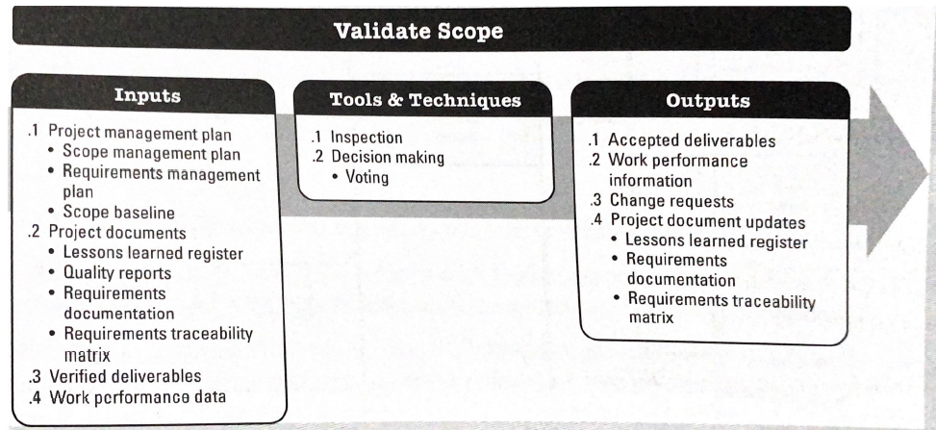
Figure 4 Validate Scope process of Inputs, Tools and Techniques and Outputs

LESSON 5 QUIZ

1. Which of the following best describes the validate scope process?
- It provides assurances that the deliverable meets the specifications, is an input to the project management plan, and is an output of control quality
- It ensures the deliverable is completed on time, ensures customer acceptance, and shows the deliverable meets specifications
- It ensures customer acceptance, shows the deliverable meets specifications
- It is an output of control quality, occurs before define scope, and ensures customer acceptance
Answer C: It ensures customer acceptance, shows the deliverable meets specifications.

2. The mangrove project is a huge project, so you have divided it into several phases. After completing each phase, you hand it over to the client and then move on to the next phase. Which process ensures that the previous phase has met all of its requirements so you can move on to the next phase?
- Close procurement
- Validate scope
- Control scope
- Control quality
Answer B: Validate scope.
3. Acceptable deliverables are?
- An input of control quality
- An output of control quality
- An input of validate scope
- An output of validate scope
Answer D: an output of validate scope.

LESSON 6 – CONTROL SCOPE

Control scope is the process of monitoring and controlling changes to the project scope. It ensures that the project remains on track and that any changes to the scope are managed effectively to prevent scope creep and keep the project within its constraints.
You can use the analogy of a construction project to explain the control scope process. Imagine building a house with a set budget and timeline. The original plan specifies the number of rooms, the size of the house, and the materials to be used. During construction, the client may request changes to the scope, such as adding a room or using a different type of material. However, these changes may impact the budget or timeline of the project.
To control the scope of the project, the project manager must evaluate the impact of the change request and determine if it can be accommodated within the constraints of the project. For example, if the client requests an additional room, the project manager would evaluate the impact on the budget and timeline and decide if it is feasible to add the room without exceeding the budget or delaying the project.

In this way, control scope helps to ensure that the project remains within its constraints and that any changes to the scope are managed effectively. By using this analogy, you can understand that control scope is a crucial process in managing changes to a project and ensuring that it is completed within its constraints. It helps to prevent scope creep and ensures that the project meets its objective.
The diagram below summarises the control scope process according to the Project Management Institute. The Project Manager uses data analysis like variance and trend analysis to provide the outputs change requests, updates to project documents and project management plan.

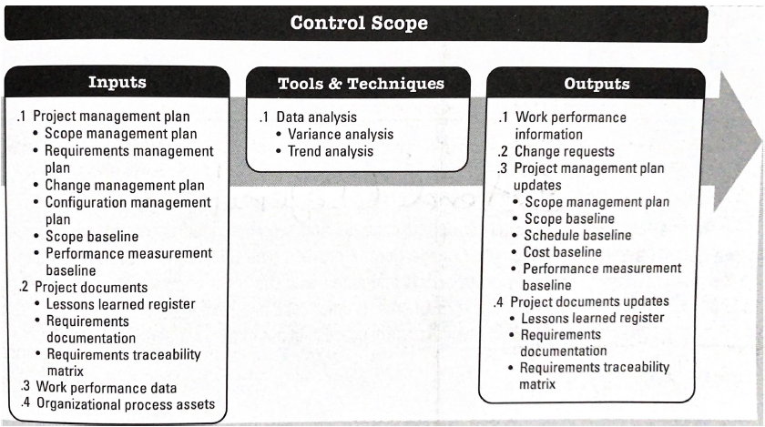
Figure 5 Control Scope: Process of Inputs, Tools and Techniques and Outputs

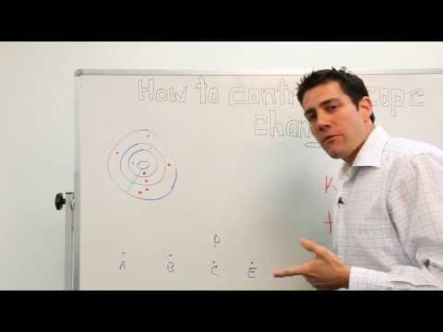

LESSON 6 QUIZ

- Scope creep is another name for what?
A. Uncontrolled expansion of project scope
B. Small changes that are processed through the change control system
C. Changes that are rejected during the change control process
D. Changes sent to integrated change control for processing

Answer A: uncontrolled expansion of project scope.

2. Which of the following is correct in regard to the Control Scope process?
A. Effective scope definition can lead to a more complete project scope statement
B. The control scope process must be done before scope planning
C. The control scope process must be integrated with other control processes
D. Controlling the schedule is the most effective way of controlling scope

Answer C: the control scope process must be integrated with other control processes

3. Variance analysis is a tool and technique of which process?
A. Plan scope management
B. Define scope
C. Validate scope
D. Control scope

Answer D: variance analysis is a tool and technique of control scope.

4. Which of the following is an input of control scope?
A. Cost baseline
B. Schedule baseline
C. Scope baseline
D. Performance measurement baseline

Answer C: since the process is about scope, the input will be the scope baseline.

MODULE 3: PROJECT SCHEDULE & TIME MANAGEMENT
_____________________________________________________________________________________

MODULE OBJECTIVES
The success of an NGO depends largely on the purpose and quality of the projects that it develops and implements. For many NGOs, the birth of a new idea can lead to the next event, campaign, socio economic improvement, and national change agent or income earner. Therefore, it is important to secure the assistance necessary to translate that new bright idea into logical strategies for execution. It is also important to conduct projects within promised timelines, so that the new bright ideas can become realities that assist the purpose of the NGOs. Time management is also critical to project success, as whenever milestone dates are missed, these may very well impact the start and completion dates of other activities and milestones. When this occurs, the whole project becomes impacted in some way, with cost escalations and disappointments from key stakeholders. As part of project management, a Project Manager must work hard to maintain time management and project deadlines for the benefit of the project.
At the end of this Module, participants will have an idea of the importance of time management and how to consider scheduling of project activities.

MODULE STRUCTURE

This module will be delivered in three lessons to be completed over the course of 6 hours.
Lesson 1 – What is Time Management
Lesson 2 – What is Project Schedule Management
Lesson 3 – Key Take-aways

INTRODUCTION

In order to be successful, a project should have:
- Defined purpose
- Specific target sector
- Well defined timelines
- Clear deliverables (Output, Outcome and Impact)
- Detailed Activity plan (people responsible, activity schedule)
- Fixed Budget
- Assigned team resources
A key requirement for a successful project is an accurate assessment of the time required to complete a project.
Having a robust estimation of timelines integral to the process:
- The schedule estimates are the foundation for setting accurate budget estimates
- These estimates set the deadlines for the delivery of the project outcomes which frames the expectations from donors and beneficiaries
Project teams sometimes fail to consider the full complexity involved with a project and they underestimate the quantity of time needed for implementation. This usually occurs when they are not familiar with the work that needs to be done and forget to take into account the time needed for the level of complexity involved, or unexpected events or unscheduled high-priority work.
For the purpose of this module, we will focus specifically on Schedule (Time) Management.
- Define Activities
- Sequence Activities
- Estimate Activity Resources
- Estimate Activity Durations
- Develop Schedule

LESSON 1: WHAT IS TIME MANAGEMENT?

Time Management is an important skill that all managers, leaders, decision-makers, and workers should possess as it plays a critical role in determining an NGO’s efficiency and effectiveness. Time management also impacts the overall project budget, which is often calculated on the expected time that some activities should take.
We have successfully fleshed out the concept of our project and defined our scope and now we go into the activities and schedule that will guide our project through to completion.

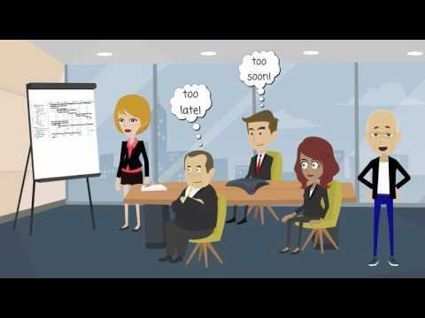

LESSON 2: PROJECT SCHEDULE MANAGEMENT

Project Schedule Management is the process required to manage the project's timely completion. The Project Management Body of Knowledge’s (PMBOK) defines 6 processes in this knowledge area:
- Plan Schedule Management
- Define Activities
- Sequence Activities
- Estimate Activity Durations
- Develop Schedule
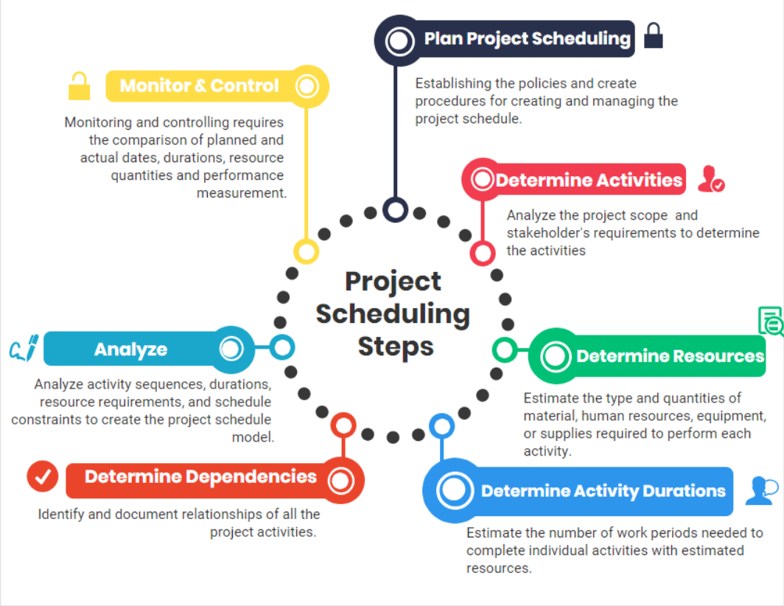
- Control Schedule

What is Plan Schedule Management?
It is establishing the policies, procedures and documentation for planning, developing, managing, executing and controlling the project schedule. This involves the creation of a Schedule Management Plan, as well as developing the expectations as to how the schedule will be met.

Why do we do it?
The key benefit of this process is to provide guidance and direction on the way in which the project schedule is to be managed throughout the project.
- How will they be outlined and controlled to ensure that everything is on track?
- Who will be involved and what is the process?

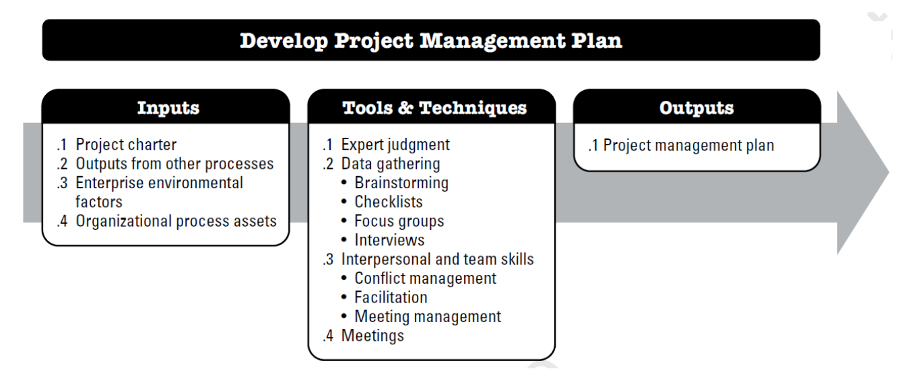
The Schedule Management Plan
The main output of the Plan Schedule Management process is a Schedule Management Plan. For small projects, this is simply a section of the project management plan. It contains the overall direction and strategy regarding the project schedule.
In most instances, you will have other similar projects from which you can borrow a schedule management plan. If your project is unique, or if you need a checklist, here are a few questions that you can answer when developing your schedule management plan:
- How will the schedule be developed? - The type of software that will be used can be identified as well as the person creating the schedule. E.g. Microsoft Project, Primavera (P6), Microsoft Planner, Excel etc
- Who will be notified? - Unique stakeholders to the schedule can be identified, as well as their communication needs. A distribution list for the final schedule and/or revisions can be determined. Regular schedule performance reporting needs can be established.
- How will the schedule performance be measured? - Schedule Performance Index (SPI), will give the project manager insight into how far ahead or behind the project is. Weekly progress meetings ensure the project team is up to speed with the project schedule and identifies progress to be achieved within the forthcoming progress period.
- If the project is behind schedule, what actions can be taken to rectify it?
  - Crashing the schedule - which means adding more resources.
  - Fast-tracking - which means performing tasks in parallel that would otherwise be done in sequence.
  - Changing the scope of the work to eliminate unnecessary tasks.
  - Updating the schedule which requires the approval of the project sponsor.

What are the assumptions embedded within the schedule?
- Every project schedule contains assumptions, from the underlying conditions to the external requirements. If these are not laid out in the plan, the project stakeholders will assume they haven’t been considered which does not bode well when project changes are encountered.
Define Activities Process
Define Activities
An Activity is a distinct, scheduled portion of work performed during the course of a project to produce the project deliverables. Define activities therefore, refers to the identification and documentation of tasks that need to be carried out to achieve project deliverables. To do that, project managers need to break down a project’s big work packages into small sets of tasks and assign teams to carry out these tasks.

What is the benefit?
The key benefit of this process is to break down work packages into activities that provide a basis for estimating, scheduling, executing, monitoring, and controlling the project work.
The smaller activities from the big work packages make it easier for managers to estimate time and costs, create schedules, implement plans, monitor project progress, and gain better control of the project.

Creating the WBS
The process of creating a WBS is that it identifies the deliverables at the lowest level in the Work Breakdown Structure

Work packages are typically decomposed into smaller components called activities that represent the work effort required to complete the work package.
A WBS is a tool in project management where a manager takes a step-by-step approach to handling large projects. With a WBS, the manager divides a project into small components. Each of these components can integrate scope, cost, and project deliverables. The components of a WBS form the work packages that are then broken down into activities. With WBS, the manager organizes the total scope of a project in hierarchies. Each level of the hierarchy shows a more detailed definition of the project work compared to the level above it.

E.g. WBS for a Fundraiser 10K Walk/ Run event hosted by an NGO
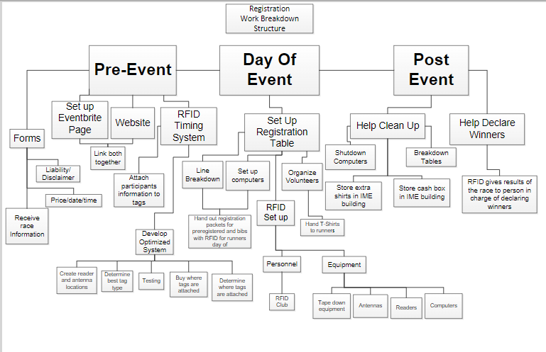

Important Terms to Note:

Decomposition - Decomposition is a technique used to divide and subdivide the project scope and project deliverables into smaller, more manageable parts.
Activity List - The activity list is a comprehensive listing of all scheduled activities required for the project. The activity list also includes the activity identifier and scope of work description for each activity in sufficient detail to ensure that project team members understand what work is required to be completed. Each activity should have a unique title that describes its place in the schedule, even if that activity title is displayed outside the context of the project schedule
Activity Attributes - Activities, as distinct from milestones, have durations, during which the work of that activity is performed and may have resources and costs associated with that work. Activity attributes extend the description of the activity by identifying the multiple components associated with each activity. During the initial stages of the project, they include the unique activity identifier (ID), WBS ID, and activity label or name. When completed, they may include activity descriptions, predecessor activities, successor activities, logical relationships, leads and lags, resource requirements, imposed dates, constraints and assumptions.
Milestone - A milestone is a significant point or event in a project. Milestones are similar to regularly scheduled activities, with the same structure and attributes, but they have zero duration because milestones represent a moment in time when an actual deliverable is met.
Milestone List - A milestone list is a list identifying all project milestones and indicates whether the milestone is mandatory, such as those required by contract, or optional, such as those based upon historical information.
So we defined the activity & now we need to put them in a sequence.

Develop a Schedule
The schedule model is used to determine the planned start and finish dates for project activities and milestones based on the accuracy of the inputs.

Schedule development can require the review and revision of duration estimates and resource estimates to create the project schedule model to establish an approved project schedule that can serve as a baseline to track progress.

Every activity except the first and last should be connected to at least one predecessor and at least one successor activity with an appropriate logical relationship. Logical relationships should be designed to create a realistic project schedule.

Simply put, your Scheduling Process should include:
- A list of tasks that must be completed to deliver the end goal / project
- Once you have all the project activities listed, identify which tasks depend on others to be completed e.g. foundation must be completed before walls are erected. This step is important.
- After you’ve established dependencies among your activities, you can sequence them. Map out the order in which all project activities should be done so that the most efficient flow is created.
- Estimate the resources needed for each project activity e.g. Personnel or sub-contractor costs
- Estimate duration of each activity.
At this point, you should have all the information needed to develop your project schedule.
There are several project scheduling techniques. Some of these techniques include

- Task lists
- Gantt charts
When we put all of the activities and timing together, with the sequencing of activities that we need, we have a detailed Gantt chart. This Gantt chart directs the project team on what work is to be done and by when as well as facilitates proper overall management and monitoring of the project to ensure successful time management. An example of a Gantt chart follows:

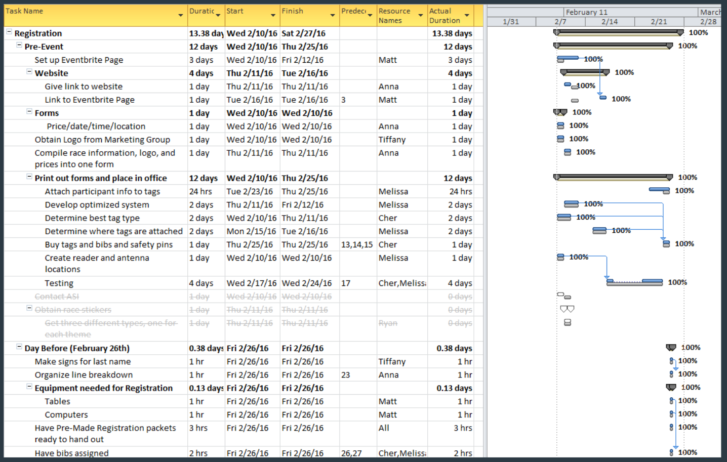
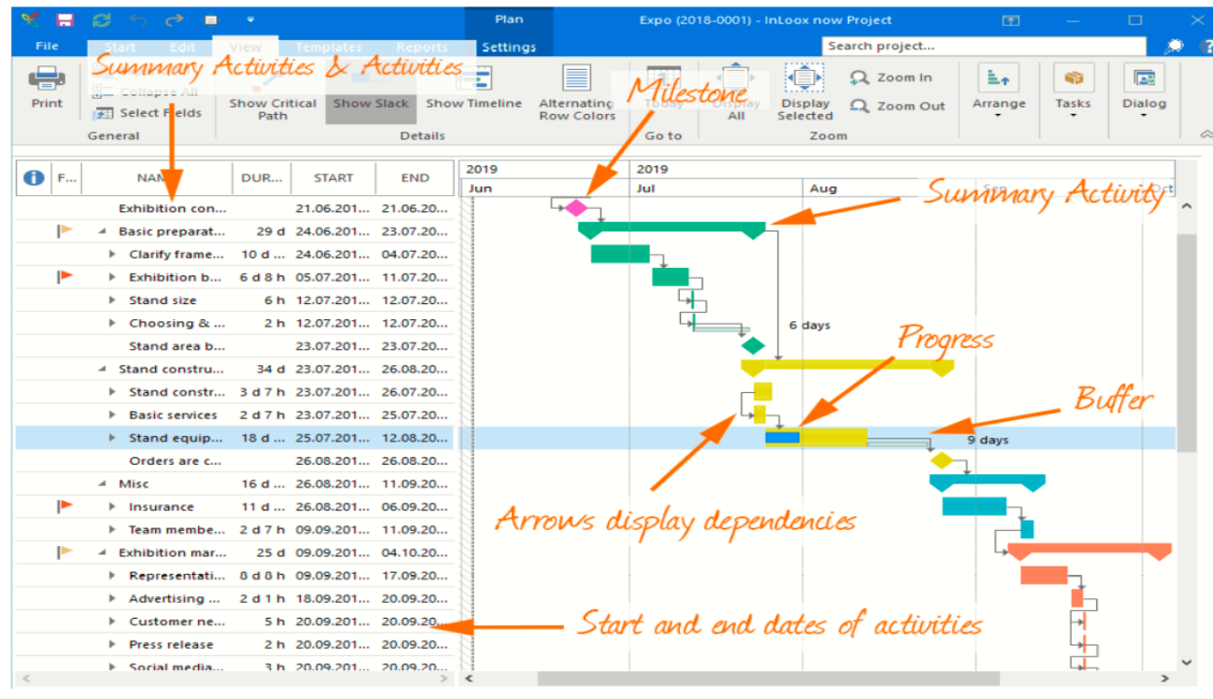
Gantt Chart for fundraiser event listed above:

However, for some NGOs, personnel who are proficient in Microsoft Projects may not form part of the skills bank available, and as such, a simpler option such as Microsoft Excel can be used.

Below is an example of a simple Gantt chart in word format highlighting the steps that must be followed over the next 6 months to execute a sustainability project, bringing drinking water to a remote village.
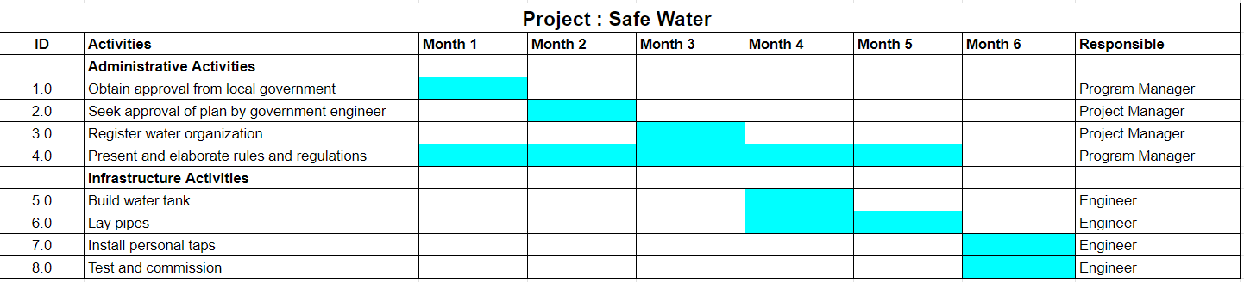

A Gantt chart clearly shows which activities need to be finished first for others to start. Some activities might be overlapping. This will also be visible at a glance in the chart. It makes it easy for you to see which tasks are of core importance at which stage of the project. Furthermore, it makes clear how many staff will be working on the project at any given time during the implementation.

You can create your own simple project schedule by using a spreadsheet or a project management software program.
To create a spreadsheet project schedule, provide project information under the following headings:

- Project name
- Start date
- End date
- Project manager
- Duration (Number of weeks/months)
- Estimated hours
- Assigned tasks
- Status

Key Take Aways
- According to a survey by the Project Management Institute (PMI), schedule performance is the top driver of project success. That same survey found that projects that meet their schedule targets are three times more likely to meet their goals and objectives than projects that do not.
- A project schedule assists you in project management by providing a clear summary of what tasks must be completed when they must be completed, and how long each activity will take.
- It guarantees that everyone is on the same page regarding tasks and deadlines
- The Project Schedule Management process entails planning, scheduling, regulating, and reporting on project-related activities and resources.
- There are many tools available for creating a Project Schedule: Project Management Software, Microsoft Excel, Project Planner Microsoft, Word or even a Whiteboard.
- The ultimate benefit of Project Schedule Management is stakeholder satisfaction. The sponsor who is shown a detailed project schedule and a well-thought through plan that stands up to scrutiny would be confident in the project’s outcome.
- Project deliverables need to be translated into a work breakdown structure, detailed task descriptions and human resource estimates. They want to know that professional scheduling techniques have been used and that the team hasn’t simply guessed. Simply put, a detailed project schedule inspires confidence, and confident project sponsors mean continued funding opportunities.

LESSON EXERCISE
Come up with your own social development project. Using this, identify the activities that you will need to do to implement this project. These activities will include things like planning activities, finding consultants to do the project work, accessing funding, and implementing the project work. Now try to schedule tese on a gantt chart or excel sheet, or WBS, whichever you are more comfortable with. To do this, you will have to put in some start and finish dates to each activity, and consider the order of your sequencing. For example, which activity should come first, second, etc. See how long your project takes, and assess whether you can afford to spend so much time on this project, or if you have to shorten timelines. Shorten the timelines, where relevant.

MODULE 4 - PROJECT RESOURCES
_____________________________________________________________________________________

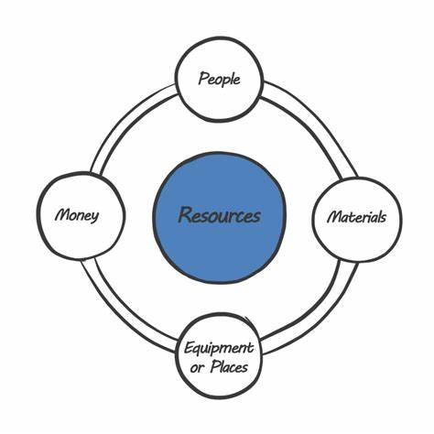

MODULE OBJECTIVES

At the end of this module participants will be able to:
- Define a project resource.
- Explain the different types of project resources, including human resources, finances, materials, and equipment.
- Discuss the importance of each type of resource in project management.
- Provide examples of how different types of project resources can be managed effectively.

MODULE STRUCTURE

This module will be delivered in three lessons to be completed over the course of 6 hours.
Lesson 1 – Types of Project Resources
Lesson 2 – Project Resource Management
Lesson 3 - Project Resource Management Process

INTRODUCTION

Let’s begin by defining a project resource. Put simply, Project Resources are any inputs for the project to be completed. It is a key element of a project’s Planning phase and is centered on the identification of resource requirements and how they will be allocated. Project Resources refer to personnel, financial, tools, equipment, and materials required to successfully complete the project.

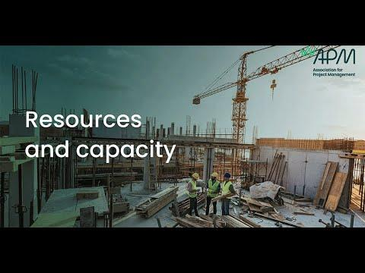

LESSON 1 - TYPES OF PROJECT RESOURCES

There are various types of project resources that may be required to successfully complete a project.
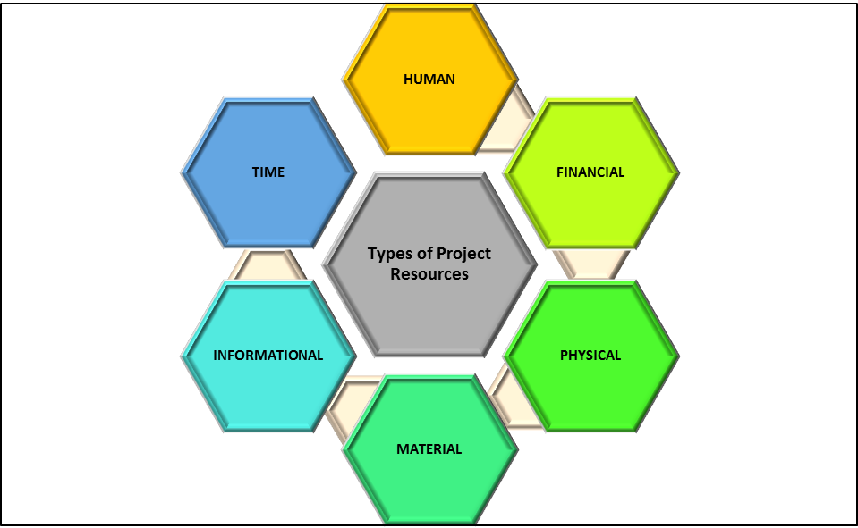

Some definitions/explanations are listed below.
Human Resources: This includes the people who will be working directly on the project, such as project managers and team members, and those who contribute to the needs of the project, such as stakeholders and vendors.
Financial Resources: This includes the money required to fund the project, and are usually identified through budgets, funding, cash flow projections etc.
Physical Resources: This includes the physical assets required to complete the project such as equipment, tools and infrastructure.
Material Resources: This includes the materials required to complete the project such as raw materials, supplies and consumables.
Informational Resources: This includes the data and information required to complete the project such as project plans, designs, specifications, legal and other professional briefs, and other documentation.
Time Resources: This includes the time required to complete the project such as project schedules, GANTT Charts, timelines and deadlines.
For example, let’s say we are undertaking a social development project that involves establishing community centers in rural areas. Human resources may include the project manager, construction workers, painters, tile men, plumbers etc. Financial resources may include the funds required for building and outfitting the centers, as defined in budgets and cash flow projections. Physical resources may include items like bricks, concrete mix, paint, tiles, signs etc. We would also need informational resources which will include our project documents. Time resources will refer specifically to project schedules and timelines.

LESSON 2 – PROJECT RESOURCE MANAGEMENT

Managing project resources is critical to the success of a project, as they are the inputs that enable project teams to deliver project outcomes within the specified constraints. Effective project resource management requires careful planning, estimation, acquisition, development, and monitoring of project resources throughout the project life cycle. This ensures that the necessary resources are properly identified and estimated according to the times needed, that they are available when needed, and that they are allocated efficiently and effectively to maximize their impact on project outcomes. In addition, managing project resources also involves addressing resource conflicts, identifying a safe and convenient storage area for the resources, dealing with resource shortages, and identifying and mitigating resource-related risks that could affect project performance.
Overall, understanding project resources and how to effectively manage them is an essential part of project planning and project management, and is key to delivering successful projects on time, within scope and budget, and with the desired quality and other outcomes.
Project Resource Management is the process of planning, organizing, scheduling and managing a project’s resources (people, finances, tools, equipment, technology, facilities, and data, as some examples) in the most efficient way.
Effective project resource management involves the following:
Name | Explanation
Resource Planning | This involves identifying the required resources for the project and estimating their availability, cost, and utilization. It also involves creating a resource plan that outlines when the resource is needed, and how the resources will be allocated and used throughout the project. This also involves identification and contracting of any subject matter expertise who may be required to identify, handle or check the resources at specific times or throughout the project life cycle (if such expertise is not available among the project team or within the organisation).
Resource Allocation | Once the required resources have been identified, the next step is to allocate them to specific tasks or activities in the project plan. This involves considering factors such as resource availability, storage or purchase lead and lag times, expertise and workload.
Resource Utilization | This involves managing the use of resources throughout the project to ensure they are being used effectively and efficiently. This includes monitoring resource usage, identifying and addressing any issues or constraints that may arise, and making adjustments to the resource plan as necessary. This also involves checking the good condition and maintaining the safety of the resources as they are put into use.
Resource Tracking and Reporting | This involves tracking the progress of the project and the use of resources over time, and reporting on this information to stakeholders. This helps to ensure that the project is on track and that any issues or concerns are identified and addressed in a timely manner.

LESSON 3 – THE PROJECT RESOURCE MANAGEMENT PROCESS

Some of the key processes that are involved in Project Resource Management are as follows:
- Planning: This is your starting point. Here, you can sit with your project team and use things like your Project Charter and other project documents to plan and determine what types of resources would be needed for your project.
- Estimate Activity Resources: Once you are done planning, the resources required for the project along with their type and quantity of tools, equipment, raw material and supplies are estimated. With this, you pinpoint what type of resources you need, in what amounts and what should be their characteristics, and when during the project you will need them.
- Acquire Resources: This deals with actually getting the resources you need. This process will help in outlining and guiding the selection process of the project resources and then assigning them to their specific activities/tasks.
- Develop Team: This process concentrates on the development of the project team members, and ensuring that they understand the project, its activities, and the quality expectations of stakeholders and Project Sponsor.
- Manage Team: Each and every team member’s performance is monitored and tracked, their problem areas identified, and the issues are resolved. Feedback is also given in order to optimize the project performance.
- Control resources: Here, the project managers ensure that the resources that are assigned and allocated for the project activities are available and take various actions to keep the project on track.

While the above components are set out in a sequential manner, in practice, they are usually performed in an iterative and integrated manner, with checking and monitoring several times during the project lifecycle.

LESSON EXERCISE
Come up with your own social development project and give examples of the types of project resources that would be required.

MODULE 5 – PROJECT COST MANAGEMENT
________________________________________________________________________________________________________

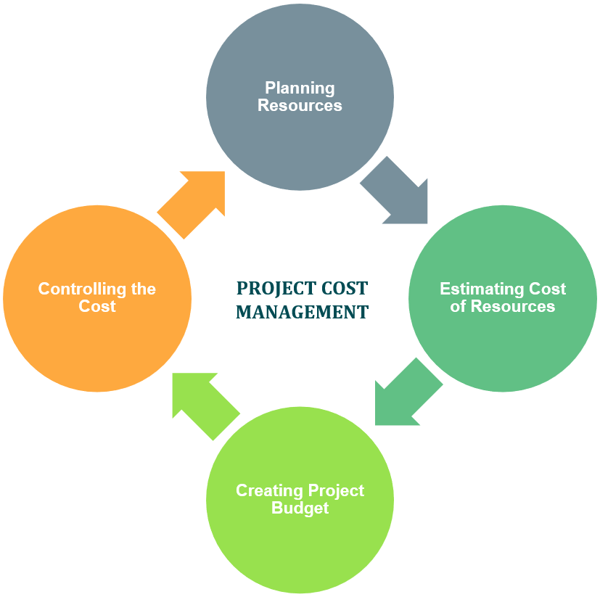

MODULE OBJECTIVES
At the end of this module participants will understand the basic principles of:
- Planning Cost Management
- Estimating Costs
- Determining Budget
- Controlling Costs

MODULE STRUCTURE
This module will be delivered in one lesson to be completed over the course of 8 hours.

INTRODUCTION

How will you go about planning costs for the project?
This process would consider the scope, time, and quality requirements of the project, as well as the stakeholder requirements for managing costs. The scope requirements help to identify what goods, services, equipment, property (as examples) need to be purchased. The quality requirements assist with decisions like whether to purchase branded versus non-branded items, and the time requirements assist decisions about when to purchase, which could have cost implications.
Depending on the stakeholder requirements, costs would be identified, quantified, and recorded in different ways or instances. For example, consider an item to be purchased. The cost for this item can be quantified either at the time of acquisition or commitment to purchase, or when the order is placed, or when the item is delivered, or when the actual cost is incurred, or recorded for accounting purposes. At some of these points, the cost of the item may only be an estimate and subject to change, while at other times, the costs will be actual or may even involve a discount for early full payment. Sometimes, on more complex projects, it is not always possible to know an exact item cost, and therefore an estimate has to be used.
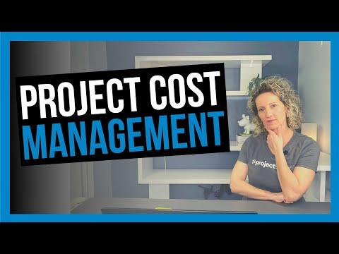

LESSON 1: PROJECT COST MANAGEMENT
Project Cost Management is primarily concerned with the identification and management of the cost of resources needed to complete a project. Project Cost Management is about managing costs such that they are reasonable in estimation and incurrence for the project requirements, and that adequate care and attention is exercised to ensure that the project is economical. The cost management planning process occurs early in the project planning process to ensure the processes would be efficient and coordinated.
In accordance with the Project Management Book of Knowledge:
Knowledge Areas | Project Management Process Groups
 | Initiation | Planning | Execution | Monitoring and Evaluation | Closing
Project Cost Management |  | - Plan Cost Management  - Estimate Costs  - Determine budgets |  | - Control costs

- PLAN COST MANAGEMENT
The process of Plan Cost Management is a process that establishes the policies, procedures and documentation for planning, managing, expending and controlling project costs. The plan would therefore provide guidance and direction on how the project costs would be managed during the project.

The process of planning cost management would deliver the Cost Management Plan as an output.

- COST MANAGEMENT PLAN
The Cost Management Plan describes how the project costs would be planned, structured, and controlled. The Plan would contain the information to guide on how to estimate costs for each activity and deliverable, and how to prepare the overall project budget. After the budget is prepared, the Plan would guide on who to approve expenditure, and how to spend and on what, to ensure the project budget is controlled and adhered to.

The Cost Management Plan contains:

- The units of measure: To be used for quantification, usually in terms of currency, volumes and time. For example, the Plan for a project would state that money would be stated in $TT, time in days or hours, measurements in millimetres (mm) and volumes in cubic meters.
- Level of precision: This would give the degree to which cost estimates are rounded up or down.
- Level of accuracy: This would give the acceptable range in determining estimates, state how these will be specified and may include an amount for contingencies. Eg. An acceptable range for estimates can be stated as +/- 15% and allowance for 10% contingencies.
- Organizational procedure links: This would include codes or chart of account numbers which link directly to the organizational accounting system.
- Control Threshold: Here the variance threshold for monitoring cost performance would be specified. The amount specified would be an agreed amount of variation that will be allowed, before some action needs to be taken to get costs back on track. This can be stated as percentage allowable variance. For example, it could be specified that once the cost of an activity or item varies by more than 10% from the budget estimates, then corrective action or some level of review would be required.
- Rules for performance measurement: The method to be used to measure performance of the project would be specified. Two common methods used are percent completion or Earned Value Measurement.
- Reporting Formats: The types, formats and frequency of the various cost reports are defined. For example, it can be specified that a brief summary cost report is to be submitted to senior management fortnightly and a detailed cost report to be submitted monthly.
- Process Descriptions: The descriptions of other cost management processes such as the Estimate Costs, Determine Budget and Control Costs processes are defined or described. These will be discussed later.
- Additional Details: Here additional details about cost management activities can be included. They can include, but are not limited to:
- Description of Funding arrangements
- Methods for documenting costs
- Guidelines for dealing with fluctuations in resources costs and exchange rates.

3. ESTIMATE COSTS
In this process the approximate amount of monetary resources to complete all project activities are determined. . The cost estimates are predictions based on the information at a given point in time. During the project execution. cost estimates should be revised to reflect additional information as it becomes available. During project execution as more information is known, the cost estimates can be made more and more accurate. This level of continuous accuracy checking will in turn ensure the accuracy of the overall project costing information.
The costs of all resources that are to be used in a project must be identified and estimated. Some of the resources for which costs are estimated would include, but not limited to, labour, materials, equipment, services, facilities, and consultants and project managers. Other special categories would include inflation, allowances, cost of financing, breach of contract, contingency costs, cost of quality and risk, and overhead costs. A cost estimate is the likely cost for resources required to complete the activity. For example, in hosting an event the cost estimates would include estimates for the rental of the venue, decorations, chairs, refreshments, and audio system.

TOOLS AND TECHNIQUES OF COST ESTIMATION
The following are some common tools and techniques used in cost estimating:
- Expert Judgement: this is guided by historical information, as well as industry experience, and provides insight about the environment and information from prior similar projects.
- Analogous Estimating: This technique uses actual costs of previous similar projects as the basis for estimating the current project. This type of estimating is cheaper and faster than other methods, however it is less accurate.
- Parametric Estimating: This method uses a statistical relationship between relevant historical data and other variables (e.g. square footage in construction) to calculate a cost estimate. Depending on the data built into the model, this method can produce higher levels of accuracy.
- Bottom up Estimating: This method involves estimating project costs as the sum of estimates of each component of work. Costs are estimated for individual work packages or activities to the greatest level of specific detail. All the detailed costs are then summarized for reporting and tracking purposes.
- Three Point Estimating: in this method, single point estimates can be improved by using three estimates to define an approximate range for an activity’s cost. The three estimates are most likely cost (realistic scenario), Optimistic Cost (best case scenario) and Pessimistic Cost (worst case scenario).

TYPES OF COST
Costs can be either variable or fixed. Variable costs change with the amount of production or work, for example costs for materials, supplies or wages.
Fixed costs do not change with the amount of production or work, for example, cost of set up or rent and utilities.
Also, costs can be either direct or indirect. Direct costs can be directly attributed to the project works such as wages, materials and equipment. Indirect costs are overhead costs or costs which are incurred for more than one project. Examples would include taxes and janitorial services.

INPUTS TO ESTIMATING
For the estimating process, many other plans and information would be required which include, but are not limited to, cost management plan, project schedule, scope baseline, human resource management plan and risk register.

4. DETERMINE BUDGET
In this process the total cost of the project is calculated to determine the amount of funds the organization needs to have available for the project. The result of this calculation is called the budget. The benefit of this process is that it establishes a cost baseline against which project performance can be monitored and controlled.
A sophisticated budgeting process can also identify approximately when payments are to be made, which will assist the organisation with cash flow management.

TOOLS AND TECHNIQUES
- Cost aggregation: in this process, cost estimates are aggregated by work packages. The work packages are then aggregated for the higher component levels and then for the entire project.
- Reserve analysis: This establishes both the contingency reserves and the management reserves for the project. Contingency reserves address cost impacts of remaining risks to the project. Management reserves are additional reserves set aside to cover unforeseen risks to the projects.
- Expert Judgement: This is guided by experience in an application area, discipline or industry etc.
COST BUDGET
The cost budget is aggregated from the lower levels up. For example, the individual activity estimates would be aggregated into work package estimates. These work package estimates would be aggregated into control account estimates. The control account estimates would be aggregated into the project estimates.
Added to the project estimates would be the contingency reserves, and the sum of these two would yield the cost baseline. The final cost budget is obtained by the addition of the management reserves to the cost baseline.

5. CONTROL COSTS
This process involves monitoring the status of the project to update the costs and manage changes to the cost baseline. This process would provide the means to recognize variance from the plan so that corrective action can be taken to minimize risk.
Some activities that would be included in cost control would be:
- Managing actual changes as they occur
- Ensuring cost expenditures do not exceed the authorized funding by period or by major item.
- Monitoring cost performance to isolate and understand variances from the approved baseline.
- Preventing unapproved changes from being included in the reported cost.
- Bringing expected overruns within acceptable limits
- Understanding the cause(s) of cost overruns and whether there is an impact on other aspects of the project such as scope, milestone dates, and quality.

TOOLS AND TECHNIQUES
One method to control costs is earned value management. This methodology combines scope, schedule and resource measurements to assess project performance and progress. Earned value develops and monitors three key dimensions for each work package.
- Planned value: this is the authorized budget assigned to scheduled work.
- Earned Value: this is a measure of work performed expressed in terms of the budget authorized for that work.
- Actual Cost: this is the realized cost incurred for the work performed on an activity during a specific time period.
During the control cost process, the schedule variance and cost variance are also monitored. Schedule variance is the amount by which a project is ahead or behind the planned delivery date at a given point in time. Cost variance is the amount of budget deficit or surplus at a given point in time.

RESERVE ANALYSIS
During the control cost process, reserve analysis is conducted to monitor the status of contingency and management reserves for the project. It will be determined if these reserves are still needed or if additional reserves are needed.

Table 1: Example of a Project Cost Table
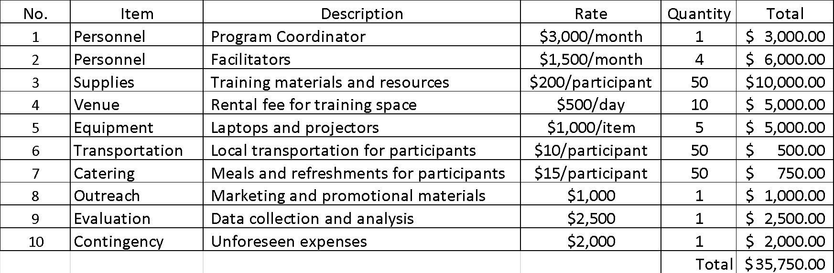

LESSON QUIZ

- True or False: The project cost management process starts with estimating costs.
Answer: True. The first step in project cost management is to estimate the costs of all the resources that will be needed for the project. This includes the cost of labour, materials, equipment, and other direct and indirect expenses.

- True or False: Cost management is an ongoing process throughout the project.
Answer: True. Cost management is an ongoing process throughout the project. The project manager must continuously monitor spending and make adjustments to the budget as needed.

- True or False: Cost management focuses solely on estimating and tracking project expenses.
Answer: False. Cost management encompasses activities such as cost estimating, budgeting, cost control, and cost forecasting.

- True or False: A project budget is a static document and should not be adjusted during project execution.
Answer: False. A project budget should be a dynamic document that can be adjusted based on changing project circumstances and priorities.

- True or False: A cost contingency is an amount of money included in the project budget to cover unforeseen expenses.
Answer: True. Cost contingencies are included in the budget to account for uncertainties and risks that may arise during the project, helping to mitigate potential cost overruns.

- True or False: Cost estimation is performed only once, at the beginning of the project.
Answer: False. Cost estimation is an ongoing process throughout the project lifecycle, as new information becomes available and the project progresses.

- True or False: The primary objective of cost control is to ensure that project costs are kept as low as possible.
Answer: False. The primary objective of cost control is to ensure that project costs are reasonable and appropriate to the project scope, and managed within the approved budget, while also optimizing value and maintaining project quality.

MODULE 6 – PROJECT COMMUNICATION
________________________________________________________________________________________________________

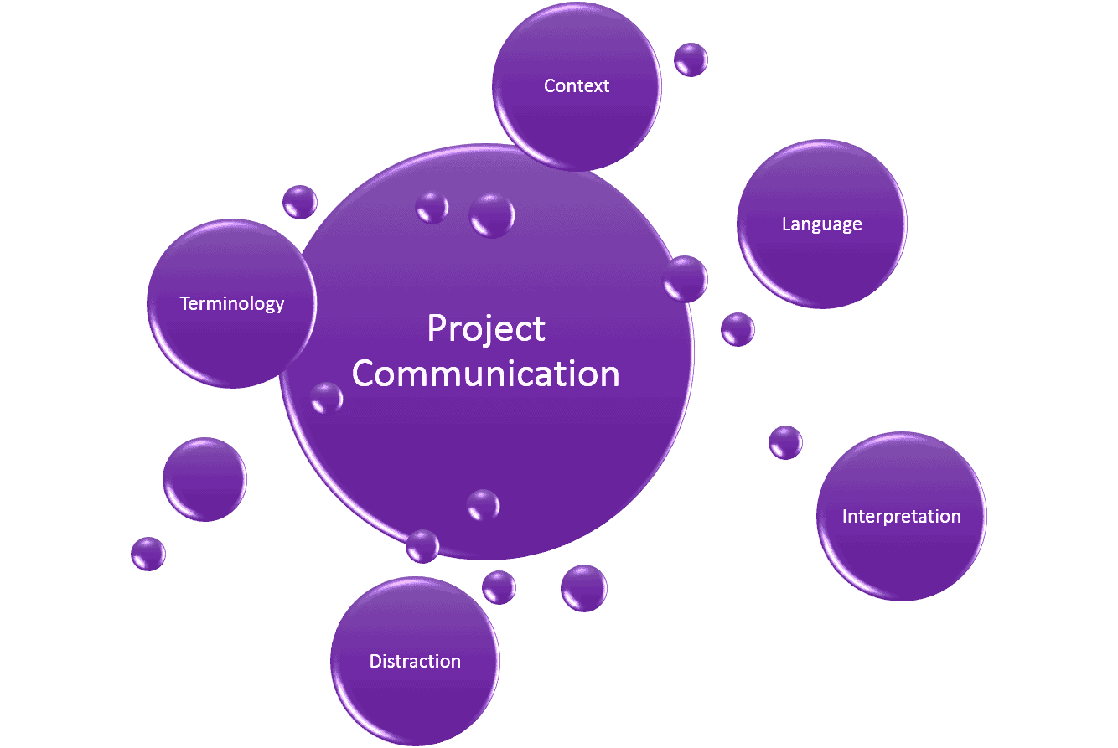

MODULE OBJECTIVE

At the end of this module, participants will be better able to:
- Understand the importance of communication on a project.
- Learn common communication tools.
- Use the communication channel formula.
- Understand what goes into creating a Communications Management Plan.
- Understand barriers and enhancers of communication.

MODULE STRUCTURE

This module will be delivered in nine lessons, and a summary at the end, to be completed over the course of 10 hours.
Lesson 1 – PMBOK ® Guide Processes in Communication Management
Lesson 2 - Communication Management Plan
Lesson 3 – Important Concepts in Communications
Lesson 4 – The 5 Cs of Written Communication
Lesson 5 - Communication Methods
Lesson 6 - Communication Model
Lesson 7 - Communication Channels
Lesson 8 - Meetings & Reports
Lesson 9 - Communication Blockers
Communication Management Summary

INTRODUCTION

A successful project requires the collaboration and effort of a diverse group of people. In many cases, a project’s team, sponsor(s) and stakeholders are individuals from different departments, with different specialties, and who may not even be located in the same city or country. The spectrum of differences that can exist on a project can range from cultural, geographical, organizational, level of skill, sector knowledge, and so on. Even under the best circumstances, communications within such diverse groups can be challenging.
Effective communication is one of the most important skills that a project manager needs. A project manager will spend more time communicating with the team, the sponsors, and the stakeholders, than on any other activity. According to the PMI (Project Management Institute), a project manager should spend ninety percent (90%) of his or her time communicating with stakeholders and team members.
Communication is not just about giving orders, and telling the project team what needs to get done and what is expected. Nor does it just mean use of tablets, smart phones and laptops, but it is about sharing relevant information on a timely basis to the right audience, with clarity of message via the correct medium that reinforces the project’s vision.
Project Communication Management is about productive listening and understanding the real issues within the team and being in touch with the challenges of the project. It is the knowledge area in Project Management where everyone is talking about the work that is getting done in the project. It is not only about speaking to and hearing from people; it’s about understanding the complete message to ensure a successful project.
It focuses on information management (generating, collecting, disseminating, and storing communication), and determining who needs what information and when, and producing the plan to provide the needed information.

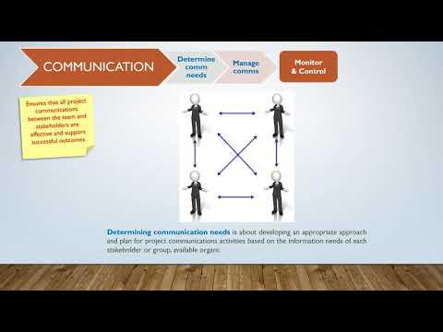

LESSON 1 – PMBOK® GUIDE PROCESSES IN COMMUNICATION MANAGEMENT

As per the Project Management Body of Knowledge (PMBOK) guide, “Project Communication Management includes the processes necessary to ensure that the information needs of the project and its stakeholders are met through development of artifacts and implementation of activities designed to achieve effective information exchange.”
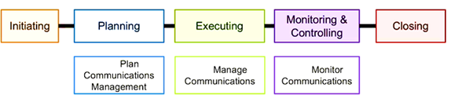
Figure 1 - Communication Management Processes
That is, Project Communication Management is the knowledge area that defines the activities, processes or documents which should be created as part of the project communication to everyone involved in the project.
There are three (3) processes that span the planning, executing, and monitoring and controlling process groups. These processes are:
1. Plan Communications Management
The first step in Communications Management is figuring out the communication requirements and needs of the various stakeholders - vis-à-vis executive management, project sponsor, project manager, cross-functional team members, other internal stakeholders, vendors, external agencies, end users, etc. - and developing the strategy or plan for information dissemination to them. There is so much information regarding the project, but what information needs to be sent to whom, and in what form, are important elements to decide. The timing of sending and receiving the information is also important.
For example, most times management want to know how the project is performing and key performance indicators (KPIs) to help them to discern that. This may be communicated to them by the project sponsor in a monthly meeting using a report, or a project dashboard, which is a computerized software solution, that will provide monthly alerts to see the information on a computer from their desk.
A project manager must identify the stakeholders’ requirements for communication, determine what information is actually needed, and then plan to deliver the needed information on a pre-set schedule or based on project conditions.
Once it is known what project information is to be shared, in what form, to whom, and how often, the Communication Management Plan can be drafted.
2. Manage Communications
Manage Communication supports the project work being done. It is here that the project manager must ensure that everyone gets the information they need while they are performing the project tasks so that they are completely equipped to perform their jobs efficiently and effectively.
Manage Communications is the process of the timely collection, creation, distribution, storage, disposal and retrieval of information. It ensures proper communication in the project, and is performed throughout the project. Such communication is critical to mitigate risks identified during project planning, as well as those that continue to arise on the project
Manage communications also assists in knowledge transfer and knowledge exchange, which is important for assisting all stakeholders, particularly those within an organisation, to develop their skills or make corrective changes in a sustainable manner.
3. Monitor Communications
Monitor Communications is the process of ensuring that the information requirements of the project are met, and that the information distributed is accurate so that timely decisions can be made by the stakeholders. It ensures the optimum information flow of the project, and it is performed throughout the project.
Monitor Communications is where the project manager needs to constantly monitor and stay in control of all communications generated throughout the project and how it is presented to the stakeholders – be it reports on the project team’s performance or updates on the project status. It is here that the outputs from the Executing process in the Manage Communications process are taken and turned into work performance information.
In summary, the three processes discussed above – Plan Communications, Manage Communications and Monitor Communications – which together make up Communications Management - ensure that everybody gets the right message at the right time, and helps in ensuring that all project work is done in the right manner.

LESSON 1 QUIZ

- Which process involves determining the information and communications needs of stakeholders?
A. Strategic planning
B. Systems management
- Identifying stakeholders
- D. Planning communications
Answer D: Planning communications management involves determining the information and communications needs of the stakeholders. Who needs what information? When will they need it? How will the information be given to them?
- Geographic location and cultural background have no impact on communications. (Ture or False)

Answer False: Geographic location and cultural background affect the complexity of project communications. For example, if project stakeholders are in different countries, it is often difficult or impossible to schedule times for a two-way communication during normal working hours. Cultural differences could result in key messages being lost within written or oral statements.

LESSON 2 - COMMUNICATIONS MANAGEMENT PLAN

In this lesson, the stakeholders’ information needs are determined and the communication approach for all stakeholders is identified.
Identifying Communication Requirements
Communications should be efficient (providing only the information needed), effective (providing information in the right format at the right time), and should add value to the project. As a general rule, project managers should provide information when its presence contributes to success or when a lack of information can contribute to failure.
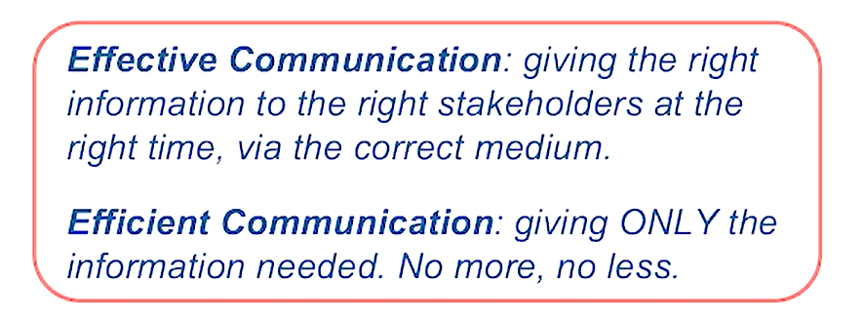
The project manager and the project team can identify the demand for communications based on:
- Project structure within the performing organization
- Number of stakeholders and their location
- Organisational level and/or skills level of stakeholders
- Stakeholder engagement plan
- The number of communication channels (discussed in another lesson).
Communication Modes
As part of the communications planning, the project manager should identify all of the required and approved methods of communicating. Some projects may be very sensitive and contain classified information that not all stakeholders are privy to; other projects may contain information that is open for anyone to explore. Whatever the case, the project manager should identify what requirements exist, if any, for the communication modes.
Communication modes include meetings, reports, memos, e-mails, and so on. The project manager should identify which are the preferred methods of communicating based on any conditions of the message to be communicated.
Communications Technology
The different ways of communicating are collectively referred to as communications technology – face-to-face, phone calls, websites, in writing, emails or instant messaging - and will have an impact on how people are kept in the loop. It is important to be aware of what communications technology is available and best suited to your team when constructing the communications management plan and keeping everyone updated on project issues.
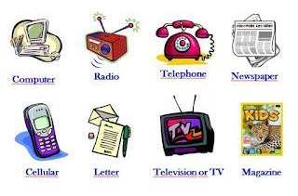
Figure 2: Examples of Communication Technology

Finalizing Communication Planning
Based on the communication requirements, the project manager and the project team can determine what communications are needed and develop the Communications Management Plan. It should be a sufficiently detailed Plan that can organize and document the process, types, and expectations of communications. It will provide:
- A system to gather, organize, store, and disseminate appropriate information to the appropriate people. The system includes procedures for correcting and updating incorrect information that may have been distributed, or including new project entrants, or deleting persons no longer on the project.
- Details on how needed information flows through the project to the correct individuals, i.e. where the information will originate, to whom the information will be sent, and in what modality the information is acceptable.
- Specifics on how the information to be distributed should be organized, the level of expected detail for the types of communication, and the terminology expected within the communications.
- Schedules of when the various types of communication should occur. Some communication, such as status meetings, should happen on a regular schedule; other communications may be prompted by conditions within the project.
- Methods to retrieve information as needed.
- Instructions on how the Communications Management Plan can be updated as the project progresses.
There are many samples of a Communications Plan available. A sample of what is typically included in a Communications Management Plan is depicted below:

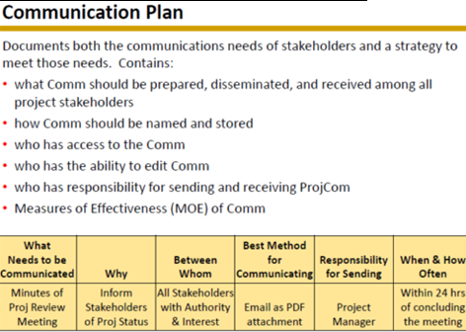
Figure 3: Sample Communication Management Plan

LESSON 2 QUIZ

- The Communications Management Plan will vary with the needs of the project. (True or False)
True: Because communication is so important on projects, every project should include a Communications Management Plan – a document that guides project communications- that is tailored to the unique needs of the project.
- The output of the _____ process is a communications management plan.
A. managing communications
B. reporting performance
C. controlling communications
D. planning communications
Answer D: Planning communications management involves determining the information and communications needs of the stakeholders. The outputs of this process include a Communications Management Plan, project management plan updates, and project documents updates.
- Project managers must assess the needs of the organization, the project, individuals, and other stakeholders in determining which communication medium to use, and when. (True or False).
Answer True: Project managers must assess the needs of the organization, the project, individuals and all stakeholders in determining which communication medium to use, and when. They must also be aware of new technologies that can enhance communications and collaboration.

LESSON 3 – IMPORTANT CONCEPTS IN COMMUNICATIONS

Some important terms to be familiar with when you manage communications:
Flow of Communication
In a project, communication flows:
- Downwards: from a higher level to a lower level. It highlights the mission and vision and communicates areas of focus and for attention.
- Upwards: flows to a higher level. It provides feedback on how well the project is performing, together with risk management and key project information.
- Lateral/Horizontal: communication between peers. It is a means of information sharing and facilitates teamwork and completion of tasks.

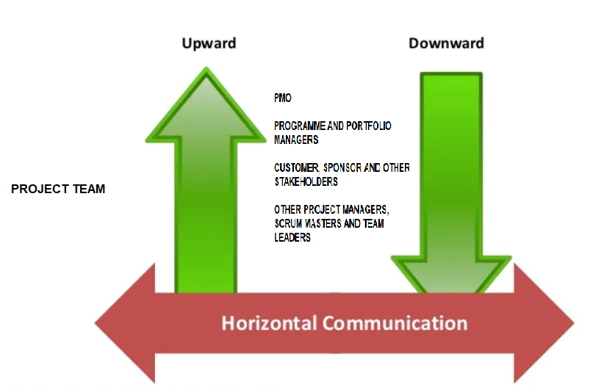
Figure 4 – Flow of Communication on a Project

Communication Types
There are four different kinds of communication. In any instance, information can be expressed formally, informally, written or verbally.
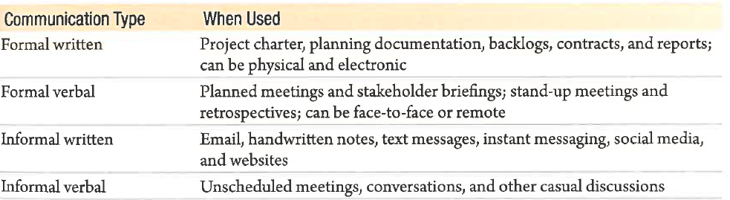
Figure 5 – Communication Types
The most common type of communication between a sender and a receiver is verbal communication. When verbal communications are involved, the project manager should remember that one half of communication is about listening. This means the project manager must confirm the receiver understands the message being sent. The confirmation of the sent message can be seen in the recipient’s body language, verbal feedback, and verbal confirmation of the sent message.
There are five terms that describe the process of communicating orally:
- Paralingual: The pitch, tone, and inflections in the sender’s voice affect the message being sent.
- Feedback: The sender confirms that the receiver understands the message by directly asking for a response, questions for clarification, or other confirmation of the sent message.
- Active listening: The receiver confirms the message is being received through feedback, questions, prompts for clarity, and other signs of confirmation of the received message.
- Effective listening: The receiver is involved in the listening experience by paying attention to visual clues from the speaker and paralingual characteristics and by asking relevant questions.
- Nonverbal: Approximately 55 percent of communication is nonverbal. Facial expressions, hand gestures, and body language contribute to the exchange and understanding of messages.

LESSON 3 QUIZ

- Which is NOT used to communicate information through face-to-face interaction?
A. body language
B. written content
C. spoken content
D. tone of voice

Answer B: Face-to-face interaction is communication that takes place through body language, how the words are said, and the actual spoken content, not written content.

- Which communication method is most appropriate for assessing the commitment of project stakeholders?
A. wiki
B. e-mail
C. website
D. meeting

Answer D: If you were trying to assess commitment of project stakeholders, a meeting would be the most appropriate medium to use.

- What is e-mail communication most suited for?
- assessing commitment to a project
- building consensus among disputing parties
- mediating a conflict between multiple parties
- communicating simple information

Answer D: E-mail is not appropriate for assessing commitment, building consensus, mediating a conflict, resolving a misunderstanding, making an ironic statement, conveying a reference document, reinforcing one’s authority, or maintaining confidentiality.

LESSON 4 - THE 5 CS OF WRITTEN COMMUNICATION

- Use correct grammar and spelling.
- Poor grammar shows your unskilful communication and the lack of attention to detail.
- Proper grammar is understandable to all and saves time and avoids potential confusion.
- Written mistakes will reflect negatively in business relations.
- Unclear communication with grammatical errors, leads the stakeholders to take wrong actions that expose it to potential lawsuits.

- Eliminate excess words and use of concise expressions.
- Time is money, so shorter messages are always better.
- Convey ideas clearly to avoid ambiguity.

- Express a clear purpose directed to the needs of the reader.
- Be sure your goal is clear and that what you write is worth taking the time to read.

- Control flow of words and ideas.
- Make your content easy to understand and control the flow of words and ideas.
- If people misinterpret what you're trying to say, then it is not useful.
- Sharp, bright, intelligent, and easy-to-understand content make it much easier for people to see its value.

- Ideas are coherent and there should be a logical flow.
- Consistent and coherent writing demonstrates that you and your business are committed to quality.
- Organize your thoughts logically and connect them effectively using transition words and phrases.
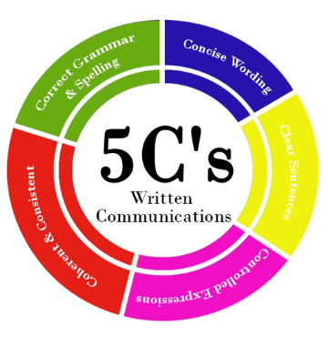
Figure 6 - PMBOK’s 5Cs of Written Communication

LESSON 4 QUIZ

- In a project, communicating badly exponentially increases the possibility of making mistakes. (True or False).
Answer True: Communicating badly exponentially increases the possibility of making fatal mistakes. A large-scale project has a lot of moving parts, which makes it that much easier to go awry. Communication is the oil that keeps everything working properly.

LESSON 5 – COMMUNICATION METHODS

Communication methods refer to how information is shared with the project stakeholders.
Communications can be:
- Interactive, where everyone exchanges information with one another. Examples are conversations, phone calls, meetings, instant messaging and video-conference calls.
- Push, where the information is shared with the stakeholders, but no feedback is necessary; it is essentially a one-way communication. For example, an emailed status report.
- Pull, where the information is accessed by everyone without having someone send it to them, for example by visiting a project dashboard.

In determining what communication method to use, considerations, such as whether feedback is necessary or whether just relaying the information is good enough, should be made.

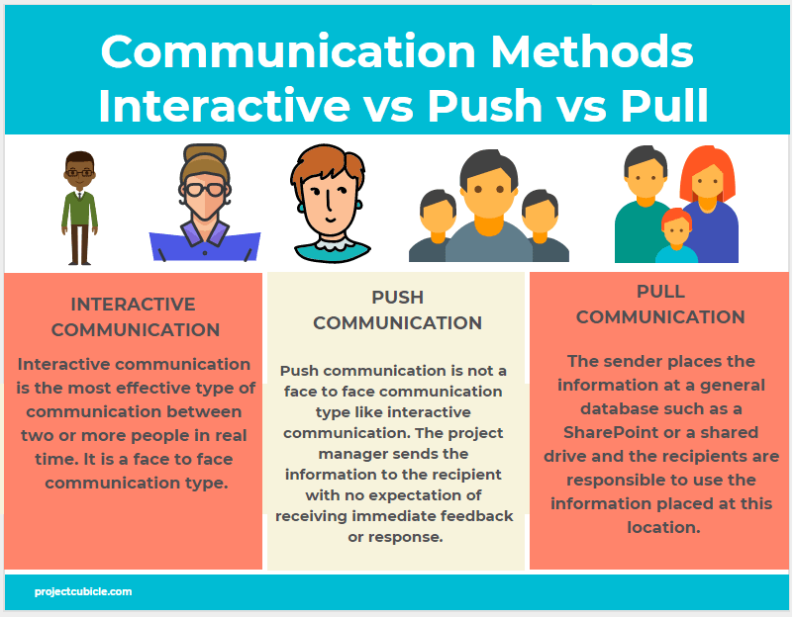
Figure 7 – Infographic on Communication Methods

LESSON 5 QUIZ

- An example of push communication is _____.
A. meetings
B. video conferencing
C. voicemails
D. blogs

Answer C: In push communication, information is sent or pushed to recipients without their request via reports, e-mails, faxes, voice mails, and other means.
2. An example of pull communication is _____.
A. meetings
B. video conferencing
C. voicemails
D. blogs
Answer D: In pull communication, information is sent to recipients at their request via websites, bulletin boards, e-learning, knowledge repositories like blogs, and other means.

- Which is true of push communication?
A. Information is sent only to recipients who request the information.
B. This method ensures that the information is understood by recipients.
C. Information is sent to recipients without their request.
D. This method ensures that the information is received by the recipients.

Answer C: Feedback: In push communication, information is sent or pushed to recipients without their request via reports, e-mails, faxes, voice mails, and other means. This method ensures that the information is distributed, but does not ensure that it was received or understood.

LESSON 6 - COMMUNICATION MODEL

The communication process or communication model consists of communication elements that demonstrate how the various people in the project will send and receive project information.
The basic model is the Sender/Receiver Model, where the information to be conveyed, the message, is encoded by the sender so that the receiver can understand it. A phone call, email and status reports are examples of messages that have been encoded. The medium to transmit the messages has to be selected to ensure the messages are received in a timely manner so that each is most effective. Mailing an Issues Log will not be as effective as presenting it verbally in a status meeting. The receiver has to decode the message or modify it to get its content and understand the message.
Interference prevents the project team from getting the intended message. This is called noise. Examples of noise include spotty internet, or a broken printer, or even including irrelevant matters.
In an Interactive Model, the receiver responds to the sender’s message through feedback, which decides the next steps. Sometimes, feedback may just be an acknowledgement of receipt of the message.

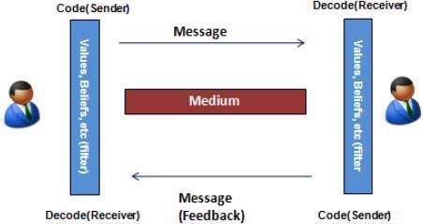
Figure 8 - The Communications Model

An Example – A Phone Call
It is easy to visualize the components of the communication model using a phone call.
Sender: This refers to the person who first initiates the communication. A team member wants to update the project manager on his tasks.
Encoder: This device encodes the message to be sent. In this case, it is the team member’s telephone.
Medium: This is the device or technology to transport the message between the encoder and the decoder. Here it is the telephone line.
Decoder: This device decodes the message to be received. Here it is the project manager’s telephone.
Receiver: This refers to the person who receives the communication finally. The receiver may interpret the information, make a comment, or ask some questions. In this case, it is the project manager.
Feedback: The communication may be disrupted by noise and misinterpret the message. A part of the message may have faded out. This would have been caused by the distortion of the phone line.

LESSON 6 QUIZ

1. What is the correct order in communication?
- Feedback, Message, Receiver, Sender
- Sender, Receiver, Feedback, Message
- Sender, Message, Receiver, Feedback
- Answer: C. See Figure 8.

2.___________ is the receiver’s response to the sender’s message that indicates understanding?
- Hearing
- Seeing
- Encoding
- Giving Feedback
Answer: D Giving Feedback

LESSON 7 - COMMUNICATION CHANNELS

The project manager will need to identify the number of communication channels or lines within a project. Knowing the number of potential communication channels can help project managers make informed decisions regarding what kind of information needs to be shared, the best format, delivery method, timing, and more. PMBOK identifies the following formula to calculate the number of communication channels:
N(N–1)/2, where N represents the number of identified stakeholders.
For example, if a project has 10 stakeholders, the formula will read 10 (10–1)/2 for a total of 45 communication channels.
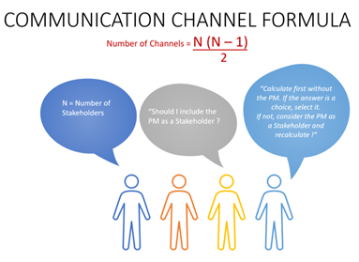
Figure 9 – Infographic on Communication Channels

LESSON 7 QUIZ

- Communication becomes simpler when you increase the number of team members. (True or False)
Answer False: An important aspect of communications is the number of people involved in a project. As the number increases, the complexity of communication increases because there are more channels or pathways through which people can communicate. The need to create differing modes of messages to address varying levels of understanding may also be more essential. Communication becomes more complex as you increase team size.
- Using the formula for calculating the number of communication channels, how many channels would five people require?
A. 9
B. 10
C. 11
D. 15

Answer B: Five people will have ten communication channels

LESSON 8 – MEETINGS & REPORTS

Project Reporting
Reports are formal communications on project activities, status, and conditions. Management, customers, and policies within the performing organization may have differing requirements for when reports are required. Reports may be produced regularly or on an exception or ad hoc basis.
Types of Reports
Based on requirements, a project manager will issue the following types of reports:
- Status report answers the question “How is the project doing right now?” and describes where the project currently stands in relation to the project baseline and outcomes.
- Progress report “How complete is the project? How much more work remains? “and describes what has been accomplished.
- Forecasting report “Will this project end on schedule? Will the project be on budget? How much longer will this project take? And how much more money will this project need to finish?”
- Variance report compares actual results to baselines.
- Earned value report uses Earned Value Analysis to assess project performance. Earned Value is the basis of a common approach to performance measurement and is a series of formulas that can reveal cost and time variances to predict what may happen in the remaining portion of the project.
- Progress metrics assess the success or performance of the project based on key metrics or indicators.
- Retrospective Findings is usually found in Agile projects and is where the team does an inspection of the work performed at the end of the work period (the sprint). The findings reflect the team’s perspectives with respect to adapting and improving its performance in order to achieve a better project outcome.
- Lessons Learned reports document the performance of the completed phase of the project, or the whole project. As the project moves through its phases, the project manager and the project team should be completing the Lesson Learned for future reference. At the end of the project closure, the Lesson Learned documentation should be updated and archived as well—for future reference.

Meetings
Meetings are the most effective tool for communicating with the project team and project stakeholders. The Plan Communications Management process requires discussion with the project team to determine the most appropriate way to update and communicate project information, and to respond to requests from various stakeholders for information.
Once the project is kicked off, the plan is in place and work has begun, regular project meetings are needed to keep everyone informed and to keep activities moving along. The project meeting cadence must make sense for the type and complexity of the project. Online meetings (or e-meetings) can be scheduled for remote teams using videoconferencing or video calls.
Guidelines for conducting effective meetings
- Determine if a meeting is necessary. Do not have a meeting if there is a better way to achieve the objective at hand. Meetings take time and can be wasteful if not properly defined and executed.

- Define the purpose and intended outcome of the meeting. Be specific about what should happen as a result of the meeting. Is the purpose to brainstorm ideas, provide status information, or solve a problem? Make the purpose of a meeting very clear to all meeting planners and participants.

- Determine who should attend the meeting. Many meetings are most effective with the minimum number of participants possible, especially if decisions must be made.

- Provide an agenda to participants before the meeting. Meetings are most effective when the agenda is clear, and participants come prepared.

- Prepare handouts and visual aids, and make logistical arrangements ahead of time. By creating handouts and visual aids, you must organize thoughts and ideas. This usually helps the entire meeting to run more effectively.

- Run the meeting professionally. Introduce people, restate the purpose of the meeting, and state any ground rules that attendees should follow. Stick to the agenda.

- Set the ground rules for the meeting. State up front how the meeting will be run.

- Build relationships. Depending on the culture of the organization and project, it may help to build relationships by making meetings a fun experience.

LESSON 8 QUIZ

1. Which document addresses where the project stands in terms of meeting scope, time, and cost goals?
A. technical reports
B. status reports
C. progress reports
D. lessons-learned reports
Answer B: Status reports address where the project stands in terms of meeting scope, time, and cost goals.
2. Status reports should be written in a consistent format, regardless of the stakeholders’ needs. (True or False)
Answer False: Status reports describe where the project stands at a specific point in time. Status reports can take various formats depending on the stakeholders’ needs.
3. Do not have a meeting if there is a better way of achieving the objective at hand. (True or False)
Answer True: One of the guidelines for conducting meetings is to determine if a meeting is necessary. Do not have a meeting if there is a better way of achieving the objective at hand.

LESSON 9 - COMMUNICATION BLOCKERS

Communication blockers are those things that can get in the way of effective communication, most likely one of the following:
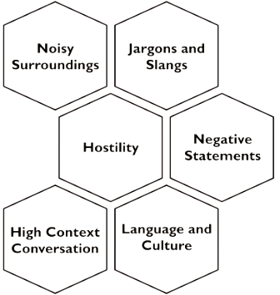
Figure 10 – Communication Blockers
Improper encoding of messages, and the distance between those trying to communicate and those receiving the messages are also impediments to effective communication.

LESSON 9 QUIZ

1. A U.S. marketing manager is irritated that his counterpart in Japan makes limited eye contact during a recent visit to his facility. Eye contact is a sign of attentiveness to one but represents inappropriate behaviour to the other. What type of barrier is this?
- Cultural
- Gender
- Physical Separation
- Language
- Status

Answer A: Cultural. Body language accounts for around 55% of communication. In situations where there is a language barrier, that percentage becomes even higher. That’s why it’s important to be aware of the type of body language you use in cross-cultural communications. If you get it wrong, you can unintentionally send wrong messages.

2. All are barriers of communication except:
- Engagement
- Inconsistent verbal/non-verbal cues
- Poor listening
- Emotionality
- Noise

Answer A: Engagement. Choices B, C, D and E are all barriers to communication.

COMMUNICATION MANAGEMENT SUMMARY

Communication is a project manager’s most important skill. Project managers have to communicate with management, customers, the project team members, and the rest of the stakeholders involved with the project. The project manager’s foundation is communication – without effective communication how will work get completed, progress reported, and information dispersed?
Communications planning centers on, “Who needs what information—and when do they need it?” Consider all of the different channels for communication on any project. That’s many different possibilities for information to be lost, messages to be skewed, and progress hindered. The formula for calculating the communication channels is N(N–1)/2 where N represents the number of stakeholders. As a general rule, larger projects require more detail—and detail means more planning for communications.
The Communications Management Plan organizes and documents the communication processes, acceptable modalities for types of communication, and the stakeholder expectations for communication. The Plan should detail how information is gathered, organized, accessed, and dispersed. The Plan should also provide a schedule of expected communication based on a calendar schedule, such as project status meetings. Some communications are prompted by conditions within the project such as cost variances, schedule variances, or other performance related issues.
The communication model illustrates the flow of communication from the sender to receiver. The sender sends the message. The message is encoded by the encoder and travels over the medium. A decoder decodes the message for the receiver. This model is easy to remember if you apply the processes to a telephone call.
Within communication, there are five characteristics that affect the message:
- Paralingual: pitch, tone, and voice inflections
- Feedback: sender confirmation of the message by asking questions, for a response, or other confirmation signals
- Active listening: receiver confirms message receipt
- Effective listening: receiver offers confirmation of the message, such as nodding their head, asking questions, or other interactions.
- Nonverbal: facial expressions, hand gestures, and body language

MODULE 7 – PROJECT PROCUREMENT
________________________________________________________________________________________________________

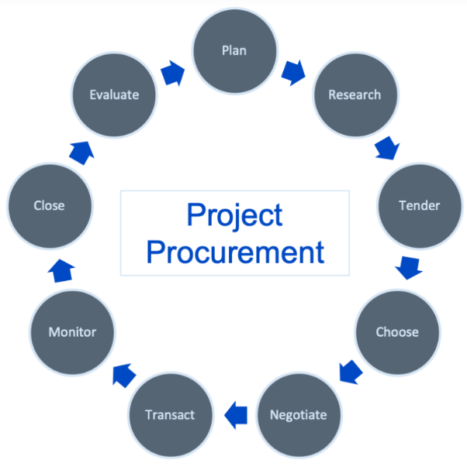

MODULE OBJECTIVE

At the end of this module participants will be able to:

- Define what is Procurement Management
- Differentiate between the different types of contracts
- Learn the importance of data gathering
- Learn the different bid documents
- Management of the contracts.

MODULE STRUCTURE

This module will be delivered in five two lessons to be completed over the course of 10 hours.

Lesson 1 – Introduction to Procurement Management
Lesson 2 – Contracts
Lesson 3 – Data Gathering
Lesson 4 – Bid Documents
Lesson 5 – Managing Procurements

INTRODUCTION

Procurement Management is the process used to purchase or acquire products, services or results needed from outside the project team.

This involves defining requirements, developing terms of reference, defining and executing a competitive procurement process, administering and the sourcing of contracts, purchase orders, memorandum of agreement (MOA), memorandum of understanding (MOU) and internal service level agreement (SLA).

LESSON 1: DIFFERENCE BETWEEN MOUs, MOAs AND SLAs

Memorandum of Understanding: A Memorandum of Understanding (MOU) is not binding like a contract, but it enables work to begin. It’s more of a gentleman’s agreement, it indicates that both parties intend to work together, that the seller is going to be awarded the contract, and that the buyer wants work to start work before the official contract is signed.

Memorandum of Agreement: A Memorandum of Agreement (MOA) is a legal document describing the business partnership between two parties that have agreed to cooperate to an agreed objective or a project. It lays out the deliverables, the agreed terms, and outlines the steps to reach the desired goal of the agreement.

Service Level Agreement: A Service Level Agreement (SLA) is a legal document that defines the level of service you expect from a vendor, laying out the metrics by which the service is measured, as well as remedies or penalties should the agreed-upon service levels not be achieved.

The personnel authorized to procure the goods/services required for the project may be members of the project team, management or members of the purchasing department, as applicable.

The project manager does not have to be an expert in procurement, but should be familiar with the process to make intelligent decisions along the process chain, as well as on contracting and execution of contract. A working knowledge of procurement is important, as the project manager is a key first reviewer that the contract with the selected supplier, contractor or consultant is being implemented with due regard for contractual terms.

The Procurement Management Plan contains a detailed approach to managing the process. This includes: type of contracts, cost estimation, the people (skills and experience) involved and the criteria for selecting sellers/contractors/consultants.

LESSON 1 QUIZ

- What is Procurement Management?

Answer: Procurement Management is the process used to purchase or acquire products, services or results needed from outside the project team.

- What is the difference between a Memorandum of Understanding, a Memorandum of Agreement and a Service Level Agreement?

Answer: A Memorandum of Understanding is not binding like a contract, but it enables work to begin. It’s like a gentleman’s agreement, it indicates that both parties intend to work together.

A Memorandum of Agreement is a legal document describing the business partnership between two parties that have agreed to cooperate to an agreed objective or a project.

A Service Level Agreement defines the level of service you expect from a vendor, laying out the metrics by which the service is measured, as well as remedies or penalties should the agreed-upon service levels not be achieved.

LESSON 2 – CONTRACTS

One of the most important documents in procurement management is a contract, which is a legally binding agreement between two parties that obligates the seller to provide the goods and/or services requested and obligates the buyer to pay for them; all deliverables and results should be clearly stated including any knowledge transfer from seller to buyer. Because contracts are legally binding, there is more accountability to deliver the work stated in the contract.

The three more common types of contracts are:

1. Fixed-Price or Lump-Sum Contracts

This is an agreed fixed price for a well-defined product/service, and is used when you don’t expect any significant changes to the scope of the project. The buyer incurs little risk (for example, if the prices of raw materials increase, the seller absorbs the cost), This contract has well-defined deliverables and deadlines and may include incentives for meeting or exceeding specific objectives.

Types of Fixed-Price or Lump-Sum Contracts:

- Firm fixed price: Price is fixed no matter what (economy, raw materials) unless the scope of the project changes
- Fixed price plus incentive fee: A little more flexibility. If the product is delivered early or is of a very high quality, there is usually an incentive fee.
- Fixed price with economic adjustments: This is used if the project is lengthy and will take a few years to complete or if payments are made in foreign currency.

Example of Fixed Price Contract:
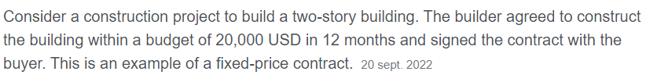

2. Cost-Reimbursable Contracts

This relates to payment to the seller for all legitimate costs incurred for completed work, plus a fee for seller profit. (For this type of contract, if the price of raw materials increases, the buyer must reimburse the seller at whatever was the permitted level of cost escalation). It is used if the scope of work is expected to change significantly during execution of the project. The buyer absorbs more of the risk with cost-reimbursable contracts than they do with fixed-price contracts.

Some common types of Cost-Reimbursable Contracts:

- Cost plus fixed fee: You reimburse the supplier for any increased prices in raw materials plus a fixed fee payment outside the cost of the raw materials.
- Cost plus incentive fee: This includes a predetermined fee the contractor can earn if the product is delivered early or with a high quality.
- Cost plus award fee: This is based on the satisfaction of certain broad subjective performance criteria that are defined and put into the contract. The fee is based solely on the subjective determination of the contractor performance by the buyer and is generally not subject to appeals.

Example of Cost-Reimbursable Contract:

Consider the construction of a house where the contractor spent $100,000.00 to complete the project and a fee of $50,000.00 was agreed as a fee. This fee is pure profit for the contractor as he will also be reimbursed for the initial $100,000.00 spent.

3. Time and Material Contracts

These are also called time and means contracts; they are a hybrid of both fixed-price and cost-reimbursable contracts. For those aspects of the project where the scope is well defined, the fixed fee part of the hybrid will pertain. For the other aspects of the project that are uncertain and/or may change, is where the cost-reimbursable formula is applied. This type of contract protects both parties.

Example of Time and Materials Contract:
Considering the construction of the same house as mentioned above, the buyer agrees to pay the builder an hourly rate of $30 an hour plus an additional 10% on any items purchased. But it also states that the buyer will not pay more than $1,000 in materials and in excess of 80 hours of labour.

LESSON 2 QUIZ

- What is one of the most important documents in procurement management?

Answer: One of the most important documents in procurement management is a contract, which is a legally binding agreement between two parties that obligates the seller to provide the goods and/or services requested and obligates the buyer to pay for them.

2. What type of contract has the least amount of risk to the buyer?

Answer: The contract that has the least risk to the buyer is the firm fixed-price contract, because the price has been agreed up front and does not change no matter what (economy, raw materials) except for a change in the project scope.

LESSON 3 – DATA GATHERING

Data gathering is another important task in the procurement process. In this part of the process, the buyer tries via internal or external means to understand as much about market pricing or about potential suppliers as possible, so that the buyer understands what available and what pitfalls the buyer is would need to consider. For example, market research is done on the industry and different seller capabilities; the services that various sellers can provide and the quality of work they have done for your organization and for other companies in the past.

Internal data gathering is the process of identifying the goods and services required for the project. This must be determined before looking at potential sellers and the services they can provide.

Make or Buy Analysis
The project team uses this type of analysis to decide if they can procure services inhouse or source it from outside the company. A make or buy analysis document is created to assess and document the cost of using inhouse resources versus outside resources.

Example of Make or Buy Analysis

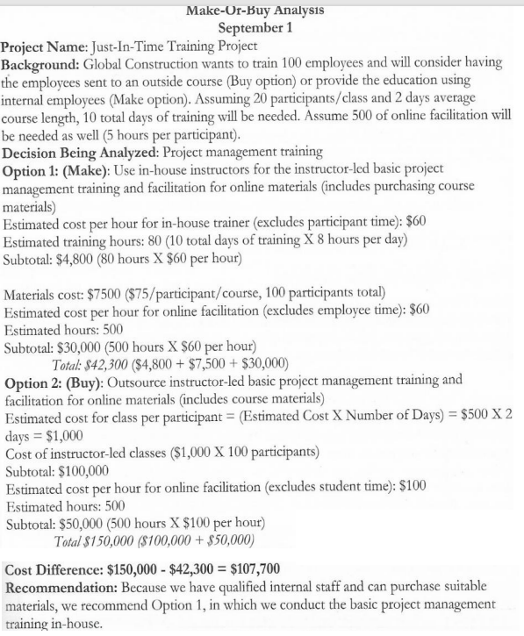

LESSON 3 QUIZ

- What is a Make or Buy Analysis?

Answer: The project team uses this type of analysis to decide if they can procure services inhouse or source it from outside the company.

- Why is internal data gathering important?

Answer: Internal data gathering is important because this helps to identify the goods and services required for the project. This must be determined before looking at potential sellers and the services they can provide.

LESSON 4 – BID DOCUMENTS

- RFP – Request for Proposal: This document solicits proposals from prospective suppliers. In this document the buyer describes what they require, and requests responses from potential sellers that explain what they will do to meet the requirements of the buyer.

An RFP contains:

- The purpose of the RFP
- Background on the organization issuing the RFP
- Basic requirements for the products/services being proposed
- Hardware/software environment (if IT related)
- Instructions on how the sellers/contractors should respond to the RFP and submit their proposals
- Statement of Work (SOW) and scheduled information
- Fee/cost information
- Terms and Conditions of contracts with successful suppliers
- Appendices.

2. RFQ – Request for Quotation: This document deals with getting quotes/pricing information. Responses to RFQs are normally faster than responses to RFPs. Selections are normally made on the lowest bids. This is used when you need pricing for standard items.

3. RFI – Request for Information: This document is used when information from sellers/contractors is needed before you send out an RFP or RFQ.

RFI versus RFP versus RFQ
These documents are used for different purposes. An RFI is used when you need more information on the sellers you want to potentially do business with; this is sent to the sellers so they can answer any questions the buyer has. An RFP is a detailed document that the seller would send to a buyer to explain how they will meet the needs of the buyer to fulfil the contract. A RFQ simply gives an estimated price that the seller will charge the buyer for the job. This is a less detailed document than an RFP as it simply lists the prices of the equipment to be purchased and the cost of the labour.

4. Procurement Statement of Work (SOW): This document describes the goods and services to be purchased. This should be included with the RFP to state what the buyer wants the supplier to provide, as well as where and when the job will be done.

Buyers should give suppliers as much information as possible so they can properly price their service.

5. Source Selection Criteria: Your organization should properly evaluate suppliers before selecting them, e.g. reviewing last performance, talking to their recent customers, talking to their management team, requesting demos/samples, where applicable.

6. Advertising: You can advertise for goods and services in different ways:

- Approach a preferred vendor – Send the RFP to a preferred vendor and wait for their response. This is usually referred to as sole select, and has various conditions to demonstrate why a competitive procurement (tender) process was not used.
- Approach several potential vendors – Advertise to different vendors and await their responses, and then select the best proposal. This is usually referred to as selective procurement or tendering.
- Advertising to anyone interested – Put an ad in the newspaper or online. This is done if you don’t know who to send the proposal to, or in a competitive “open tender” process.

7. Bidder Conferences: Also called contractor conferences, vendor conferences and pre-bid conferences. These are meetings between the organization and prospective sellers prior to them submitting their proposals. These meetings are used to ensure that all prospective bidders have a clear understanding of the procurement and that there is no preferential treatment.

LESSON 4 QUIZ

- What is the difference between RFP, RFI and RFQ?

Answer: An RFI is used when you need more information on the sellers you want to potentially do business with; this is sent to the sellers so they can answer any questions the buyer has.
An RFP is a detailed document that the seller would send to a buyer to explain how they will meet the needs of the buyer to fulfil the contract.
An RFQ simply gives an estimated price that the seller will charge the buyer for the job. This is a less detailed document than an RFP as it simply lists the prices of the equipment to be purchased and the cost of the labour.

- What is a Statement of Work?

Answer: This document describes the goods and services to be purchased. This should be included with the RFP to state what the buyer wants the supplier to provide, as well as where and when the job will be done.

LESSON 5 – MANAGING PROCUREMENTS

After the contract has been awarded, management of the agreement is the next step in this process to ensure that the supplier/contractor is doing what they said they would do, and also that the organization is adhering to its promises. This includes:

- Inspection of the work
- Claims Administration
- Audits
- Closing out contracts

The key benefit of this process is that it ensures that both the buyer and seller performances meet the project’s requirements according to the terms of the legal agreement. This is done throughout the project lifecycle as needed.

- Inspection of the Work: This is a structured review of the work being performed by the contractor, this can be a simple review of the deliverables or a physical review of the work itself.

- Claims Administration: This is when both parties cannot agree on compensation for a change or even agree that a change has occurred. When these matters cannot be resolved, they become disputes and then an appeals process must be implemented so that the contracted works/ project can be completed successfully. In such circumstances, the claims are documented, monitored and managed throughout the contract lifecycle. If both parties cannot resolve the claim, then it will have to be handled by the alternate dispute resolution, in accordance with procedures set out in the contract.

- Audits: This refers to a structured review of the procurement process to check and ensure that all policies and procedures of the procurement process were properly implemented. The procurement contract should state the rights and obligations related to audits and the observations from the audits should be brought to the attention of the project managers for the benefit or corrective action of both the buyer and seller.

- Closed Procurements: The buyer will provide formal written notice to the seller that the contract has been completed. Requirements for formal procurement closure are usually defined in the terms and conditions of the contract and should be included in the procurement management plan. All deliverables should have been provided on time and met technical and quality requirements, and there should be no outstanding claims or invoices. All final payments should have been made. The project team must approve all deliverables prior to closure.

LESSON 5 QUIZ

- After the contracts are awarded, what is the next step in the process?

Answer: The next step in the process is to ensure that the supplier/contractor is living up to the contract and the organization is adhering to its promises.

- What is the purpose of audits?

Answer: Audits are a structured review of the procurement process to check and ensure that all policies and procedures of the procurement process were properly implemented.

MODULE 8 – PROJECT RISK
________________________________________________________________________________________________________

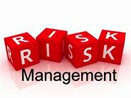

MODULE OBJECTIVE
At the end of this module participants will be able to:

- Define basic risks on projects
- Differentiate between likelihood of risk and acknowledging existence of risk
- Learn the importance of risk identification and management
- Understand various risk documents.

MODULE STRUCTURE

This module will be delivered in four lessons to be completed over the course of 8 hours.

Lesson 1 – What is Project Risk Management?
Lesson 2 – Plan Risk Management and Identifying Risks

Lesson 3 – Perform Qualitative Risk Analysis
Lesson 4 - Perform Quantitative Risk Analysis

INTRODUCTION
A risk is something unknown, and by its very nature, is difficult to identify and manage. Quite often, a risk occurs only after or because of certain other events, which are themselves difficult to predict or manage, as not all circumstances are within one’s control. When they do occur, risks can be one of the most critical, debilitating aspects on a project, causing untold damage.
There are many different types of risks, including funding issues, illness, injury, liability, property damage, theft, fraud, market fluctuations, among others. For example, in cases where your organization heavily depends on a small number of major donors for funding, there's a potential risk of donor dependency. To prevent or guard against the damage that can result from risks, a key part of project management is to proactively identify, as much as possible, the risks associated with each project, the likelihood of the risk occurring, and determine how best to manage these. Risk Management is fundamental to the well-being of each project.
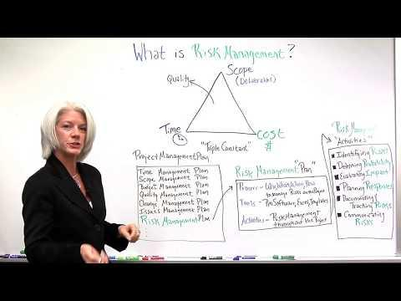

LESSON 1 - What is Project Risk Management?

Definition of Risk:
Risk is defined as an “uncertain event that can have either a positive or negative effect” on project objectives.
Project Risk Management has several stages/ steps:
- Risk management –
- planning
- identification
- analysis
- response planning
- response implementation
- monitoring risk on a project
(PMBOK 6th Ed.)
Why is this important?
On any project, there will be unknowns, challenges and issues. For instance, it can be difficult to undertake a project when local communities express objection or resistance. Therefore, it is important to try as much as possible to identify what can derail the project and manage these to ensure they don’t. Accordingly, it is important to focus on increasing “the probability and/or impact of positive risks and to decrease the probability and/or impact of negative risks”.
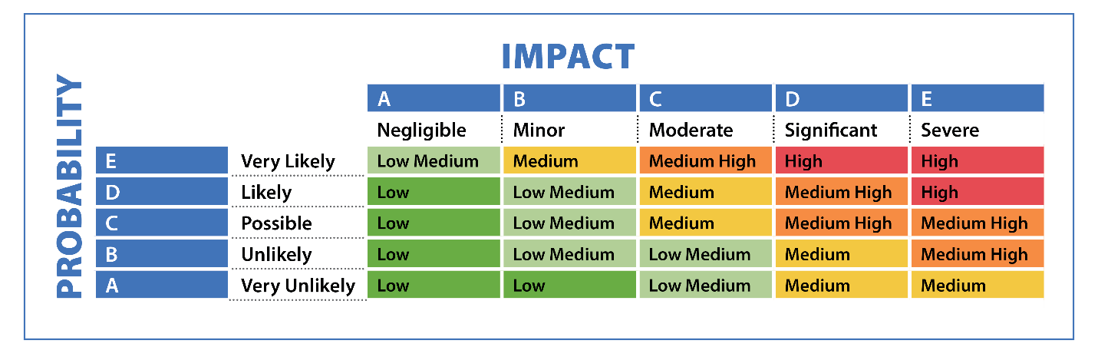Figure 1

Benefits of Risk Management:
It allows an organization to –
- anticipate and manage change
- assist with decision making
- seek lower cost solutions to issues
- increase the probability of capitalizing on opportunities
- inform stakeholders of the likely uncertainties.

Risk Management is more than identification of circumstances that can negatively impact the project. For example:
- Is it possible to identify opportunities as a result of the Risk Management process?
- What do you consider an opportunity?
An opportunity is a “risk” that can have a positive impact on one or more project deliverable. Your business, for instance, investing in digital tools and leveraging technology can improve outreach, data collection, and service delivery. The organization may become more effective and have a wider audience as a result of this risk.
NOTE: Project risk exists at an individual and overall level.
- Individual Project Risk: any uncertain event or condition that can have either a positive or negative impact on the project.

- Overall Project Risk: any uncertainty that arises from all sources, inclusive of individual risk.

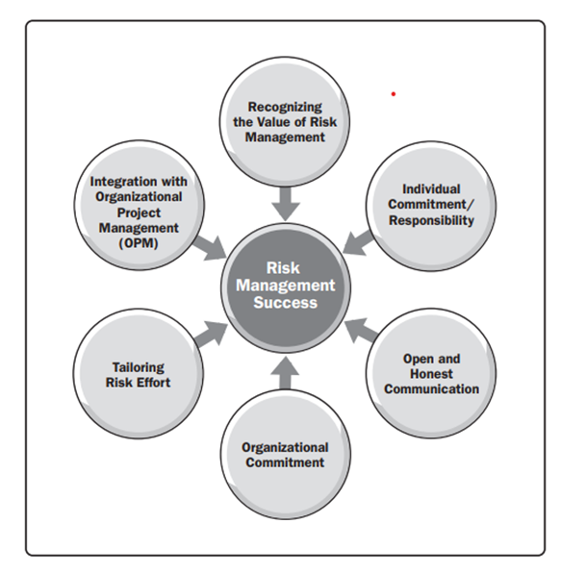
Factors to successful risk management:
Three main inputs are:
Recognizing the value of risk management: Management, stakeholders, and team members accept that project risk management is valuable and will provide a positive outcome.
Individual commitment/responsibility: Project participants and stakeholders accept responsibility for risk-related activities as required. There must be an agreement that the management of risk is everyone’s responsibility.
Open and honest communication: “Any actions or attitudes that hinder communication about risk reduce the effectiveness of risk management.” In the end, this will reduce the organization’s ability to provide proactive solutions and ensure “effective decision making.”
Key point to remember: Risk Management is everyone’s responsibility.
SOURCE: The Standard for Risk Management in Portfolios, Programs, and Projects (2019).
The Project Risk Management processes:
- Plan Risk Management
- Identify Risks
- Perform Qualitative Risk Analysis
- Perform Quantitative Risk Analysis
- Plan Risk Responses
- Implement Risk Resources
- Monitor Risks.
These processes and the role of Risk Management in projects are explained further in the lessons below.

LESSON 1 Quiz (True/False)
- A risk is a certain event that can impact the project.

False - A risk is an “uncertain event that can have either a positive or negative effect” on a project.

- The stages of risk management are planning, identification, analysis, response planning, response implementation and monitor risk.

True.

- Risk management involves increasing the probability and/or impact of positive risks.

False – It involves increasing the probability and/or impact of positive risks and decreasing the probability and/or impact of negative risks.

- An opportunity is a “risk” that can have a positive impact on one or more project deliverable.

True.

LESSON 2 – Plan Risk Management and Identifying Risks


How do you plan project risk management?
What do you need to develop the Risk Management Plan?
What is a Risk Register?

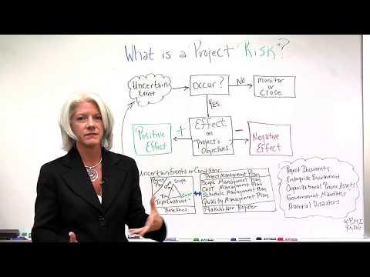
https://youtu.be/nbhLDJkNnzY

To develop the Risk Management Plan and Risk Register, we need the following:
- Project Charter
- Project Management Plan
- Project Documents – Stakeholder Register
- Aggrements
- Procurement Documentation.
These are just some of the inputs used by project managers as they navigate planning risk management responses and identifing risks.
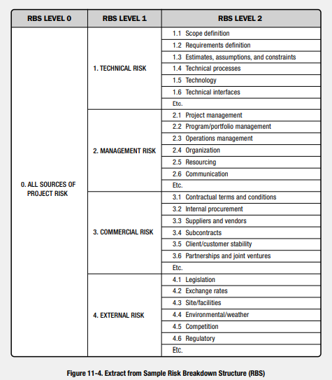

Risk Management Plan…What is it?

The Risk Management Plan decribes what will be done to manage projcet risk. This plan will have most or all of the following:
- Risks Identification – risks considered important to the project
- Risk Strategy – the way forward
- Methodology – tools and analysis
- Roles and Responsibility – who will do the tasks assigned
- Funding – budget
- Timing – when and how often
- Risk Categories – structure used to group risks

Source: PMBOK

Identifying Risks

This process involves “identifying the individual project risks, sources of overall project risks and the individual characteristics of each”.

Who is involved?
- Project Manager
- Project Team
- Customers
- S.M.E (Subject Matter Experts)
- Stakeholders

Risk Register

The process of identifying and documenting risks produces the Risk Register. This contains the identified individual risks associated with the project along with “limited or extensive risk information”.
The Risk Register may also contain the following components:
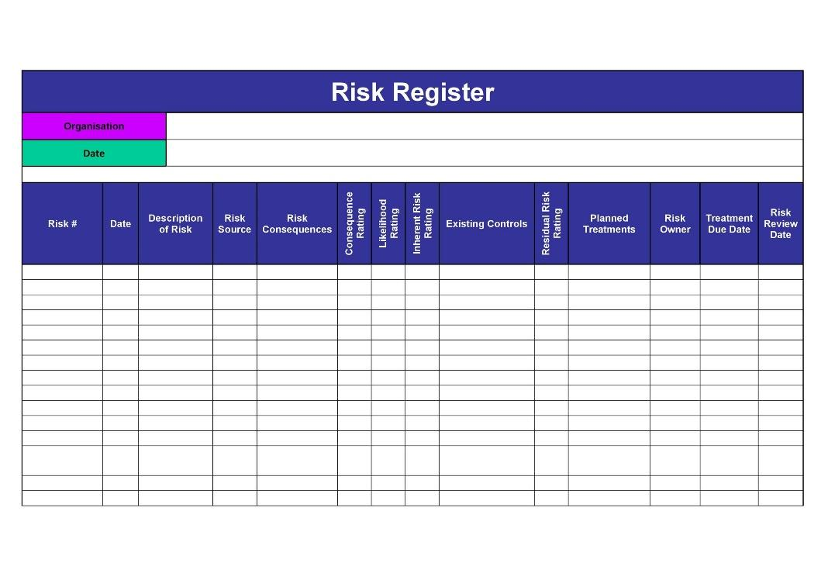
- List of Identified Risks – At this stage each identified risk is assigned a “unique identifier” and explained in detail to avoid any confusion.

- Potential Risk Owner – Any identified risk owners are recorded here.

- List of Potential Risk Responses – Any identified responses to the risks are recorded here.
Figure 2

LESSON 2 Quiz (True/False)
- The risk management plan describes what will be done to manage project risk.

True.

- The risk management plan only contains information on risk strategy and funding.

False - The risk management plan contains most of the following: Risk strategy, Methodology, Roles and Responsibility, Funding, Timing and Risk Categories.

- Sources of project risk include technical risk, management risk, commercial risk, and external risk.
True.

- The project charter and procurement documents are the only inputs to the risk management plan and the risk register.

False The project charter, project management plan, project documents (stakeholder register), agreements and procurement documentation are all used to develop the risk management plan and risk register.

- The risk register is created during the process of identifying risks.

True.

- The risk register identifies the list of identified risk, the risk owner and possible risk responses.

True.

LESSON 3 – Perform Qualitative Risk Analysis

This is the process of “prioritizing individual project risks for further analysis or action”.

How is this done?
By:
- Assessing the probability of the risk occurrence and impact
- Outlining any other characteristics of the risk
- Identifying the risk owner for each risk to whom the responsibility of implementing the risk response is assigned.
It is a process conducted and actively managed throughout the life of the project, with a focus on “high-priority risks”.
Qualitative Risk Example for an NGO:
Risk: Volunteer Availability
Description: There is a qualitative risk that the NGO may face challenges in recruiting and retaining volunteers due to competition with other organizations for volunteer resources.
Qualitative Assessment: High
Explanation: This assessment is based on the observation that there are several NGOs and community initiatives in the area, making it competitive to attract and maintain a dedicated volunteer base.
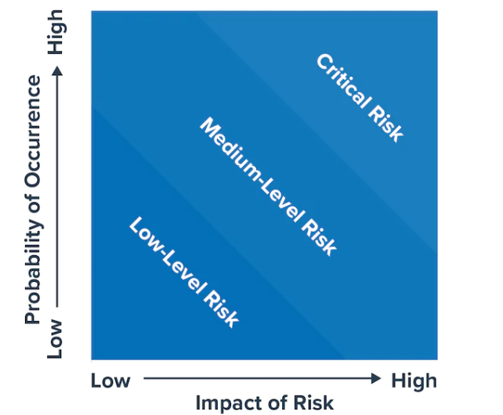
Risk management is the process used to identify the risk probability and impact.
Probability. The chance of a risk occurring, which can range from slightly above 0% to just below 100%.
Impact. Risks, should they occur, can have either a positive or negative consequence for the organization. The magnitude or significance of the impact may have varying implications and influences.
Source: The Standard for Risk Management in Portfolios, Programs, and Projects (2019).
Figure 3
Source: https://www.mindtools.com/ah8ju2z/risk-impactprobability-charts

- Low impact/low probability – These are risks in the bottom left corner of the matrix. They are low level and can often be ignored.
- Low impact/high probability – These are risks in the top left corner of the matrix. They are of moderate importance – they can be addressed with relative ease. However, effort should be made to reduce the likelihood that they'll occur.
- High impact/low probability – These are risks in the bottom right corner of the matrix. They are of high importance if they do occur, but very unlikely to happen. In this instance the focus should be on what you can to reduce the impact they'll have on the project or organisation. For these risks, the project team must ensure that there are contingency plans in place just in case they do.
- High impact/high probability – These are risks in the top right corner of the matrix and are of critical importance. These are top priorities and are risks that the project team must pay close attention to.
For example, a financing insufficiency risk has a significant impact and a moderate likelihood, making it a financial risk for the organization accountant to pay close attention too.
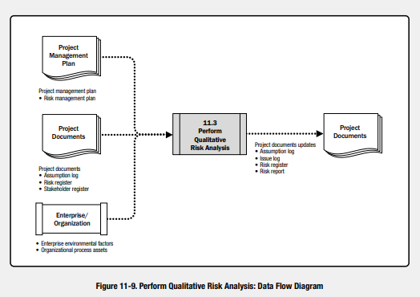
What are the major inputs?
- Project Management Plan
- Project Documents
- Assumption Log
- Risk Register
- Stakeholder Register
- Enterprise Environmental Factors
- Organizational Process Assets
Source: PMBOK

What are the Tools/Techniques?
- Expert Judgement
- Data Gathering
- Data Analysis
What are the benefits/ outputs?
Updated Project Documents
Reduction of risks occurring
Less impact, where risks occur
Possible opportunities for improvement, within the project deliverables or within the organisation

LESSON 3 Quiz (True/False)
- Qualitative risk analysis involves the process of “prioritizing individual project risks for further analysis or action”.

True.

- This process only involves assessing the probability of the risk occurrence and impact.
False - The process also involves outlining any other characteristics, identifying the risk owner and the agreed upon risk response.

- Qualitative risk analysis is a process conducted throughout the life of the project and focuses on “high-priority risks”.

True.

- The impact of a risk can either have a positive or negative consequence for the organization.
True.

- Low impact/low probability risk should be given full priority while high impact/low probability risks can be ignored.

False – Low impact/low probability risk can be “ignored” while risks with a high impact/low probability should have contingency plans to reduce any impact they may have on the project.

LESSON 4 - Perform Quantitative Risk Analysis

The Perform Quantitative Risk Analysis process shows the combined effect of identified risks on the desired outcome. As part of the process, “numerical analyses” provide guidance on the effect that the identified risk has on the project. It is not required for every project, but when utilized the major benefits are:
  - Quantifying overall project risk
  - Providing additional risk information to support risk planning.
This process considers:
- Correlation between risks
- Interdependency
- Feedback loops
- The degree of overall risk faced by the project.

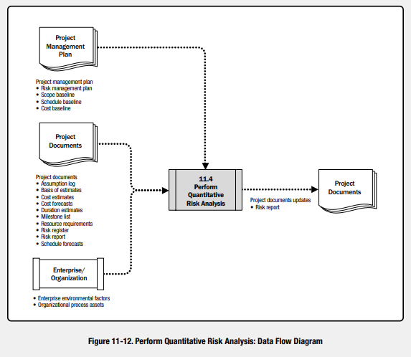
What is the purpose?
Quantitative risk analysis provides a more “realistic estimate” of risks. However, it is not always possible, or necessary.
Factors to successful quantitative risk analysis includes:
- Prior risk identification and qualitative risk analysis.
- Appropriate model
- Competence with the corresponding technical analysis tools
- Commitment to collecting credible risk data.
“The Standard for Risk Management in Portfolios, Programs, and Projects (2019).”
Source: PMBOK

Quantitative Risk Example for an NGO:
Risk: Decrease in Donor Contributions
Description: There is a quantitative risk that the NGO may experience a 10% or greater decrease in annual donor contributions.
Quantitative Assessment: Likelihood: Moderate | Impact: High
Explanation: This assessment considers historical data, donor feedback, and economic indicators to estimate the likelihood and impact of a significant decrease in donor contributions. It suggests a moderate likelihood based on past patterns but a high impact due to the potential financial strain on the organization.

LESSON 4 Quiz (True/False)
- Quantitative risk analysis numerical analyses is the effect that the identified risk has on the project and must be done for every project.

False It is a numerical analysis of identified risks but is not needed for every project.

- Quantitative risk analysis shows the combined effect of identified risks on the desired outcome. True.

- Qualitative risk analysis only takes into consideration the interdependency of identified risks.

False - The process also considers correlation between risks, feedback loops and the degree of overall risk faced by the project.

- Successful quantitative risk analysis is not impacted by the commitment to collecting credible risk data.
False – The effectiveness of quantitative risk analysis is impacted by several factors, one of which is the collection of credible risk data.

MODULE 9 – PROJECT QUALITY
________________________________________________________________________________________________________

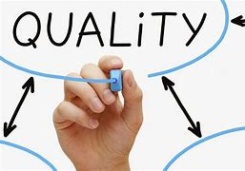

MODULE OBJECTIVE
At the end of this module participants will be able to:
- Define Quality Management
- State why good Quality Management is important
- Define the main concepts used while implementing Quality Management
- Understand what the ISO 9001 standard is about
- Understand the Quality Management Process as defined by PMI
- Learn the various Tools & Techniques that could be used when Implementing Quality Management in your projects

MODULE STRUCTURE
This module will be delivered in five lessons to be completed over the course of 15 hours.
Lesson 1 – What is Quality Management and Why it is Important.
Lesson 2 – Definitions Used in Quality Management you Need to Understand
Lesson 3 – What is ISO and Why is it Important
Lesson 4 – Quality Management Process (PMI)
Lesson 5 – Tools & Techniques for your Quality Management Process

INTRODUCTION
In projects, we speak of the Triple Constraint of Project Management—time, cost and scope. These are competing demands found in every project that can have an impact on the project success. The triple constraint of Project Management is also referred to as the Project Management Triangle (see Figure 1) because it represents a continuously dynamic relationship between —time, cost and scope (changing one can have an impact on the others). Also, time, cost and scope can impact the quality of project deliverables (see Figure 2) and determine whether the project succeeded in fulfilling its requirements.

Figure 1 - Triple Constraint of Project Management courtesy Project-Management.com
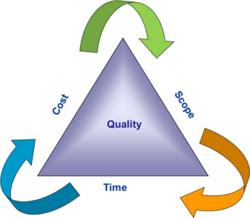

Figure 2 - Triple Constraint of Project Management and its impact on quality - courtesy Project-Management.com
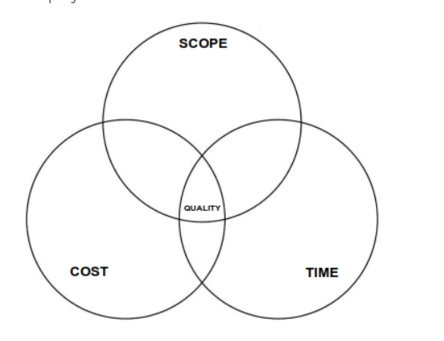

As stated in the PMI Pulse of the Profession report (PMI is the leading professional association for Project Management), a project is only successful if it delivers the specific benefit(s) that an organization envisioned by the project. To deliver this benefit, the project must meet the agreed needs of the key stakeholders, in an efficient, effective and economical manner. The means of doing this is through Quality Management—the means by ensuring that the project requirements and product requirements are met and validated.

For instance—You are responsible for a project to have a fundraising event— Sunday evening Easter tea event where the patrons are given the opportunity to create an Easter Basket. These patrons can also purchase Easter bonnets created in the Easter Bonnet competition leading up to the event (prizes were donated by sponsors). There is a budget of $20,000 and the event is to be held on April 10th, 2023. The event needs to raise at least $500,000 (to cover annual operating expenses for the NGO). The venue to be used is donated by a sponsor to help with alleviating costs but can only hold 2,000 people.

You are on budget, ready for the event (well sort of) but due to poor execution not all the hats were collected, and not enough materials were there for people to make their baskets. The result—many disgruntled patrons left the event. In addition, the tea and hors d’oeuvres were of poor quality and the live performances did not occur due to booking conflicts and miscommunication. The event gets pretty bad reviews on social media. Memes began to circulate—with a fury—as is typical in the current Trinidad environment. So now the organization’s Board advises that going forward you should not have this fundraiser as it has too much bad press associated with it —this can’t be the recurring fundraiser as expected (well at least until the bad publicity dies down).

Would you consider this project a success? The event did occur on the date and venue as planned. It was on budget. However, did it meet the quality criteria to be considered a success? The response of most persons would be NO, and they would be correct.

So, as you can see, you need to consider Quality Management as a very important part of your branding strategy to ensure that your NGO is associated with a high standard—one that will garner support for your organization’s goals and result in donations for your organization’s good cause. So, by now you can see that Quality Management is integral to the success of any project and by extension to the preservation of any organization’s good name because the final outcomes of the project – a product, service, or result – are measured against the requirements agreed to by the project team and stakeholders (including the SMEs – Subject Matter Experts).

At the end of the day, Quality is about doing the right thing right, each and every time. Our organizational and personal reputations are judged by our continuous Quality actions.

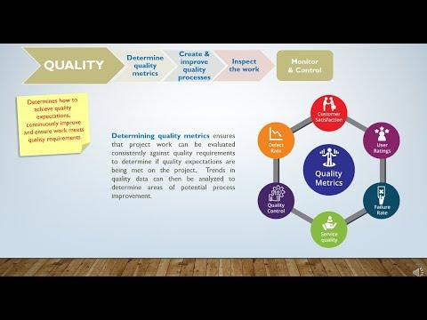

LESSON 1 – WHAT IS QUALITY MANAGEMENT AND WHY IS IT IMPORTANT

An NGO working on community development collaborates closely with local residents, involving them in project design, decision-making, and implementation. Regular community meetings are held to gather feedback and address concerns. Quality Management ensures that the project meets the needs of the stakeholders—that the project requirements and product requirements are met and validated.

- It has an impact on requirements and by extension - project success. For a project to succeed, you need to plan, monitor, analyze, communicate and control requirements continuously throughout the project. PMI’s Pulse of the Profession report (2014) indicates that 47% of projects fail due to poor requirements.
- If there is poor Quality Management, there can be negative consequences to an organization. It can result in the delivery of poor products and services which can impact confidence in the organization and what it provides to stakeholders. This is of particular concern for NGOs which use their branding to garner financial support.
- It ensures the delivery of quality products which can build confidence in the organization and ensure support for the organization and the product it offers.
- It reduces the likelihood of errors, defects and bugs in products that are being used by the wider public as they support your organization – contributing to your branding as an organization.
- Good Quality Management matters because:
  - It ensures customer/stakeholder satisfaction
  - The cost of preventing mistakes is usually lower than correcting mistakes.
  - It ensures that there is a standard that is defined by the organization and is being met.
  - It results in continuous improvement, operational efficiency and improvement in how things are done—this is critical because we live in a fast paced BANI world.
- BANI – Brittle, Anxious, Non-Linear and Incomprehensible - where change is the only constant - a world where systems can seem to be working but could be on the verge of collapse (Brittle), a world flowing with too much information, a world where we can’t easily determine the link between cause and effect so we can’t always determine the true impact of decisions made, a world which is not always comprehensible because of how rapidly things change.

LESSON 1 QUIZ

- Stakeholders’ needs would only pertain to the product requirements. (True/False)
Answer False - the needs of the stakeholders would consist of both the project and product requirements.

- Poor Quality Management has no impact on product and service delivery so it’s not important for an organization.
Answer False: poor Quality Management can result in delivery of poor-quality products and services which impact Stakeholders’ confidence in an organization.

- Good Quality Management is expensive—it can increase costs in the long run.
Answer False: Quality Management does incur costs, which must be outlaid but the cost of preventing mistakes is usually lower than the cost of fixing them.

- Good Quality Management can ensure Continuous Improvement.
Answer True: the efforts to ensure quality which include tracking errors can improve the way things are done in an organization.

- BANI means Brittle, Anxious, Non-Linear and Incomprehensible. (True/False)
Answer: True.

LESSON 2 – DEFINITIONS IN QUALITY MANAGEMENT YOU NEED TO UNDERSTAND

An NGO working on women's empowerment conducts regular impact assessments to measure the effectiveness of their programs. They track outcomes such as increased income, improved literacy, and enhanced leadership skills among beneficiaries. During a project, the Project Quality Management Plan is prepared and used by the Project Manager to ensure that the service or product is delivered as defined by the requirements for both the project and product.
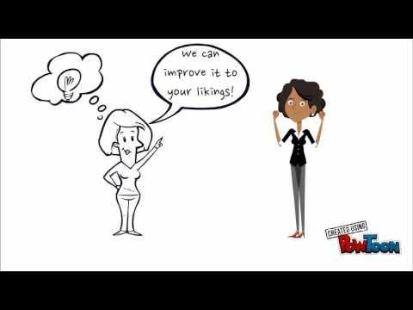

- Customer Satisfaction
  - Without customer satisfaction, there can’t be any quality.
It’s crucial to document requirements and ensure that there is an Acceptance Criteria defined and agreed to by stakeholders.
  - All aspects that impact customer satisfaction should be considered during a project. Not only the product that is to be delivered but the processes that support that product.
For example: for the Online Learning platform for adults to learn hydroponics, how would registration occur? What if persons who want to register, but don’t have access to a laptop (perhaps there can be use of the library computers facilitated)? What if the person is not too tech savvy (perhaps have a computer orientation system built into the learning)? What about persons without email addresses? (Consider how to reach these persons).
  - Process redesign and processes are integral to the success of a project after implementation.

- Prevention Over Inspection
  - Quality does not come free.
  - The Cost of Quality is the money spent to deal with and fix issues and errors during and after the project, where necessary.
This is separated into:
      - Cost of Conformance
        - Preventative Costs – training, documentation costs, equipment and time required to get quality right (for instance – deciding to adopt ISO9001 and sending members of the team for training).
        - Testing—sometimes the test may require use of the product (as part of registration for your event, you give registrants a package that has samples and you open the samples to ensure there are no issues)
        - Inspection— requires resources, training of these resources, additional time which can have an impact on efficiency.
      - Cost of Non-Conformance
        - Internal failure costs – the costs incurred when something must be reworked or scrapped completely (you created fliers for a fundraiser, and they have to be scrapped due to incorrect spelling or poor-quality print).
        - Liability – damage that can occur from your product (you offer smoothies at your fundraiser and persons get food poisoning), or lost patronage.

- Continuous Improvement
  - This is the effort to improve how deliverables are delivered over time. This change can be incremental and small or large. The way things are done can always be improved, made better, more efficient, or have better quality.
  - When you monitor and document the challenges that occur, then the lessons learned in the current project can be applied to future projects to reduce the likelihood of repeating the same mistakes. This increases the chance that future projects will be successful and be implemented more efficiently.

LESSON 2 QUIZ

- Cost of Quality is the cost it takes to create a product. (True/False)
Answer False: Cost of Quality is the money spent to deal with issues and errors during and after the project, as well as the cost to fix these issues and errors.

- Cost of quality is the cost of Non-Conformance.
Answer: False – Cost of quality is the cost of Conformance and Non-Conformance.

- Cost of Conformance is akin to preventative costs.
Answer: True

- Training is an example of the Cost of Conformance.
Answer: True
- Cost of Non-Conformance is when something has to be reworked or scrapped completely.
Answer: True

- Continuous Improvement is the effort to improve how deliverables are delivered over time.
Answer: True

LESSON 3 – WHAT IS ISO AND WHY IS IT IMPORTANT

An NGO operating a healthcare clinic implements quality control measures to ensure that all medical staff adhere to best practices and that medical equipment is regularly maintained and replaced to provide the highest quality care to patients. This need for Quality is recognized internationally, so much so that a series of Standards for Quality was established by ISO (International Organization for Standardization) to ensure the quality, safety and efficiency of products, services and systems to be adhered to.
The ISO 9000 family is a standardized set of rules for Quality Management Systems to help organizations meet statutory and regulatory requirements, as well as the needs of their customers/stakeholders.
- ISO 9001: 2015 is a Quality Management system that is based on the idea of continuous improvement – the Japanese have termed this “Kaizen”. Kaizen refers to the idea that small incremental positive change can result in significant improvements. The purpose of this continuous improvement is to ensure that organizations consistently perform well because mistakes tend to be repeatedly made when they are not logged and analyzed to determine why they occur – In other words, for organizations to improve how things are done and to become better from it –they have to learn lessons from their prior mistakes.
- ISO requires you to maintain careful records of problems, seek root causes, identify lasting solutions, and implement the solutions. The result – less waste, better quality and lower costs.
- The ISO standards provide a structured set of guidelines for any organization to use to make it more efficient and effective.
Certification in ISO standards is globally recognized.

LESSON 3 QUIZ

- ISO is the International Organization of Standards and is an American standard
Answer: False

- ISO 8001 is a Quality Management System based on continuous improvement or kaizen Cost of quality is the cost of Non-Conformance.
Answer: False – It is ISO 9001.

- Kaizen refers to improvements resulting in large changes done incrementally.
Answer: False – Kaizen refers to small ongoing positive changes resulting in significant results.

- Mistakes will continue to occur if they are not logged and analyzed to determine why they occur.
Answer: True.

LESSON 4 – QUALITY MANAGEMENT PROCESS (PMI)

An NGO focusing on sustainable agriculture invests in comprehensive project planning, taking into account factors like climate conditions, local agricultural practices, and the specific needs of the target community, resulting in a well-structured project plan. According to the Association for Project Management (APM), Quality is the fitness for purpose or the degree of conformance of the outputs of a process or the process itself is to requirements.
According to the Project Management Institute (PMI), The Quality Management Process has three components:
- Plan Quality: What is Required and Why, for the project and product to be considered a success.
- Quality Assurance: How will you provide the assurance that it meets these requirements.
- Quality Control: What measures you are going to put in place to monitor and ensure these standards set (requirements) are met.

Figure 1 - Quality Management Processes – ProjectManager.com
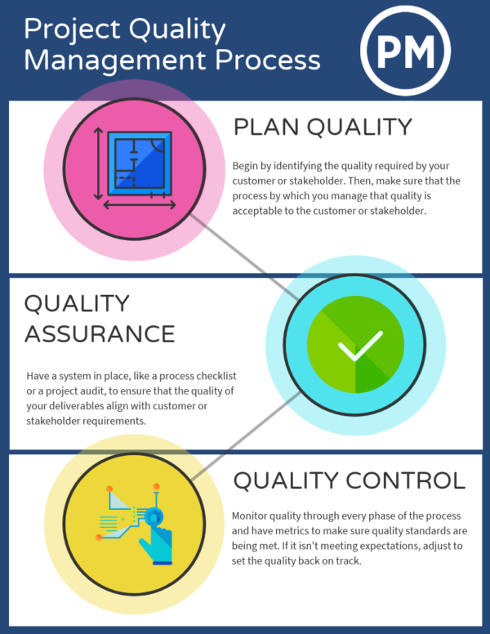
- Plan Quality
This involves:
- Determining the requirements for the product or service to be delivered and requirements for the project.
- Agreement with stakeholders on the acceptance criteria (conditions the product must satisfy to be considered complete).
- Determining how the quality management for the project would be managed (how consensus will be obtained, how sign offs will be obtained – meetings, emails, workshops, how would change in requirements be managed) is also important as this will also be impacted by the project management approach being used.
Metrics will be identified as part of this process so that there is a standardization of how quality will be determined.
When establishing Acceptance Criteria, ensure that the Acceptance Criteria is:
  - Testable: You can easily determine if the criteria is met or not.
  - Concise & Clear: No ambiguity. Everyone can easily ascertain if the criteria was met.
  - Understood by all Stakeholders: (Project Team, Subject Matter Experts and Users)
  - Looks at the Problem from the User’s Perspective: For instance, if your NGO is creating an online course to educate children on why mangroves need to be protected and how it could be done, then the course should be viewed with the Child user in mind.

The metrics defined as part of planning of quality, are not only used during project planning but also used during the project as they are monitored—as a means of determining whether or not the project meets requirements agreed to by all stakeholders (project success criteria).
There are two types of metrics to consider when planning:
- Project Metrics
Customer Satisfaction
      - How are you going to measure customer satisfaction?
      - How will we know and capture whether customers were satisfied?
      - How do we capture, report upon, and address customer complaints?
Resource Conflict
      - How will we assess conflicts, and determine whether the occurrence is occurring too frequently?
      - How can we use the conflict result to identify better solutions and/or how can we escalate conflicts?
Innovation can come out of conflict when you understand why someone is resistant to the idea and you can work to address this.
Number of Time (deliverable date) and Budget Changes
      - To what extent can the project absorb changes in milestone/ delivery/and completion dates?
      - What is the impact on the project’s budget, for changes being contemplated in the project scope, timing or specific requirements to be achieved?
Number of Errors & Customer Conflicts
      - After deployment, could there be the possibility of an increase in errors and complaints once the project has delivered its new product or service?
Anticipation of this occurring can help with determining the Change Management Strategy that needs to be implemented prior – should this be for staff or clients or third parties that interact with the organization.
          - Sensitization can help with this and putting mechanisms in place to manage this change.
          - Humans are resistant to change, so having a change management strategy is crucial to many projects.
          - Also always consider if the process needs to change as well because of the change in the product or service.
On Time Completion and Planned Time vs Actual Time
      - How do we monitor that we are meeting timelines or have missed them?
This may also guide future planning to ensure better estimations of how long tasks will take.
Net Promoter Score
      - How likely is your product or service to be referred?

- Product Metrics

Product Metrics can either be:
      - Lead Management Metrics:
        - New Customers/Market Penetration – number of new customers within a time period (per day, per week, per month).
        - Lead Generation & Nurturing - Number of new leads you get within a time period and how many convert to new customers/supporters of your organization.
      - Engagement Metrics:
        - User Adoption – how many use your product.
        - Conversion Rate –Percentage that act based on a particular promotion/advertisement.
        - Net Promoter Score – how likely they are to recommend your product/organization.
        - Customer Service – the support requests that are generated and the time it takes for them to be resolved and the level of satisfaction after resolution.
      - Organizational Performance Metrics:
        - Cost to acquire a new customer.
        - Lifetime value of an average customer.
        - Average revenue per customer.
      - Feature Metrics (a product feature is what does the product or service look like and supposed to do)
        - Performance – response time in comparison to competitors
        - Reliability & Defects - the number of defects and how often they occur.
        - Downtime & Response Time – if a website is the product or a website is integrated into the process (those that patronize your NGO can purchase tickets online for instance) – how often it is down and the lag time for an output when the user submits an input into the site (for instance the user clicks the submit button – how long after the results is shown to the user).
        - Durability - how long does the product typically last.
        - Conformance – the frequency of the product confirming or not conforming to requirements.

B. Quality Assurance
- Quality assurance ensures that products created by an organization attain designated standards.
    - It is a process that allows for the detection and removal of defects.
    - It provides evidence to stakeholders that the project team has processes in place to ensure that deliverables will fulfil the Acceptance Criteria (standards set for the work to be considered complete and for the product to be of an acceptable quality).
- Quality Assurance can increase efficiency.
    - The team will better understand what specifically is to be delivered, and how delivery of a quality product will be achieved.
- Quality Assurance can be done both to products and services delivered by the project, as well as processes and procedures used to manage the project.
- Quality assurance uses a system of metrics to ensure that the Quality Assurance plan is progressing.
    - These metrics are both qualitative and quantitative metrics.
    - These Quality Assurance tests help to map quality metrics to quality goals which can then be reported in Project Review meetings.
    - It allows the organisation and project team to determine if any corrective action is needed and ensure that this is done in a timely manner.
    - Quantitative vs Qualitative metrics
      - For instance, if you have a fundraising event during Easter, and Easter Baskets will be given to each patron, an example of quantitative metric would be how many baskets can be created per hour (quantitative) versus a qualitative metric – if persons who attended the event left positive comments on social media about the baskets.

There are three methods that can be used for Quality Assurance (the best suited Quality Assurance method would depend on the industry and the type of project):

- Statistical Process Control
    - This would entail the collection and analysis of data (statistical methods) to identify quality issues and measure effectiveness of business processes.
    - These statistical methods could involve random sampling and determining if those samples are of the standard set for acceptance.
      - This is more often used by companies when developing software or chemical products but can also be used for more everyday project events.
      - For instance, the Project Manager may want to evaluate how long it takes the team to put up booths for an event and then determine how many of those booths are not up to standard so they can determine if there is a variation in efficiency of delivery through the booth, and what contributes to this (the contractor, the personnel, the time of day – workers are more tired at the end of day, ineffective supervising by the supervisor at certain times of the day), and then make changes to ensure quality as prescribed.

- Failure Testing
    - Used primarily for software projects.
    - In the software development lifecycle (the process used to design, develop and test software), the testing and integration part of the life cycle is also referred to as Quality Assurance.
      - For instance, in the case of baskets being created for a fund raiser, the basket may be tested for its strength by putting objects of varying weights for varying periods of time. In the case of a website being created by an NGO, a vendor could be hired to do penetration testing to determine vulnerability to cyber-attacks.

QUALITY ASSURANCE STEPS:
  - Plan
    - Prepare test cases (test scripts) based on the standards and functionality that needs to be provided.
    - Create the templates to be used to record results.
    - Choose the persons to perform the testing activity (the SMEs need to be involved in this planning).
  - Do
    - Perform the test varying the conditions.
  - Check
    - Compare the Actual Result against the Expected Result as defined by the requirements and record the errors and the scenarios which resulted in the error (inputs vs outputs).
  - Act
    - Fix any errors or bugs discovered during testing or put a workaround in place to address those bugs.
    - Frequency of use and importance of the feature (i.e., prioritization) will determine if it should be fixed or not.
    - If the feature is used frequently or critical to the process it should be fixed, but if the features are used less frequently or not critical— a manual work around could be implemented and documented so that the bug could remain without risk, or the feature could be removed.
Figure 2 - Software Development Life Cycle (SDLC) - image courtesy Bigwater Consulting
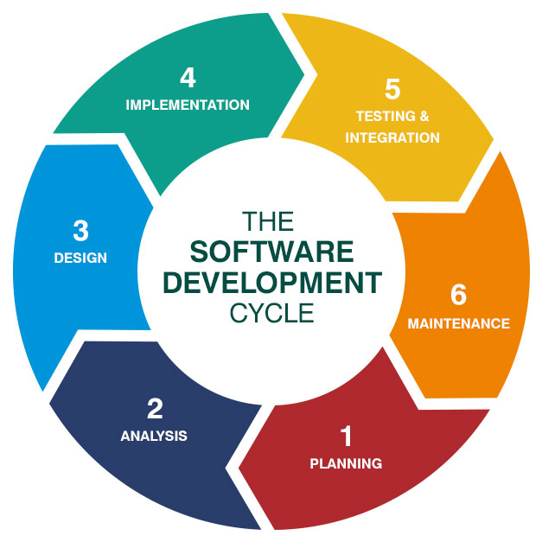
TOTAL QUALITY MANAGEMENT: Is a business approach designed to meet and exceed customer satisfaction. It requires that all members of the organization be committed to a high standard of work in all aspects of the organization – processes, services, products and organizational culture. It is:
    - Process Centered and Integrated
      - Every member must comprehend the vision and mission of the organization, as well as what are the expected outcomes and key processes.
      - There is continual communication and monitoring of these processes.
    - Strategic and Systematic
      - The strategic plan developed must have Quality Management integrated into it.
    - Continual Improvement
      - Consider Kaizen – a Japanese approach to continuous improvement which is based on the idea that small ongoing changes can reap significant improvement.
    - Fact Based Decision Making
      - Data is collected with respect to Performance and used to determine how well the organization is performing. This data is being collected continuously and analyzed to improve accuracy of decision making, forecasting and to achieve consensus.

- Quality Control
This is the process of monitoring and recording the results of executing the Quality Control activities.
- This is the policing of processes to ensure that the rules/standards set are being followed and the expected quality is met – the product or service can meet the acceptance criteria.
- The quality of deliverables should be checked throughout the project – not only at the end. Remember, it is more efficient to readjust along the way, than redo.

LESSON 4 QUIZ

- The Quality Management Process consists of:
- Quality Assurance to ensure that the customer is satisfied.
- Plan Quality, Quality Assurance, Quality Control
- Determine Quality, Quality Assurance, Quality Control.
- Quality Insurance, Quality Control.

Answer: B. a is a definition of quality assurance. c & d are missing processes.

- Quality Assurance steps include:
- Plan, Do, Check, Act
- Plan and Check.
- Plan, Quality Assurance, Quality Control.
- Plan Quality, Quality Assurance, Quality Control.

Answer: A Tasks. It can’t be D because that is the Quality Management Process. C is incorrect; it has an incorrect version of the Quality Management Process. B is missing Quality Assurance steps.

- The three methods which could be used for Quality Assurance are:
- Quality Assurance, Statistical Process Control and Kaizen.
- Plan Quality, Quality Assurance, Quality Control
- Plan, Do, Check, Act
- Statistical Process Control, Failure Testing and Total Quality Management

Answer: D. It can’t be C because that is the Quality Management steps. It can’t be B because that is the Quality Management Process. A is incorrect, it is mixing Quality Assurance methods with Quality Management Process.

- Quality is the fitness for purpose or the degree of conformance of the outputs of a process or the process itself to requirements. (True/False)

Answer: True.

- Quality Assurance is a means of providing evidence to all stakeholders that there are efforts to ensure quality as the project progresses.

Answer: True.

- Quality Assurance ensures that the deliverables meet requirements as defined by stakeholders at the onset and as the project progresses.

Answer: True.

- Quality Control is the controlling of costs when maintaining quality. (True/False)

Answer: False – Quality control is the process of monitoring and recording the results of executing Quality Control activities.

LESSON 5 – TOOLS & TECHNIQUES FOR YOUR QUALITY MANAGEMENT PROCESS

Quality management is essential for NGOs to ensure that they deliver their services and meet their goals effectively and efficiently. Here are the tools and techniques for quality management processes:
Plan Quality - What is needed to start this process:

  - Project Plan – to develop the Quality Management Plan.
    - You would examine the Project Plan to determine:
      - What product or service the project should deliver.
      - What issues could impact this delivery.
        - This could be found in the Project Plan, Project Charter, Scope Statement etc.
  - Stakeholder Register – to determine how each stakeholder can have an impact on quality.
    - The stakeholder register lists all stakeholders, their departments, interest in relation to the project and influence.
  - Risk Register – to determine the risks that can be threats or opportunities that could have an impact on quality.
    - Risk in our everyday conversational definition has a different meaning to risk in Project Management.
      - In Project Management a risk could be a threat or an opportunity. It is defined as a circumstance that could arise during the project that could alter the outcome of the project for better or worse.
    - As part of Project Management, a risk register is created to monitor and to determine how to handle these risks when they occur.
    - The risk register would indicate risk:
      - Probability
      - Priority
      - Impact of risk if it occurs
      - How to manage the risk if it occurs
    - Risks can be managed by:
      - Accepting the risk
        - For instance, you have a fundraising event where patrons can request up to four more tickets for sale which determines if they are eligible for a discount and the amount of discount, when purchasing their ticket. This feature of the fundraising event means that you are accepting the risk that some patrons may do this just to get the discount and not sell all their tickets.
      - Transferring the risk
        - For this same fundraising event, to transfer the risk of tickets requested that may not be sold, you can create a rule that this discount option is only for staff of certain corporate organizations and advise the organization that could put up a booth at the event (at no cost) but that they would be responsible for paying for any unsold tickets at a discounted price –reducing the likelihood of persons taking tickets they know they would be unable to sell (another example of transferring risk is insurance).
      - Avoiding the risk.
        - For this same fundraising event, having identified the risk of persons just taking tickets, there can be a stipulation to return sold tickets by a certain date (early enough to be resold) but there would be a penalty fee otherwise they would have to pay for those additional tickets to be allowed entry.

  - Enterprise Environmental Factors –
    - Laws and Governmental Agency regulations.
    - Rules, Standard, Guidelines – ISO 9000 etc.
    - Standard Practices in field, including Industry requirements.
    - Working conditions that could impact quality.
    - Cultural Perceptions about quality.

  - Organizational Project Assets –
    - An organisation’s Vision, Mission, Values, Objectives.
    - Standard Operating Procedures (SOPs), Service Level Agreements (SLAs), Policies, Guidelines.
    - Manuals.
    - Sharepoint.
    - Lessons Learned from Other Projects.
    - Historical Databases.

Tools & Techniques You can Use for Planning Quality Management

  - MEETINGS
    - Meetings can be used to:
      - Brainstorm (such as when developing a Fishbone diagram or brain mapping).
      - Get inputs from Subject Matter Experts on requirements and user acceptance criteria.
      - Get staff buy-in
        - The lack of adequate buy-in can be an integral part of project failure.
      - Train staff in Quality Assurance methods.

  - COST BENEFIT ANALYSIS
    - The aim in projects should be always to get the highest return while controlling costs.
      - Costs include:
        - Direct, indirect, opportunity cost (what you have to give up by choosing a particular option or sales that you are losing due to the time that the project is taking) and costs of potential risks.
      - Benefits include:
        - Direct, indirect, total benefits, net benefit.

SEVEN BASIC QUALITY TOOLS

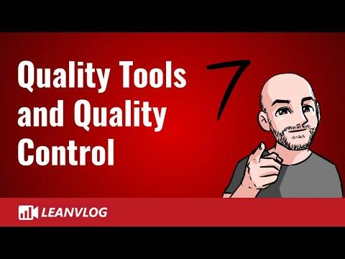

- Cause and Effect/Fishbone Diagrams – used when solving a problem to think of all the possible causes that contributed to the problem’s creation.
      - The fishbone diagram is a visual way to brainstorm all the possible root causes of an issue/problem.
      - The fish head is the problem.
      - The bones of the fish represent the possible causes.
- Flowcharts – used to show the sequential steps involved in a particular process and the decisions involved in that process – visually.
      - The symbols used indicated whether it is a starting or ending point, decision point or step in the process.
      - Flowcharts can help clarify who is responsible for what in an organization’s process.
      - It can also identify redundancies (where the same tasks are being done by the different departments).
      - It could also identify bottlenecks in a process (inefficiencies that slow that a process)
- Checklists – are used to outline a selected process to ensure the best possible result.
      - A simple and effective tool to ensure consistency regardless of who is performing the process by ensuring no step is missed.
- Pareto Diagrams – it is a bar graph that compares two items. You put the item being compared on one axis and the quantity on the other (X axis and Y axis) (eg: Amount of Money donated by type of organization).
      - The bars are used to show frequency or cost (time or money) and are arranged so the longest bars are to the left and the shortest to the right.
        - It could be used to identify:
          - strengths or problems in an organization.
          - root causes of a problem.
        - It allows the organization to determine what to focus on, it identifies where efforts, time and money can be best optimized (eg: the issue having the greatest impact to the organization can be identified and then all resources focused on alleviating this issue).
- Histograms – this is a bar graph that is used to show the distribution or frequency of something occurring.
      - It can be used for analyzing a process (eg: from recruitment up until the day of the event, at which point in the process volunteers tend to stop volunteering- helping to identify challenges in your organization).
- Control Charts – used to determine if a process is stable and in control.
      - It helps to analyze how a process changes over time. Data is plotted in time order.
      - The Control Chart always has three lines:
        - The middle – average.
        - Upper Limit
        - Lower Limit
      - By comparing the current process to these lines, you know if the current process variation is within control or out of control.
- Scatter Diagrams – A scatter diagram is used to determine the correlation between two items identified. These two items are put on the x and y axis. This correlation could be strong or weak (to what extent changing one has an impact on the other), negative or positive (increasing one decreases the other and vice versa) or does not exist.
      - Eg: after you use a Fishbone diagram to brainstorm all the possible root causes of person’s not finishing an online course being offered to educate the public, you can then use the Scatter Diagram to determine if there is a correlation between these identified root causes and the public not completing this course
        - Straight line – strong correlation.
          - This could be negative or positive (as one increases the other decreases or as one increases the other increases).
        - Points scattered - weak correlation.

  - BENCHMARKING – the process of measuring products, services and processes against organizations that are leaders in these areas.
    - It allows you to compare your organization’s performance to an industry leaders and other organizations.
    - It can be used to identify areas for incremental (continuous) improvement or dramatic improvement (business process re-engineering).

  - STATISTICAL SAMPLING – samples are a means of ensuring quality. However, it is not possible to sample all items.
    - eg: Organizations that produce pamphlets about their organizations or have an informational packet, could choose to sample a percentage of items being produced.

Sample Diagrams of the Tools Identified in Plan Quality are Shown Below.
Figure 1 - Fishbone Diagram courtesy Slidemodel.com
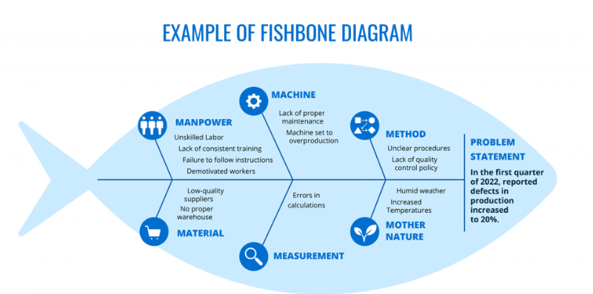
Figure 2 - Process Flowchart courtesy support.microsot.com
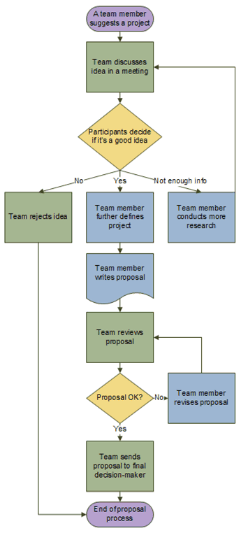
Figure 3 - Pareto Chart courtesy ASQ website
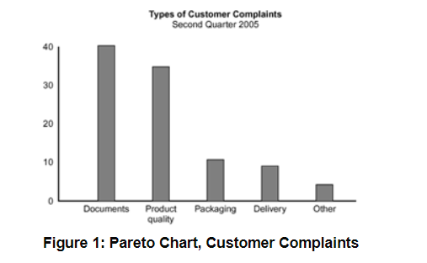

Figure 4 - Histogram courtesy ASQ website
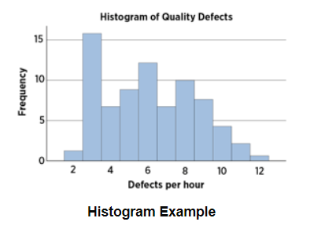
Figure 5 - Control Chart courtesy Clear Point Strategy
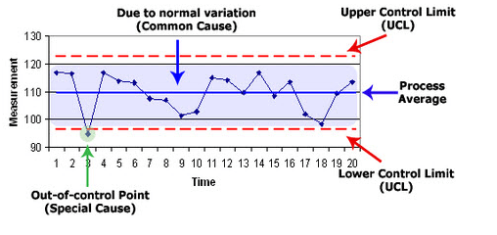
Figure 6 - Scatter Chart courtesy Byjous.com
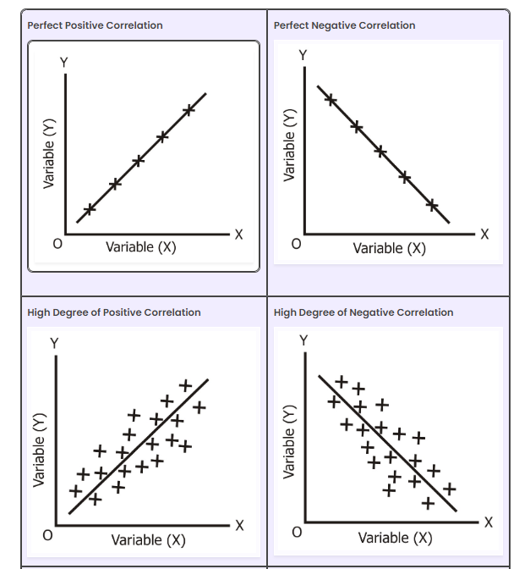

Figure 7 - Scatter Chart cont’d courtesy Byjous.com
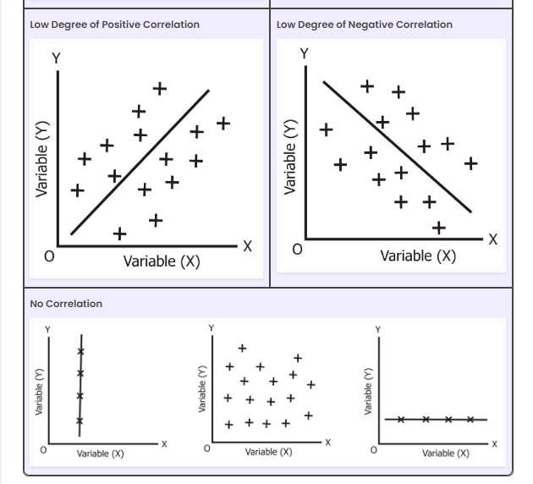

What do you get after completing the Planning Quality Management process:
  - Quality Management Plan including Quality Requirements
  - Process Improvement Plan
    - This is a component of the Project Plan.
      - You would look at metrics, targets for improved performance, bottlenecks, feedback forms from clients etc as well as, the boundaries of the process (issues tend to occur here) and the software and systems used.
    - Quality Metric
      - This is a project or project attribute and the actual value and the variations allowed: + or – 10 as an example.
    - Quality Checklists
      - Checklists are a simple method to assist the project manager to remember to review and properly sign-off that key areas of project requirements have been satisfactorily achieved. Properly developed checklists can assist the timeliness of the project manager in his/her determination of whether the project is completed or not.
Quality Assurance
Quality assurance is that part of project management that provides a level of confidence that the project has been completed properly, whereby contractual obligations have been fulfilled, such that the product or service has been completed to the approval and benefit of the relevant stakeholders, as well as any relevant government or regulatory requirements.
- What is needed to start this process:
  - Quality and Process Improvement Plan
  - Quality Metrics
  - Quality Control Measurements
  - Project Documents

- Tools & Techniques You can Use for Performing Quality Management
  - PROCESS ANALYSIS
    - analyzing processes with the intent of improving them. It can identify issues in an organization’s process such as bottlenecks and redundancies.
  - QUALITY AUDIT
    - Review of what has been achieved measured against what was supposed to be achieved, taking into consideration: time period, costs incurred, % of project activities completed, whether project is on time and within scope and budget, and other aspects. It also includes stakeholder feedback and preliminary customer feedback, as relevant.
  - QUALITY MANAGEMENT & CONTROL TOOLS
    - Affinity Diagram – organizes a large number of ideas into their natural relationships.
      - It is the organized output from a brainstorming session.
      - It could be used to:
        - organize ideas when they seem chaotic.
        - analyze complex scenarios, issues or processes.
    - Tree Diagrams represents decomposition hierarchies (decomposition can be horizontally- left to right or vertical top to bottom).
      - Another well-known popularly known example is the Work Breakdown Structure or WBS (decomposition is shown vertically- top to bottom).
    - Prioritization Matrices - is a weighted scoring model. Several options are scored based on a few criteria (each criteria carries a specific weighting).
      - The options are ranked highest score to lowest which is an indicator on priority.
      - Useful to do on an ongoing basis because the organization’s priority can change.

Figure 8- Affinity Diagram courtesy ASQ.com
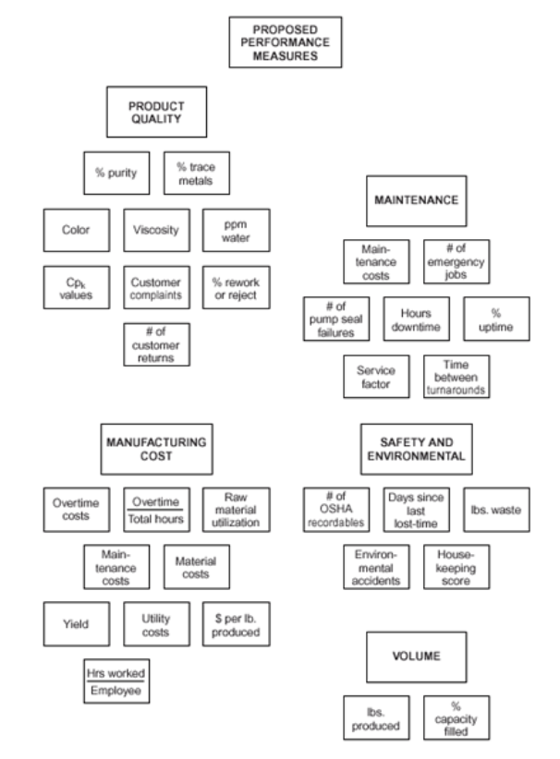
Figure 9a - Tree Diagram courtesy ASQ
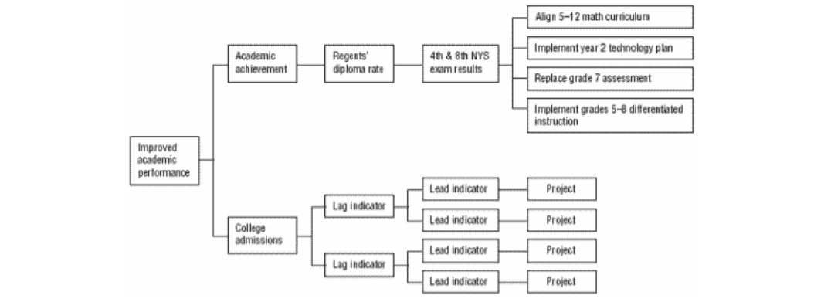

Figure 9b - WBS Work Breakdown Structure courtesy Knowlegehut.com
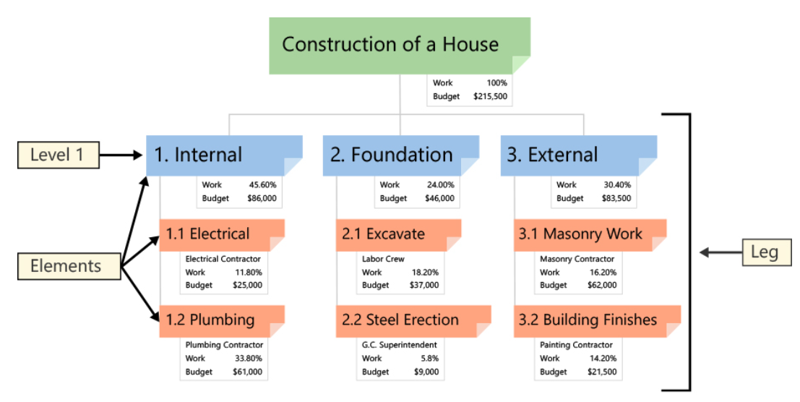

Figure 10 – Prioritization Matrices courtesy Product Plan
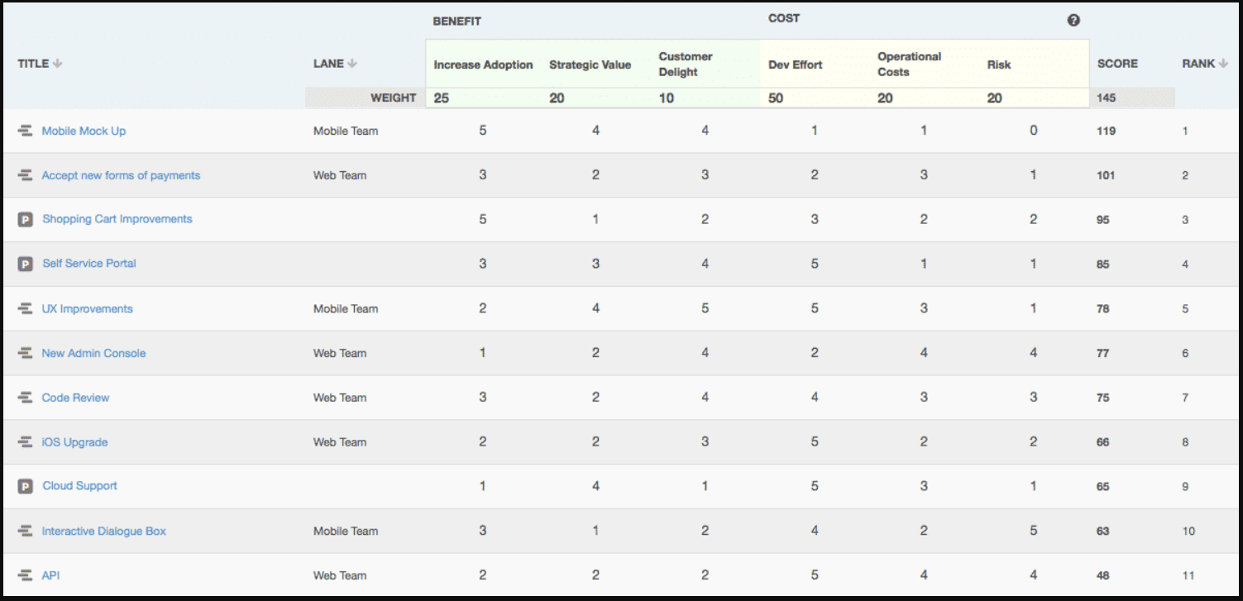
- What do you get after completing the Quality Management process:
  - Change Requests
    - After the product is tested and Quality Assurance is performed (user feedback through Focus Groups etc) it may be determined that a change to requirement is required.
  - Project Management Plan Updates
    - Dependent on the approved changes to requirements, this could have an impact on milestones.
  - Organizational Process assets Updates
    - As a result of the project, processes may have to change.
      - A Model Office using the new product or service, with set scenarios, can be used to evaluate the new process and ensure it works effectively.
Quality Control
What is needed to start this process:
  - Project Management Plan
  - Quality Metrics
  - Quality Checklists
  - Work Performance Data
  - Work Performance Data
  - Approved Change Requests
  - Risk Register
  - Deliverables
  - Project Documents
  - Organizational Process Assets

Tools & Techniques You can Use for Planning Quality Management
  - SEVEN BASIC QUALITY TOOLS (refer to Plan Quality)
    - Cause and Effect Diagrams
    - Flowcharts
    - Checklists
    - Pareto Diagrams
    - Histograms
    - Control Charts
    - Scatter Diagrams
  - STATISTICAL SAMPLING
  - INSPECTION
  - APPROVED CHANGE REQUESTS
    - This is where the original requirements defined in the planning stages are adjusted as the project progresses.
    - As part of planning, a formal change request process is designed and then implemented as the project progresses.
    - Based on feedback from Quality Assurance, a change may have to be implemented – because projects involve progressive elaboration – your understanding and knowledge grows as the project progresses and you look at requirements early in a project when you know the least about the project. This formal process for Change Requests is incorporated into the project plan.

- What do you get after completing the Quality Management process:
  - Quality Control Measurements
    - Documented results from Quality Assurance, User Acceptance and Model Office activities.
  - Quality Assurance
    - Removal of bugs or defects from the product, service or process.
      - USER ACCEPTANCE
        - Assuming there are no bugs or that the bugs don’t have a major impact, having the user use the product ensures that the process or product or service can meet the needs of the user.
        - A product or service or process can have no defects and still not meet the needs of the user. It is important to get the user’s perspective to ensure all that is involved is taken into consideration using real world scenarios.
        - Feedback via surveys and questionnaires can be used to determine this.
      - MODEL OFFICE
        - Ensuring that the existing process, new process or redesigned process can support the new product or process.
        - This tests your process and ensures that all persons impacted are aware of all the changes made to the process (if any).
        - Selected scenarios are walked through (re-enactment) with the various persons who are used as test clients/users, at various times and in various situations according to prepared test scripts.
  - Validated Changes
    - The results of the Quality Management activities would document whether items changed or repaired are accepted or rejected.
    - Rejected items require rework.
  - Verified Deliverables
    - Products and services that have gone through the Quality Assurance process.
    - Quality Management involves determining the correctness of deliverables.
  - Work Performance Information
    - This is performance data collected from controlling processes.
  - Change Requests
    - If the corrective action to remove a defect or implement preventative action requires a change in the Project Management Plan, a change request would have to be initiated.
  - Project Management Plan Updates
    - The major project plans that would be updated is the Quality Management Plan and the Process Improvement Plan based on the results from Quality Assurance & User Acceptance Testing. Other project plans can be impacted as well.
  - Project Document Updates
    - All project documents related to Quality Management process would be updated.

LESSON 5 QUIZ (Multiple Choice, Matching & True or False)

- Use from the following list of Tools (Affinity Diagram, Benchmarking, Cost Benefit Analyst, Checklist, Flowcharts, Fishbone Diagram, Histogram, Pareto Chart, Prioritization Matrix, Scatter Diagram, Statistical Sampling, Tree Diagram) to match to the correct scenario below:
  - You are on the Board of an NGO that has programs to upskill the young persons in the area, to ensure they are able to leverage these skills to get jobs and hence increase opportunities for the impoverished through technical skills such as programming, database development, analytics and graphic design.
    - After your first run of the program, you want to improve the program by determining which technical skill set would be of the greatest benefit to participants and meeting the goals of the program given the overall $500,000 budget the NGO has available.

    - You have identified an area to be improved and you want to break this down into manageable tasks so that these tasks could be assigned to various NGO team members.

    - You want to determine best practices for NGOs that offer courses as part of its program to ensure that the best approaches are used in the teaching of this online course, how students are evaluated and how to provide job opportunities during and after the course.

    - Students are complaining about the course on social media. Students who are on a payment schedule, are not being notified when the payment is due and they are then terminated from the course, losing their previous payments. You want to document and analyze the current process to identify what are the challenges (bottlenecks, redundancies) in the current process is resulting in this issue.

    - After the analysis it is realized that some students never complain because complaints seem based on the office administrator that is handling the payment process for the student. You want to ensure that every step is followed, no matter which office administrator is handling a student payment.

    - You are seeing that students are not completing the course and you want to brainstorm all the possible causes for students not completing the course.

    - After the brainstorming session, you realize that it is a much more complex problem than you had realized, and you want to break down the causes into a few categories which you would like to present to the NGO board to discuss to determine the best way forward with the program.

    - You have determined the three top reasons for students not completing the course and you want to determine in which order these issues should be resolved (issues not resolved in the current budget period would have to be resolved in the upcoming budget period).

    - Student success seems to be tied to whether they opt to do an internship at the end of the program (this is not mandatory but is at an additional cost). You want to prove this correlation.

    - You want to randomly select students to get their feedback on their experience to determine how to improve the program, you want to vary the persons being sampled by area they live, age and the length of time they finished the program.

Answers:
1. Cost Benefit Analysis
2. Work Breakdown Structure
3. Benchmarking
4. Flowchart and or Fishbone diagram
5. Checklist
6. Fishbone Diagram
7. Affinity Diagram
8. Prioritization Matrix
9. Scatter Diagram
10. Statistical Sampling.

MODULE 10 – PROJECT INTEGRATION
________________________________________________________________________________________________________

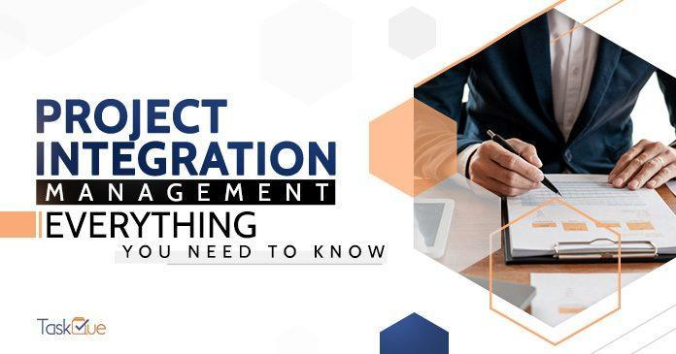

MODULE OBJECTIVES
At the end of this module participants will be able to:
- Define project integration management.
- Understand the steps in project integration management.
- Understand the importance of project integration management.
- Understand how to succeed in project integration management.

MODULE STRUCTURE
This module will be delivered in one lesson to be completed over the course of 8 hours.
Lesson 1 - Project Integration Management
Lesson 2 - Project Integration Management Steps
Lesson 3 - Importance of Project Integration Management
Lesson 4 - How to Succeed in Project Integration Management

INTRODUCTION
What is Project Integration Management? Project Integration Management is the coordination of all elements of a project. This includes the processes and activities to identify, define, combine, unify, and coordinate the various processes and project management activities within the Project Management Process Groups.
Integrated project management ensures projects are not managed in isolation; but considers how aspects of your project relate to each other and how other parts or projects of the organization may impact your project. It is considered a critical success factor for Project Managers and their projects.

LESSON 1 - PROJECT INTEGRATION MANAGEMENT

The process of bringing all the various components of a project together into a unified whole is known as project integration management. The entire project, from developing the project charter and creating the project management plan to overseeing and controlling project work, is covered in this. To put it another way, integration management is the thread that connects all the other project management procedures.

Project Integration Management involves a collaborative system among the key elements of project management. These are typically:

1. Scope
2. Schedule, including time
3. Cost
4. Quality
5. Human Resources
6. Communications
7. Risk
8. Procurement

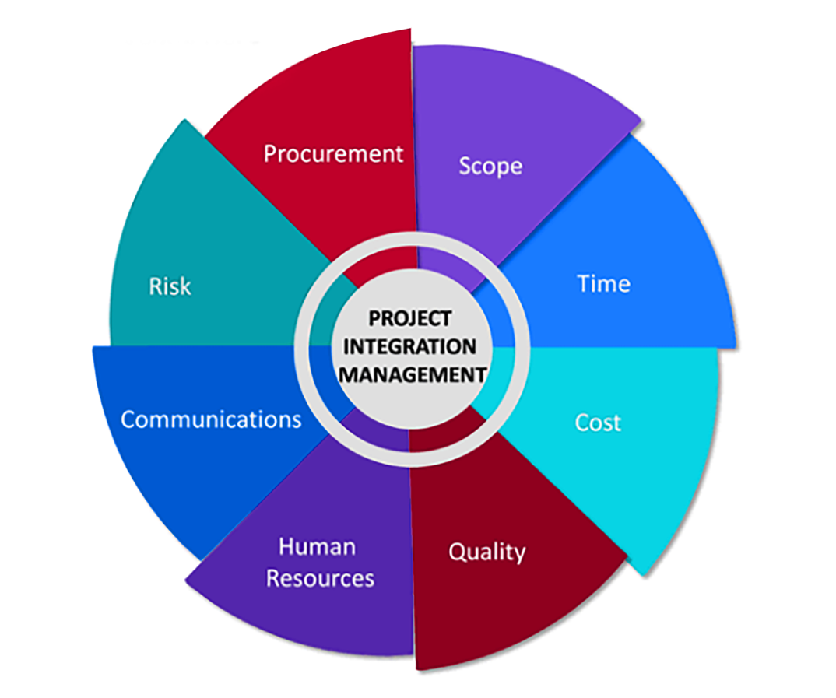

When various teams and processes interact, project integration management is required. The goal of project integration management is to make sure that procedures are effective and achieve set objectives.

LESSON 2 - PROJECT INTEGRATION MANAGEMENT STEPS
Project integration management consists of seven processes to effectively coordinate project activities as shown in the figure below.
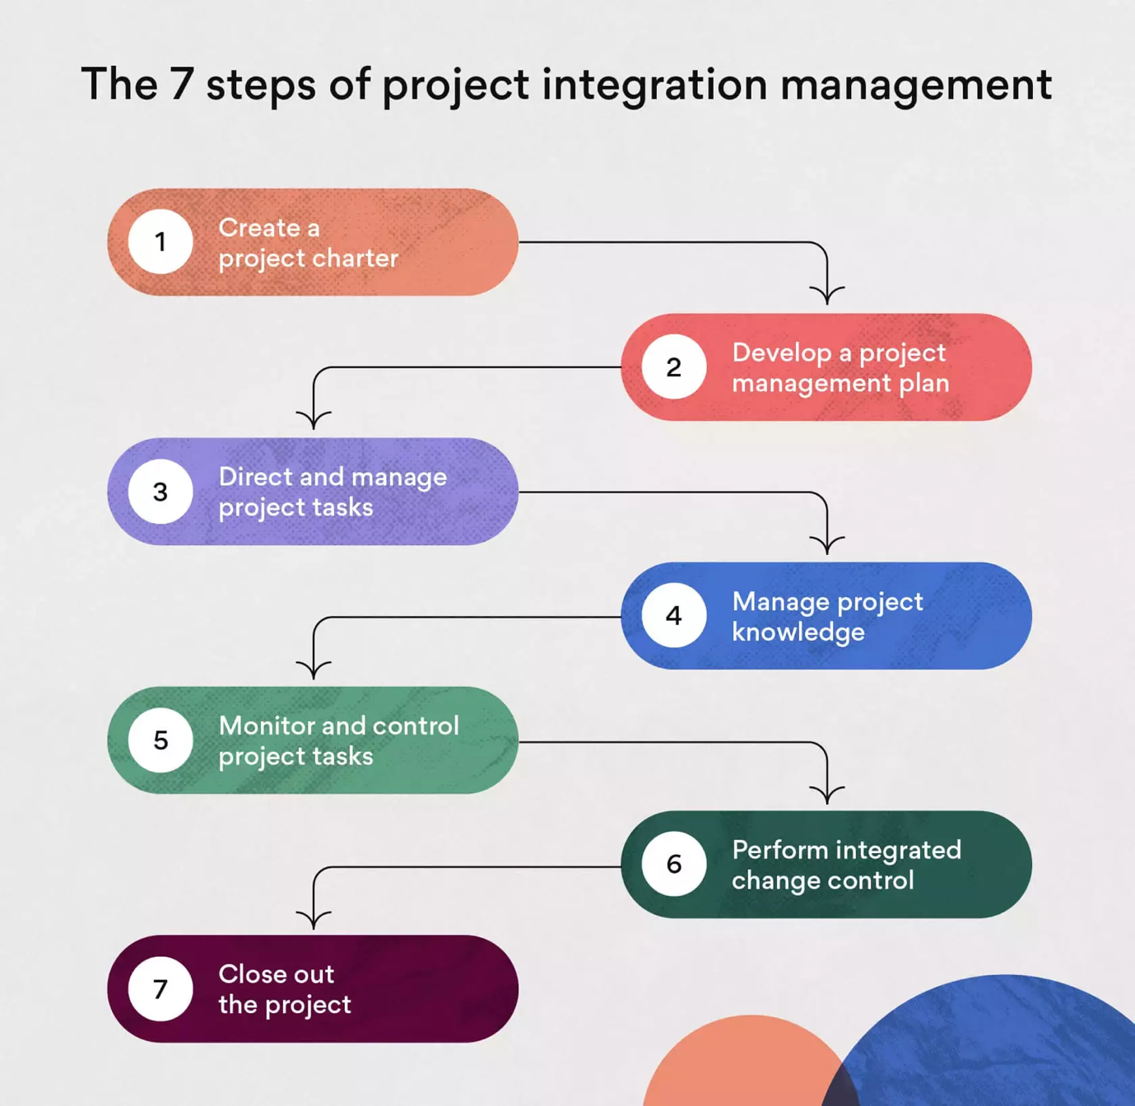
Step 1: Create Project Charter

The Project Charter serves as a formal announcement that a new approved project is about to commence. It authorises the project and identifies the Project Manager.

The process of developing a Project Charter typically commences with the consideration of the following points:
- Project vision: This defines the overall objective of the project which includes the vision and mission of the project, the benefit of the project on the organization and the final deliverable.
- Project organization: The roles and responsibilities of the project team participating in the project development are specified. It also includes relevant stakeholders, their relation to the project, internal and external human resources and the customers.
- Implementation: The next step is creation of an implementation plan. This plan will keep the stakeholders updated on the key milestones, changes or updates in project progress and distinct dependencies toward project completion.
- Risk management: Performing risk management is important as it will identify any potential risks that may delay the delivery of the project.

The above points are documented within the Project Charter. In addition, the Project Charter sets out the following:

- Scope
- Objectives and deliverables
- Key aspects of the Business Case
- Project team members
- Project risks
- Returns on investment
- Budget

The various inputs, tools and techniques and outputs involved in the creation of the Project Charter are listed in the table below:

Inputs | Tools and Techniques | Outputs
- Business Documents  - Business Case  - Benefits Management Plan  - Agreements  - Enterprise Environmental Factors  - Organisational Process Assets | - Expert Judgement  - Data Gathering  - Brainstorming  - Focus Groups  - Interviews  - Interpersonal and Team Skills  - Conflict Management  - Facilitation  - Meeting Management  - Meetings | - Project Charter  - Assumption Log  - Risk Register  - Milestone Plan  - Project Plan or Schedule  - Communication Plan

Step 2: Develop Project Management Plan
The next step involves developing a Project Management Plan. This identifies the project scope statement, and describes the deliverables, timelines, milestones, and metrics to evaluate success. The Project Management Plan identifies the key activities to be completed, including how the project is executed, monitored, controlled and closed. The Project Management Plan is supported by a detailed Project Plan that identifies the details of activities to be performed, by whom, when, and what outputs/deliverables to be achieved.

This is also the stage where Project Managers and Team Leaders divide the project into smaller milestones and steps, giving it a work-breakdown structure, hence making it an essential resource for decision making and risk management to control the project.

The various inputs, tools techniques and outputs involved in this process are listed in the table below:

Inputs | Tools and Techniques | Outputs
- Project Charter  - Outputs from other processes  - Enterprise Environmental Factors  - Organizational Process Assets | - Expert Judgement  - Data Gathering  - Brainstorming  - Checklists  - Focus Groups  - Interviews  - Interpersonal and Team Skills  - Conflict Management  - Facilitation  - Meeting Management  - Meetings | - Project Management Plan

Step 3: Direct and Manage Project Work
The next phase is project execution, in which the Project Manager takes charge of the day-to-day work that must be done, such as:
- Directing the project team
- Holding stakeholder meetings
- Tracking project progress
- Managing risks
- Managing communications

This phase ensures that project activities are executed effectively according to the project plan and scope statement.

The various inputs, tools and techniques, and outputs involved in this process are listed in the table below:

Inputs | Tools and Techniques | Outputs
- Project Management Plan  - Any Component  - Project Documents  - Change Log  - Lessons learned register  - Milestone List  - Project Communications  - Project Schedule  - Requirements Traceability Matrix  - Risk Register  - Risk Report  - Approved Change Requests | - Expert Judgement  - Project Management Information System  - Meetings | - Deliverables  - Work Performance Data  - Issue Log  - Change Requests  - Project Management Plan Updates  - Any Component  - Project Document Updates  - Activity List  - Assumption Log  - Lessons Learned Register  - Requirements documentation  - Risk Register  - Stakeholder Register  - Organizational Process Assets Update

Step 4: Manage project knowledge
Project knowledge management refers to the process of using existing information or obtaining additional knowledge to attain project goals. This step ensures the project team has all the required information to successfully produce the required deliverables. Project Knowledge Management takes place alongside the conduct of the project activities.

Any knowledge or expertise gained during this step contributes to the organisation’s overall body of knowledge, which is useful for future strategic endeavours.

In this process, Project Managers utilize the existing information and acquire additional information to achieve the project goals. The expertise acquired during the implementation of the project will expand the organisation's intellectual wealth, and increases the value of knowledge exchange within the organization.

Various inputs, tools and techniques, and the outputs involved in this process are listed in the table below:

Inputs | Tools and Techniques | Outputs
- Project Management Plan  - All Components  - Project Documents  - Change Log  - Lessons learned register  - Project Team Assignments  - Resource Breakdown Structure  - Source Selection Criteria  - Stakeholders Register  - Deliverables  - Enterprise Environmental Factors  - Organizational Process Assets | - Expert Judgement  - Knowledge Management  - Information Management  - Interpersonal and Team Skills  - Active Listening  - Facilitation  - Leadership  - Networking | - Lessons Learned Register  - Project Management Plan Updates  - Any Component  - Organizational Process Assets Update

Step 5: Monitor and control project work
Since processes in Project Integration Management are interconnected, they should be adhered to, to ensure that activities follow the Project Management Plan.

The objective of this step is to keep the project on track. If there are any deviations from the project plan, they need to be identified and corrected. There are three approaches to this step:
- Preventive action: an action performed to reduce the negative impact of project risks
- Corrective action: an action performed to bring existing and future project performance back in line with the project plan
- Defect repair: an action to repair or replace a documented project defect.

A common technique to measure project performance is to do an earned-value analysis to assess the current status of the project’s budget and schedule. If project changes need to be made and are approved, project documents, such as the work performance report, may need to be updated. Monitoring the project ensures that it is continuously on track to meet objectives.

Various inputs, tools and techniques, and outputs involved in this process are listed in the table below:

Inputs | Tools and Techniques | Outputs
- Project Management Plan  Any Component  - Project Documents  - Assumption Log  - Basis of estimates  - Cost Forecasts  - Issue Log  - Lessons learned register  - Milestone List  - Project  - Quality Reports  - Risk Register  - Risk Report  - Schedule Forecasts  - Work Performance Information  - Agreements  - Enterprise Environmental Factors  - Organizational Process Assets | - Expert Judgement  - Data Analysis  - Alternatives Analysis  - Cost-Benefit Analysis  - Earned Value Analysis  - Root Cause Analysis  - Trend Analysis  - Variance Analysis  - Decision Making  - Meetings | - Work Performance Reports  - Change Requests  - Project Management Plan Updates  - Any Component  - Project Document Updates  - Cost Forecasts  - Issue Logs  - Lessons Learned Register  - Risk Register  - Schedule Forecasts

Step 6: Perform integrated change control
This process is performed to control the various change requests received during the project life cycle. At this stage, the team utilises a Change Control Log to document all the change requests, approved changes, modifications of the final deliverable, project documents and project management plan, that is continuously reviewed. The Change Control Log will also allow the team to assess the overall risks which might arise due to the new changes, as well as any new issues that need to be communicated to relevant internal and/or external stakeholders, and to teams on other projects being undertaken by the organisation.

Various inputs, tools and techniques, and outputs involved in this process are listed in the below table:

Inputs | Tools and Techniques | Outputs
- Project Management Plan  - Change Management Plan  - Configuration Management Plan  - Scope Baseline  - Schedule Baseline  - Cost Baseline  - Project Documents  - Basis of estimates  - Requirements Traceability matrix  - Risk Report  - Work Performance Reports  - Change Requests  - Enterprise Environmental Factors  - Organizational Process Assets | - Expert Judgement  - Change Control Tools  - Data Analysis  - Alternatives Analysis  - Cost-Benefit Analysis  - Decision Making  - Voting  - Autocratic Decision Making  - Multicriteria Decision Analysis  - Meetings | - Approved Change Requests  - Project Management Plan Updates  - Any Component  - Project Document Updates  - Change Log

Step 7: Close the Project
This is the final process of Project Integration Management, whereby all project activities, phases, and contracts are finalized. It provides a controlled environment in which the project can be successfully closed. The closing process includes the activities such as the preservation of project information, completion of planned work and the release of resources.

Various inputs, tools and techniques, and outputs involved in this process are listed in the table below:

Inputs | Tools and Techniques | Outputs
- Project Charter  - Project Management Plan  - Any Component  - Project Documents  - Assumption Log  - Basis of estimates  - Change Log  - Issue Log  - Lessons learned register  - Milestone List  - Project Communication  - Quality Control Measurements  - Quality Reports  - Requirements Documentation  - Risk Register  - Risk Report  - Accepted Deliverables  - Business Documents  - Business Case  - Benefits Management Plan  - Agreements  - Procurement Documentation  - Organizational Process Assets | - Expert Judgement  - Data Analysis  - Document Analysis  - Regression Analysis  - Trend Analysis  - Variance Analysis  - Meetings | - Project Documents Updates  - Lessons Learned Register  - Final Product, Service, or Result Transition  - Final Report  - Organizational Process Assets Updates

LESSON 3 - IMPORTANCE OF INTEGRATION MANAGEMENT

1. Provides coordination and synchronization throughout the project lifecycle
Project Integration Management allows a collaborative approach among all stakeholders to ensure the ease of flow of project processes throughout the project, and information exchange within the organisation. Integration management is necessary to ensure there is teamwork and all information is synchronized.

2. Ensures the project runs smoothly
With proper integration management, the project activities are completed without any confusion. After finishing all the activities, the project can be officially closed and resources can be released for use on other activities or utilized for the next project.

3. Clear understanding of their roles and responsibilities
With structured integration management, all the stakeholders will be clear about their roles and responsibilities, including their authority. The planning and coordination between the stakeholders are monitored by the Project Manager.

4. Measures and monitors the project’s progress
Integration management ensures the project’s information is distributed to all relevant stakeholders, in pertinent format.

5. Decisions are clearer
Decisions about key changes required for smooth project flow is taken by conducting meetings with all relevant stakeholders. The reasons for key decisions are documented for future reference and/or audit purposes.

6. Manages and controls the performance
Project Integration Management manages and controls the team’s or individual performance, or delay due to the input from other teams or departments.

7. Ensures due dates, results, project lifecycle, and that the benefits of the project management plan are aligned
With proper coordination, the project deliverables are delivered on time.

LESSON 4 - HOW TO SUCCEED AT PROJECT INTEGRATION MANAGEMENT

Successful Project Integration Management comes with experience and requires a Project Manager with the competency to drive results on even the most complicated projects. Project Managers must have a combination of soft and hard skills including Planning, Communication, Relationship Management, Leadership, Critical Thinking, Data Analysis, Budgeting, Change Management and Risk Management.

Establishing open communication channels with the team is important to ensure that information is shared on time. Appropriate impact assessments need to be performed periodically to determine integration points or dependencies. Using integrated management software or tools can also increase the chances of project success.

LESSON QUIZ

- Which of the following processes is not part of Project Integration Management?
- develop the project business case
- develop the project management plan
- close the project

Answer: A develop the project business case.

- A _____ is a document that formally recognizes the existence of a project and provides direction on the project's objectives and management.
- Project Charter
- preliminary scope statement
- Business Case
- Project Management Plan

Answer: A Project Charter.

- A ______ often includes sensitive information, so it should not be part of the overall project plan for anyone to see.
- Business Case
- Project Charter
- Personnel chart
- Stakeholder analysis

Answer: D stakeholder analysis.

- A list of project documentation, project closure documents and historical information produced by the project are all examples of ______
A. Lessons learned
B. Deliverables
C. Project management software outputs
D. Process assets

Answer: D process assets.

- _________ reserves allow for future situations that are unpredictable.
- Contingency
- Financial
- Management
- Baseline

Answer: B financial.

- Which of the following processes is not part of Project Integration Management?
- developing the project Business Case
- developing the Project Charter
- developing the Project Management Plan
- closing the project or phase

Answer: A developing the project Business Case.

- Which of the following items is not normally included in a Project Charter?
- the name of the project manager
- budget information
- stakeholder signatures
- Gantt chart

Answer: D Gantt chart.

- What tool and technique is used for all processes of Project Integration Management?
- project management software
- templates
- expert judgment
- all of the above

Answer: C expert judgement.

- Which of the following statements is NOT true about projects?
- The Project Charter establishes a partnership between the performing and requesting organizations.
- Projects are initiated by an entity internal to the project.
- Projects are initiated due to internal business needs or external influences.
- A Project Charter is not considered to be a Contract.

Answer: Choice B. Projects can be initiated by an entity external to the project such as a sponsor, program or project management office (PMO), or a portfolio governing body chairperson or authorized representative. Projects can also be initiated within a department or unit, but must obtain approval from the relevant organisational Head.

- The project kick-off meeting is usually associated with the end of planning and start of executing. As the Project Manager, you will use the kick-off meeting for all of the following outcomes EXCEPT:
- To communicate the objectives of the project.
- To gain the commitment of the team for the project.
- To explain the roles and responsibilities of each stakeholder
- To formally authorize the existence of the project

Answer: Choice D. Formal authorization of a project happens at the time of Project Charter, not at the kick-off meeting.

MODULE 11 – PROJECT CLOSURE
________________________________________________________________________________________________________

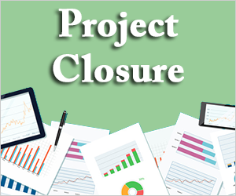

MODULE OBJECTIVES

At the end of this module, participants will be able to:
- Understand what the project closure phase involves
- Understand the different reasons for closing a project
- Describe the different project closure scenarios
- Identify the different stakeholders involved in the project closure phase
- Identify the inputs and outputs of the project closure phase.

MODULE STRUCTURE

This module will be delivered in six lessons to be completed over the course of 6 hours.
Lesson 1 - Activities Involved in Project Closure
Lesson 2 – Reasons for Project Closure
Lesson 3 – Project Closure Scenarios
Lesson 4 - Stakeholders Involved in Project Closure
Lesson 5 - Inputs of Project Closure
Lesson 6 - Outputs of Project Closure

INTRODUCTION
Project closure is the process of finalizing all activities for a project, phase, or contract which involves checking and confirming that all planned work is completed in accordance with the Project Charter, Project Plan, or Contract, arranging for the completion of any outstanding planned work, archiving project information, communicating project completion to stakeholders as necessary, and releasing organizational resources to pursue new endeavours. It is the final phase in the project lifecycle or project management process and is performed once or at predefined points. It is vital to plan for project closure activities in the early stages to ensure that the project closure process is efficient and compliant. As part of a comprehensive project management plan, this can be in the form of a project closure plan or a simple project termination checklist that describes the specific actions needed to be undertaken.

LESSON 1 - ACTIVITIES INVOLVED IN THE PROJECT CLOSURE PHASE

During project closure, the Project Manager will utilize the Project Plan to validate whether all project work has been completed and whether the project objectives have been met. Administrative activities include but are not limited to:

- Actions and activities necessary to satisfy completion or exit criteria for the phase or project such as:
- Making certain that all documents and deliverables are up-to-date and that all issues are resolved
- Confirming the delivery and formal acceptance of deliverables by the customer
- Ensuring that all costs are charged to the project
- Closing project accounts
- Reassigning personnel
- Dealing with excess project material
- Reallocating project facilities, equipment, and other resources, and
- Elaborating the final project reports as required by organizational policies.

- Activities related to the completion of the contractual agreements applicable to the project or project phase such as:
- Confirming the formal acceptance of the seller’s work
- Finalizing open claims
- Updating records to reflect final results and
- Archiving such information for future use

- Activities needed to:
- Collect project or phase records
- Audit project success or failure
- Manage knowledge sharing and transfer
- Identify lessons learned and
- Archive project information for future use by the organization

- Actions and activities necessary to transfer the project’s products, services, or results to the next phase or to production and/or operations.

- Collecting lessons or recommendations for any suggestions for improving or updating the policies and procedures of the organization and sending them to the appropriate organizational unit.

- Measuring stakeholder satisfaction.

LESSON 2 - REASONS FOR PROJECT CLOSURE
There are different reasons why a project or phase may close:
- The project or phase has successfully met its objectives.
- Funding is no longer available to complete the project.
- The project is no longer feasible to implement due to changes in requirements.
- Significant risks or external factors make completion of the project impossible.
- The organization no longer needs the project deliverables.

LESSON 3 - PROJECT CLOSURE SCENARIOS
The end of a project may sometimes be characterized as a transition phase rather than a definite close. Some typical project closure scenarios include:
- Closure: When the project has formally ended, and all project closure activities have been completed.
- Handover: When the continuation of the product or service from the project is handed over to a local partner or entity.
- Extension: Due to unforeseen circumstances during project implementation projects may require additional time to be completed. (Could be at additional or no cost).
- Expansion: Involves identification of elements of a project for replication with a new target area or population. According to the level and complexity of the expansion, this may evolve as a new project.
- Redesign: Involves continuation of a project through a new phase with modified interventions or activities.

LESSON 4 - STAKEHOLDERS INVOLVED IN THE PROJECT CLOSURE PHASE
The Project Manager is primarily responsible for ensuring that all project work has been completed and objectives have been met. However, the entire project team and relevant stakeholders should be involved to ensure that the process is as robust, effective, and complete. For instance, involving the operations or administrative support team, project beneficiaries and project partners can assist in gathering information for completing Financial Reports, Lessons Learned and Evaluations which are examples of important outputs of the Project Closure Phase. Additionally, individuals or groups with specialized knowledge or training should be considered when required to report on activities such as audits, legal and procurement, and legislation and regulations.
Project Closure Meetings are an excellent opportunity or technique for involving stakeholders in the closure process. This comprises of meetings with key stakeholders, project beneficiaries and the project team to finalize work, ensure acceptance of deliverables, confirm close-out results, formalize the competition of contracts, evaluate stakeholder satisfaction, gather lessons learned, transfer knowledge and celebrate the project’s success. Meetings can be held separately to focus on each activity, for instance; close-out reporting meetings, stakeholder or customer wrap-up meetings, lessons learned meetings, and celebration meetings.

LESSON 5 - INPUTS OF THE PROJECT CLOSURE PHASE
Inputs used to effectively close a project are those documents and other communication that would have been used during the life of the project, to drive the completion of project activities. The following are some of the main inputs required:
- Project Charter
- Project Management Plan or Implementation Plan (including the project exit criteria or closure plan)
- Project Documents (milestone lists, issues log, lessons learned log, Monitoring, Evaluation, Accountability and Learning (MEAL) report, risk register etc.)
- Accepted Deliverables
- Financial Reports
- Contract and Agreements
- Procurement Documentation
- Status Reports

These documents are reviewed to ensure a proper understanding of the project, as well as to gain an understanding of the status of the project. This guides an understanding of whether the project is in fact completed or alerts one to possible outstanding activities or project issues that require deeper review, prior to closure.

LESSON 6 - OUTPUTS OF THE PROJECT CLOSURE PHASE
- Updated project documents: All project documents should be updated as final versions. For example, the Lessons Learned Register is an important document in this phase to record information on the project’s implementation that can be used to improve future projects.
- Transition of the final product or service: Involves the transition of the final product, service, or phase of a project from one team to another.
- Final reports: A summary closure report on the project’s performance which should include information such as the following:
- A summarized description of the project or phase.
- A summary of achievement of objectives.
- A summary of risks or issues encountered on the project and how they were addressed.
- A summary of expenses or cost objectives, including the acceptable cost range, actual costs, and reasons for any variances.
- A summary of scope objectives, the criteria used to evaluate the scope, and evidence that the completion criteria were met.
- A summary of quality objectives, the criteria used to evaluate the project and product quality, the verification and actual milestone delivery dates, and reasons for variances.
- Evaluation reports: Includes mid-term evaluations and post evaluations that assesses how the project was implemented and provides recommendations for improvement. Post evaluations can also assess the project’s impact over time.
- Asset management: All project equipment and supplies should be well documented or logged. Assets are either returned after the closure of the project or allocated to another project for use.
- Resource reassignment: Communication to transfer resources (e.g., human resources/project team members) back to regular or other duties. To assist with personal and professional improvement, It would be beneficial for the project manager to provide a documented performance assessment to each person of how he/she performed on the project. This should be reviewed with the person, as a part of the overall performance appraisal system for the person.
- Contract closure: Document(s) to attest to the completion and release of contracts.

LESSON QUIZ

- Project closure can be performed once or at predefined points in a project. (Trues/False)

Answer: True (Project closure can be performed once at the end or anytime throughout a project or at predefined points in a project to mark the closure of a particular phase.)

- A project may close even if it has not met its objectives due to changes in requirements.

Answer: True (A project may close for various reasons, which can include not meeting its objectives due to unaccounted changes in requirements.)

- The closing process is mainly the Project Manager's responsibility and does not involve the project team.

Answer: False (It is essential to involve all relevant stakeholders in the closing process to ensure it is robust, effective, and complete)

- The Project Charter is not an input required in the Project Closure Phase.

Answer: False (The Project Charter defines key aspects of a project such as the objectives and scope which can be used during project closure to validate the project’s success.)

- An example of an output of project closure is financial reports.

Answer: True (Financial reports provide a summary of project expenditure and can be used to verify reasons for variances from the planned budget.)

